 | National River Conservation Directorate  Ministry of Jal Shakti, Department of Water Resources,  River Development & Ganga Rejuvenation  Government of India

Industrial Profile of Narmada River Basin

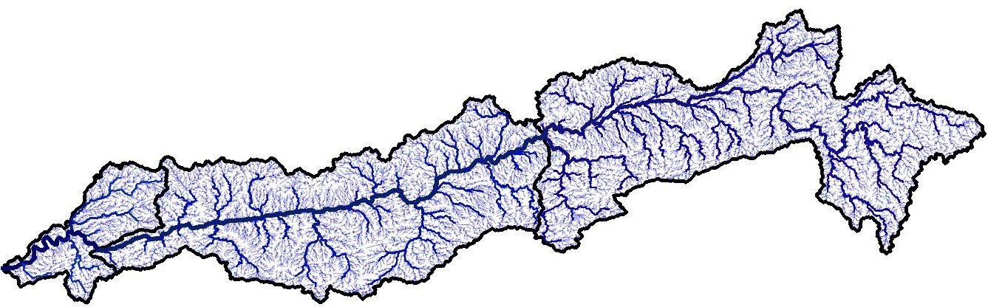

November 2025

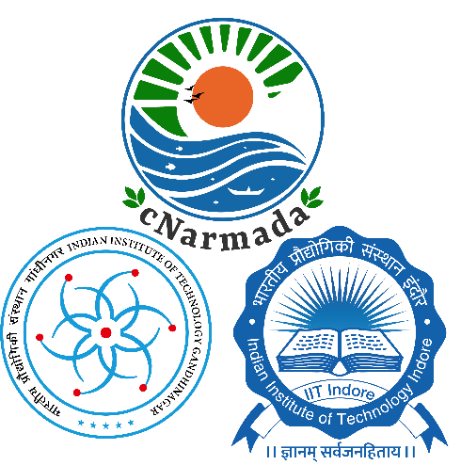
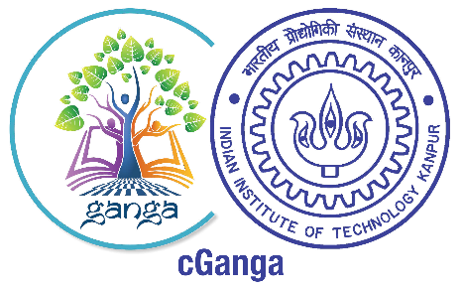

© cNarmada, cGanga and NRCD, 2025

Industrial Profile of
Narmada River Basin

© cNarmada, cGanga and NRCD, 2025
National River Conservation Directorate (NRCD)
The National River Conservation Directorate, functioning under the Department of Water Resources, River Development & Ganga Rejuvenation, and the Ministry of Jal Shakti, provides financial assistance to the State Government for the conservation of rivers under the Centrally Sponsored Schemes of ‘National River Conservation Plan (NRCP)’. National River Conservation Plan to the State Governments/ local bodies to set up infrastructure for pollution abatement of rivers in identified polluted river stretches based on proposals received from the State Governments/ local bodies.
www.nrcd.nic.in

Centres for Narmada River Basin Management and Studies (cNarmada)
The Centre for Narmada River Basin Management and Studies (cNarmada) is a Brain Trust dedicated to River Science and River Basin Management. Established in 2024 by IIT Gandhinagar and IIT Indore, under the supervision of cGanga at IIT Kanpur, the centre serves as a knowledge wing of the National River Conservation Directorate (NRCD). cNarmada is committed to restoring and conserving the Narmada River and its resources through the collation of information and knowledge, research and development, planning, monitoring, education, advocacy, and stakeholder engagement.
www.cnarmada.org

Centres for Ganga River Basin Management and Studies (cGanga)
cGanga is a think tank established under the aegis of NMCG, with one of its stated objectives being to make India a global leader in river and water science. The Centre is headquartered at IIT Kanpur and has representation from most leading science and technological institutes of the country. cGanga’s mandate is to serve as a think-tank in the implementation and dynamic evolution of the Ganga River Basin Management Plan (GRBMP) prepared by the Consortium of 7 IITs. Additionally, it is responsible for introducing new technologies, innovations, and solutions to India.
www.cganga.org

Acknowledgment
This report is a comprehensive outcome of the project jointly executed by IIT Gandhinagar (Lead Institute) and IIT Indore (Fellow Institute) under the supervision of cGanga at IIT Kanpur. It was submitted to the National River Conservation Directorate (NRCD) in 2024. We gratefully acknowledge the individuals who provided information and photographs for this report.

Team Members

Prof. Manish Kumar Goyal, cNarmada, IIT Indore
Prof. Pritee Sharma, cNarmada, IIT Indore
Prof. Kiran Bala, cNarmada, IIT Indore
Dr. Mayur Shirish Jain, cNarmada, IIT Indore
Dr. Priyank Sharma, cNarmada, IIT Indore
Dr. Ashootosh Mandpe, cNarmada, IIT Indore
Dr. Ritu Jain Kothari, cNarmada, IIT Indore
Adarsh Singh, cNarmada, IIT Indore
Shreya Dixit, cNarmada, IIT Indore
Shashank Agrawal, cNarmada, IIT Indore

PREFACE

The Narmada River Basin is one of the most significant river systems in central India, supporting a wide range of ecological, social, and economic activities. With rapid industrial expansion across the Upper and Middle Basin regions, it has become essential to evaluate industrial distribution, environmental impacts, and the increasing adoption of real-time monitoring technologies by industries. This report presents a comprehensive assessment of the industrial profile of the Narmada Basin, highlighting sector-wise patterns, spatial distribution, raw material linkages, waste generation, and environmental compliance across industrial units.
The document integrates district-level industrial data, geospatial mapping, industry classification, and detailed analysis of real-time monitoring systems, including CEMS, CEQMS, CAAQMS, Flow Meters, and IPC installations. By examining MSME parks, MPIDC industrial estates, registered Udyog Aadhaar units, and major industrial clusters, the report provides a clear overview of the basin’s industrial strengths, disparities, and emerging development trends. The study aims to support policymakers, regulatory authorities, researchers, and planning agencies in understanding the current industrial scenario and enhancing environmental governance.
We extend our sincere gratitude to the government agencies, research institutions, project staff, and individuals whose contributions of data and insights made this assessment possible. It is our hope that this report inspires informed dialogue and coordinated action, contributing to the restoration and long-term sustainability of the Narmada River Basin for both ecological health and socio-economic development.

Centre for Narmada River Basin
Management and Studies (cNarmada)
IIT Gandhinagar, IIT Indore

Table of Contents
1 Introduction 1
2 Registered Aadhaar Udyog 2
2.1 Registered Aadhaar Udyog in the Upper Narmada Basin 2
2.2 Registered Aadhaar Udyog in the Middle Narmada Basin 4
3 Industrial Clusters landscapes of the Narmada Basin 7
3.1 Industrial landscapes, raw material Utilization in Upper Narmada Basin 7
3.2 Industrial landscapes, raw material Utilization in Middle Narmada Basin 8
3.3 Status of Green Belt, Waste Treatment, and Water Consumption in Upper Narmada Basin 12
3.4 Status of Green Belt, Waste Treatment, and Water Consumption in Upper Narmada Basin 13
4 Industrial Areas of the Basin 16
5 Industrial Parks in the Basin 17
5.1 MSME Industrial Park in Upper Narmada Basin 18
5.2 MSME Industrial Park in the Middle Narmada Basin 19
5.3 MPIDC Industrial Park in Upper Narmada Basin 21
5.4 MPIDC Industrial Park in the Middle Narmada Basin 23
6 Industries in the Basin 24
6.1 Industries in the Upper Narmada Basin 24
6.2 Industries in the Middle Narmada basin 26
7 Agro-Based Industries 28
7.1 Agro-Based Industries in the Upper Narmada Basin 29
7.2 Agro-Based Industries in the Middle Narmada Basin 31
8 Forest/Wood-Based Industries 33
8.1 Forest/ Wood-based Industries in the Upper Narmada Basin 33
8.2 Forest/Wood-based Industries in the Middle Narmada basin 35
9 Chemical & Allied Industries 37
9.1 Chemical & Allied Industries in the Upper Narmada basin 38
9.2 Chemical & Allied Industries in the Middle Narmada basin 40
10 Mineral & Metal-Based Industries 42
10.1 Mineral & metal-based Industries in the Upper Narmada basin 42
10.2 Mineral & metal-based Industries in the Middle Narmada basin 45
11 Engineering & Services 47
11.1 Engineering & Service-based Industries in the Upper Narmada Basin 48
11.2 Engineering & Service-based Industries in the Middle Narmada basin 51
11.3 Other Industries in the Upper Narmada Basin 54
11.4 Other Industries in the Middle Narmada Basin 57
12 Real-Time Monitoring Systems Installed by Industries in the Basin 59
12.1 Real-time monitoring of Agro & Food Industries in Upper Basin 59
12.2 Real-time monitoring of Agro & Food Industries in Middle Basin 61
12.3 Real-time monitoring of the Manufacturing sector in Upper Basin 63
12.4 Real-time monitoring of the Manufacturing sector in the Middle Basin 64
12.5 Real-time monitoring of chemical-based Industries in the Middle Basin 66
12.6 Real-time monitoring of Thermal Power Plants in Upper Basin 67
12.7 Real-time monitoring of Thermal Power Plants in Middle Basin 69
12.8 Real-time monitoring of Mines in Upper Basin 70
12.9 Real-time monitoring of Mines in Middle Basin 72
12.10 Real-time monitoring of water & waste management in Upper Basin 73
12.11 Real-time monitoring of water & waste management in Middle Basin 74
13 Raw Materials for Different Industries 75
14 Waste Generation from Different Industries 79
15 Summary and Conclusion 81
References 82

List of Tables
Table 1: Registered Aadhaar Udyog in the Upper Narmada Basin 4
Table 2: Registered Aadhaar Udyog in the Middle Narmada Basin 6
Table 3: Industrial landscape and Raw Material Utilization in the Upper Narmada Basin 8
Table 4: Industrial landscape and Raw Material Utilization in the Middle Narmada Basin 9
Table 5: Green Belt, Waste Treatment, and Water Consumption Data in Upper Narmada Basin 12
Table 6: Green Belt, Waste Treatment, and Water Consumption Data in Middle Narmada Basin 14
Table 7: Industrial Profile of Upper Narmada Basin Districts 25
Table 8: Industrial Profile of Middle Narmada Basin Districts 28
Table 9: Agro-Based Industries in the Upper Narmada Basin 30
Table 10: Agro-Based Industries in the middle Narmada basin 32
Table 11: Forest/Wood-based Industries in the Upper Narmada basin 34
Table 12: Forest/Wood-based Industries in the Middle Narmada basin 36
Table 13: Chemical & Allied Industries in the Upper Narmada basin 39
Table 14: Chemical & Allied Industries in the Middle Narmada basin 41
Table 15: Mineral & metal-based Industries in the Upper Narmada basin 44
Table 16: Mineral & metal-based Industries in the Middle Narmada basin 47
Table 17: Engineering & Service-based Industries in the Upper Narmada Basin 50
Table 18: Engineering & Service-based Industries in the Middle Narmada basin 54
Table 19: Other Industries in the Upper Narmada Basin 56
Table 20: Other Industries in the Middle Narmada basin 58
Table 21: Real-time Monitoring of Agro & Food Industries in the Upper Narmada Basin 60
Table 22: Real-time Monitoring of Agro & Food Industries in the Middle Narmada Basin 62
Table 23: Real-time Monitoring of the Manufacturing Sector in the Upper Narmada Basin 64
Table 24: Real-time Monitoring of the Manufacturing Sector in the Middle Narmada Basin 65
Table 25: Real-time Monitoring of Chemical-Based Industries in the Middle Narmada Basin 67
Table 26: Real-time Monitoring of Thermal Power Plants in the Upper Narmada Basin 68
Table 27: Real-time Monitoring of Thermal Power Plants in the Middle Narmada Basin 70
Table 28: Real-time Monitoring of Mining Industries in the Upper Narmada Basin 71
Table 29: Real-time Monitoring of Mining Industries in the Middle Narmada Basin 72
Table 30: Real-time Monitoring of Water and Waste Management Facilities in the Upper Narmada Basin 73
Table 31: Real-time Monitoring of Water and Waste Management Facilities in the Middle Narmada Basin 75
Table 32: Literature Review of Raw Materials in Indian Industries 75
Table 33: Literature Review of Waste Generated from Industries 79

List of Figures
Figure 1: Spatial Distribution of Registered Medium, Small, and Micro Industries in the Upper Narmada Basin 3
Figure 2: Spatial Distribution of Registered Medium, Small, and Micro Industries in the Upper Narmada Basin 6
Figure 3: Spatial distribution of industrial areas across the Narmada River Basin 8
Figure 4: Geographical distribution of MSME Industrial Parks in the Upper Narmada River Basin 10
Figure 5: Geographical distribution of MSME Industrial Parks in the middle Narmada River Basin 11
Figure 6: Location of MPIDC Industrial Parks within the Middle Basin of the Narmada 13
Figure 7: Location of MPIDC Industrial Parks within the Middle Basin of the Narmada 14
Figure 8: Spatial Distribution of Real-Time Monitoring Stations in Agro & Food Processing Industries of the Upper Narmada Basin 50
Figure 9: Spatial Distribution of Real-Time Monitoring Stations in Agro & Food Processing Industries of the Middle Narmada Basin 52
Figure 10: Spatial Distribution of Real-Time Monitoring Installations in Manufacturing & Industrial Processing Sector of the Upper Narmada Basin 54
Figure 11: Spatial Distribution of Real-Time Monitoring Installations in Manufacturing & Industrial Processing Sector of the Middle Narmada Basin 55
Figure 12: Geographical Mapping of Real-Time Monitoring Stations in Chemical & Fertilizer Industries of the Middle Narmada Basin 57
Figure 13: Distribution of Real-Time Monitoring Systems across Thermal Power Plants in the Upper Narmada Basin 58
Figure 14: Distribution of Real-Time Monitoring Systems across Thermal Power Plants in the Middle Narmada Basin 59
Figure 15: Location of Real-Time Monitoring Systems in Mining Industries of the Upper Narmada Basin 61
Figure 16: Location of Real-Time Monitoring Systems in Mining Industries of the Middle Narmada Basin 62
Figure 17: Spatial Distribution of Real-Time Monitoring Stations in Waste & Water Management Sector within the Narmada Upper Basin. 63
Figure 18: Spatial Distribution of Real-Time Monitoring Stations in Waste & Water Management Sector within the Narmada Middle Basin. 64

Abbreviations and Acronyms
CAAQMS – Continuous Ambient Air Quality Monitoring System
CEMS – Continuous Emission Monitoring System
CEQMS – Continuous Effluent Quality Monitoring System
CPCB – Central Pollution Control Board
CPP – Captive Power Plant
DMF – District Mineral Foundation
DOE – Department of Environment
EIA – Environmental Impact Assessment
ETP – Effluent Treatment Plant
IPC – Industrial Pollution Control
IDA – Industrial Development Area
ISO – International Organization for Standardization
JICA – Japan International Cooperation Agency
LD – Limestone Deposits
MLD – Million Litres per Day
MPIDC – Madhya Pradesh Industrial Development Corporation
MPPCB – Madhya Pradesh Pollution Control Board
MSME – Micro, Small, and Medium Enterprises
MSW – Municipal Solid Waste
NRCD – National River Conservation Directorate
PCB – Pollution Control Board
PM – Particulate Matter
RO – Remote Online Monitoring System (context-based)
RTEMS – Real-Time Environmental Monitoring System
RTWQMS – Real-Time Water Quality Monitoring System
STP – Sewage Treatment Plant
SPCB – State Pollution Control Board
ULB – Urban Local Body
WTP – Water Treatment Plan

Introduction
The Narmada River, a prominent west-flowing river in India, serves as a critical water resource for millions of people residing across Madhya Pradesh, Gujarat, Maharashtra, and Chhattisgarh. Spanning a vast area of nearly 98,786 square kilometres, the Narmada Basin supports a population of more than 61 million, comprising 52.89% males and 47.11% females. The basin comprises 38 districts, over 17,000 villages, and nearly 3 million households, underscoring its extensive socio-economic and geographic diversity. Madhya Pradesh dominates the basin, covering around 89% of its total area and population, thereby forming the core region for developmental planning and resource management. The Upper Narmada region features major urban centres such as Jabalpur, which alone has a population exceeding 2.4 million, along with key towns like Narsimhapur, Mandla, and Hoshangabad. In contrast, the middle and lower basin regions are predominantly composed of rural and tribal communities, particularly in districts such as Khargone, Dhar, and Barwani.
The Narmada Basin, one of the most significant river systems of central India, supports an extensive network of industries that rely on the river and its tributaries for water, raw materials, and transportation. Spanning the Upper and Middle Basin regions, the industrial landscape comprises diverse sectors, including agro- and food processing, manufacturing and industrial processing, chemical industries, mining and minerals, energy and power generation, as well as waste and water management. The rapid expansion of industrial activity across these districts has heightened the need for advanced environmental monitoring and regulatory mechanisms, particularly to protect water quality, mitigate pollution loads, and maintain ecological balance.
Over the past decade, industrial development in the Narmada Basin has diversified into micro-, small-, medium-, and large-scale establishments, each contributing to regional economic growth. However, industrial clusters located in Jabalpur, Indore, Dhar, Sagar, Katni, Balaghat, Raisen, and Khandwa exhibit concentrated activities that pose substantial environmental challenges due to wastewater discharge, solid waste generation, air emissions, and mining-related impacts. Recognizing these pressures, regulatory agencies such as the Madhya Pradesh Pollution Control Board (MPPCB) and the Central Pollution Control Board (CPCB) have mandated real-time environmental monitoring systems to strengthen compliance and ensure continuous oversight of industrial pollution.

Registered Aadhaar Udyog
The distribution of Registered Aadhaar Udyog across the Narmada Basin reveals a predominantly micro-enterprise-driven industrial structure, underscoring the region’s reliance on small-scale, resource-based, and locally anchored economic activities. Both the Upper and Middle Narmada Basins exhibit a strong dominance of micro-industries, supported by traditional skills, locally available raw materials, and decentralized growth patterns. While the Upper Basin reflects a more dispersed and rural-focused industrial landscape, the Middle Basin exhibits greater diversification, urban clustering, and higher levels of small- and medium-scale industrial development, largely due to the presence of major commercial centers, including Indore, Bhopal, Dhar, and Dewas. Overall, the registered industrial units across the basins reveal a dynamic yet regionally differentiated industrial ecosystem that combines micro-entrepreneurship with emerging industrial clusters, significantly contributing to local employment, economic resilience, and balanced regional development.

Registered Aadhaar Udyog in the Upper Narmada Basin
The industrial profile of the Upper Narmada Basin, shown in Table 1, demonstrates a strong dominance of micro-industries, which constitute the backbone of the regional economy. Out of a total of 1,68,748 registered Udyog Aadhaar units, micro-enterprises account for around 95%, small industries make up approximately 4.4%, while medium industries represent a minor 0.2% share. This distribution pattern suggests that industrial activities in the region are predominantly small-scale and localized, with a focus on agro-processing, utilization of forest products, mineral-based operations, and household-scale manufacturing. The industries are scattered across rural and semi-urban areas, reflecting decentralized and resource-dependent development patterns.
Among the 15 districts, Jabalpur (22,734 units) leads the basin in total registered industries, followed by Balaghat (18,762), Raisen (17,124), Sagar (15,336), and Chhindwara (15,257). These five districts together account for more than 50% of the total registered industries in the basin. Jabalpur’s dominance is attributed to its strategic connectivity, the availability of skilled labor, and well-developed infrastructure that supports engineering, manufacturing, and service-based industries. Raisen has a substantial number of industries (16,142 micro, 936 small, and 46 medium units) due to its proximity to the Mandideep Industrial Area near Bhopal, a key industrial hub in Madhya Pradesh. Similarly, Balaghat and Katni exhibit strong industrial bases, particularly in mineral extraction, forest-based industries, and metal processing. In contrast, Sagar and Narsinghpur exhibit diversified growth, with both the agricultural and mechanical sectors making significant contributions.
Districts such as Hoshangabad, Seoni, Damoh, and Betul exhibit moderate industrial activity, primarily comprising micro and small enterprises linked to agricultural processing, woodworking, and repair services. Meanwhile, Anuppur, Dindori, and Mandla display relatively limited industrialization, with a total of 6,000–7,000 registered units, mostly at the micro-level. These districts are resource-rich but face constraints, including limited infrastructure, inadequate power supply, and poor transportation connectivity, which hinder large-scale industrial development. Overall, the Upper Narmada Basin exhibits a pattern of resource-driven and decentralized industrial growth, where micro and small industries predominate the economic landscape, as illustrated in Figure 1. A gradual trend toward the expansion of medium-scale units is also observed in urban-adjacent regions, offering potential for balanced and inclusive industrial development.
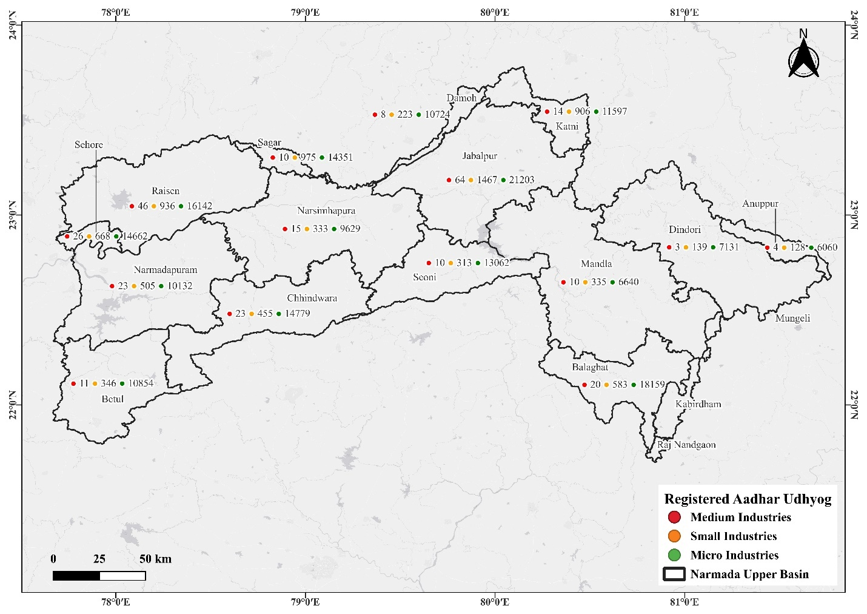
Figure 1: Spatial Distribution of Registered Medium, Small, and Micro Industries in the Upper Narmada Basin

Table 1: Registered Aadhaar Udyog in the Upper Narmada Basin
S No | DISTRICT_NAME | TOTAL_UDYOG_AADHAAR | MICRO | SMALL | MEDIUM
1 | ANUPPUR | 6192 | 6060 | 128 | 4
2 | BALAGHAT | 18762 | 18159 | 583 | 20
3 | BETUL | 11211 | 10854 | 346 | 11
4 | CHHINDWARA | 15257 | 14779 | 455 | 23
5 | DAMOH | 10955 | 10724 | 223 | 8
6 | DINDORI | 7273 | 7131 | 139 | 3
7 | HOSHANGABAD | 10660 | 10132 | 505 | 23
8 | JABALPUR | 22734 | 21203 | 1467 | 64
9 | KATNI | 12517 | 11597 | 906 | 14
10 | MANDLA | 6985 | 6640 | 335 | 10
11 | NARASINGHPUR | 9977 | 9629 | 333 | 15
12 | RAISEN | 17124 | 16142 | 936 | 46
13 | SAGAR | 15336 | 14351 | 975 | 10
14 | SEONI | 13385 | 13062 | 313 | 10
*Data retrieved from the website of Micro, Small & Medium Enterprises.
**Data is for the whole district

Registered Aadhaar Udyog in the Middle Narmada Basin
The Middle Narmada Basin exhibits a robust and diversified industrial structure, as evident in the distribution of Registered Aadhaar Udyog across its 15 districts, as shown in Table 2. The basin collectively hosts more than 2.68 lakh industrial units, primarily dominated by micro-industries, which form the foundation of local economic development. Out of the total registered units, micro-industries account for nearly 90–92%, followed by small-scale industries, which constitute around 7–8%. Medium-scale industries represent less than 1% of the total. This industrial pattern, illustrated in Figure 2, signifies a strong orientation toward localized, resource-based, and labor-intensive activities that drive employment and small-scale entrepreneurship across both rural and semi-urban landscapes of the basin.
Among all districts, Indore (45,158 units), Bhopal (35,238 units), and Dhar (29,854 units) emerge as the principal industrial hubs of the Middle Narmada Basin. Indore, being the commercial capital of Madhya Pradesh, exhibits the highest concentration of micro (38,657), small (6,253), and medium (248) industries, covering sectors such as food processing, engineering goods, packaging, textiles, and plastics. Bhopal is closely followed by 32,261 micro, 2,871 small, and 106 medium enterprises, largely clustered around industrial areas such as Mandideep and Govindpura, specializing in engineering, pharmaceuticals, and chemicals. Dhar also exhibits significant industrial growth, with over 25,000 micro and 4,000 small industries, which benefit from its proximity to Indore and Pithampur, one of India’s major industrial corridors. Similarly, Dewas (20,185 units) and Khandwa (17,315 units) exhibit diversified growth in food processing, textiles, and engineering sectors, driven by favorable connectivity and local raw material availability.
Districts such as Sehore (15,356 units), Khargone (15,661 units), Raisen (17,124 units), and Burhanpur (10,750 units) represent moderate industrial development, mainly concentrated in agro-based, forest-based, and service-oriented sectors. Smaller districts, such as Harda (6,659 units), Alirajpur (5,711 units), and Barwani (10,469 units), have emerging micro-industrial bases linked to agriculture, woodcraft, and rural enterprises, reflecting localized economic potential. The distribution highlights that industrial activities are highly concentrated around urban and transportation corridors, particularly along the Indore–Bhopal–Dewas–Dhar–Khandwa route, forming the industrial spine of the Middle Narmada Basin. Overall, the region exhibits a balanced mix of micro-entrepreneurship and expanding small- to medium-scale industries, underscoring its role as a critical driver of industrialization and regional economic growth in central India.
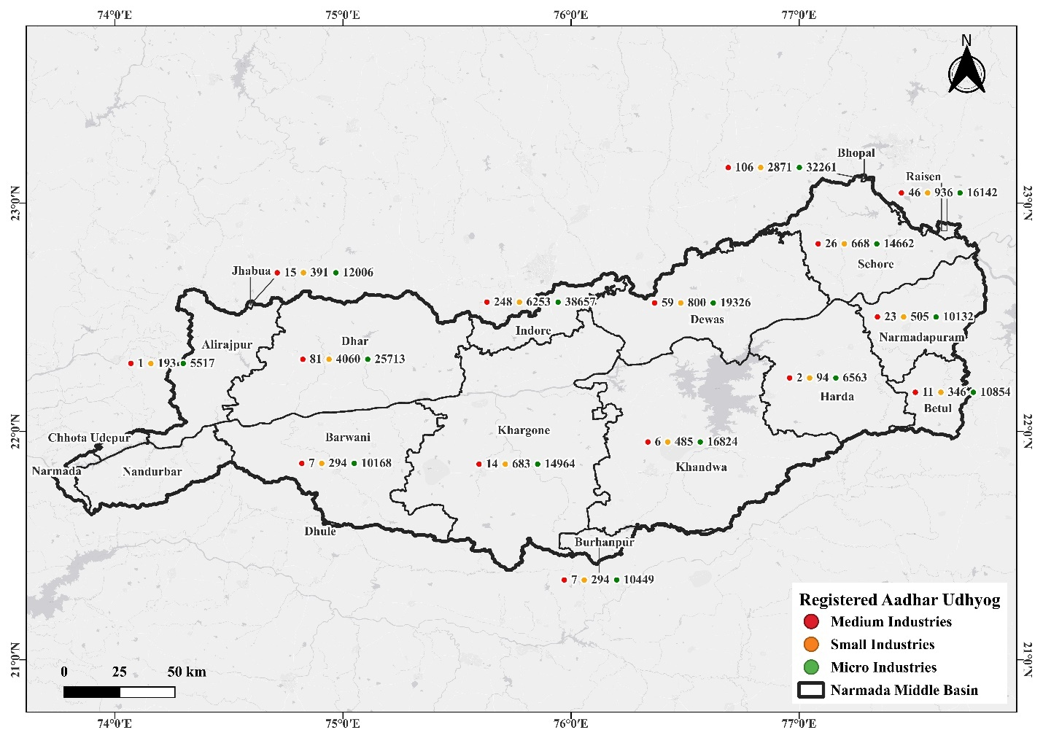
Figure 2: Spatial Distribution of Registered Medium, Small, and Micro Industries in the Upper Narmada Basin
Table 2: Registered Aadhaar Udyog in the Middle Narmada Basin
S No | DISTRICT_NAME | TOTAL_UDYOG_AADHAAR | MICRO | SMALL | MEDIUM
1 | ALIRAJPUR | 5711 | 5517 | 193 | 1
2 | BARWANI | 10469 | 10168 | 294 | 7
3 | BETUL | 11211 | 10854 | 346 | 11
4 | BHOPAL | 35238 | 32261 | 2871 | 106
5 | BURHANPUR | 10750 | 10449 | 294 | 7
6 | DEWAS | 20185 | 19326 | 800 | 59
7 | DHAR | 29854 | 25713 | 4060 | 81
8 | HARDA | 6659 | 6563 | 94 | 2
9 | HOSHANGABAD | 10660 | 10132 | 505 | 23
10 | INDORE | 45158 | 38657 | 6253 | 248
11 | JHABUA | 12412 | 12006 | 391 | 15
12 | KHANDWA (E.N.) | 17315 | 16824 | 485 | 6
13 | KHARGAONE (W.N.) | 15661 | 14964 | 683 | 14
14 | RAISEN | 17124 | 16142 | 936 | 46
15 | SEHORE | 15356 | 14662 | 668 | 26
*Data retrieved from the website of Micro, Small & Medium Enterprises.
**Data is for the whole district

Industrial Clusters: landscapes of the Narmada Basin

Industrial landscapes, raw material Utilization in Upper Narmada Basin
The Upper Narmada Basin, covering the districts of Mandla, Jabalpur, Seoni, and Chhindwara, hosts a diverse range of multi-product and agro-based industrial clusters. In Mandla, the Industrial Park IGC Maneri uses raw materials such as iron scrap, paddy, fruits, vegetables, paper, PVC, HDPE, and steel, reflecting a combination of metal fabrication, agro-processing, packaging, and plastic-based manufacturing activities. The nearby Food Park Maneri further strengthens the region’s agro-industrial character through food processing unit’s dependent on paddy, vegetables, milk, and spices. In Jabalpur district, major industrial zones like Hargarh and Umariya–Dungariya Phases 1 and 2 exhibit strong raw material diversity ranging from iron ore, cement, and dolomite to plywood, plastic scrap, grains, pulses, dairy products, fruits, rice husk, and glass, indicating a balanced mix of mineral-based industries, wood and paper processing, recycling units, and food-related manufacturing. Seoni’s Bhurkhalkapa industrial area showcases a blend of agricultural and mineral resource utilization, with paddy, manganese, coal, soybeans, grains, cement, and sand supporting both agro-processing and construction material industries. Similarly, the Lahgadua industrial cluster in Chhindwara processes cement, sand, grains, and used tyres, pointing to activities involving building materials, tyre pyrolysis, and food-related production. Overall, the Upper Narmada Basin’s industrial profile is characterized by strong agro-based inputs, significant utilization of mineral resources, and emerging multi-product manufacturing, underscoring the need for careful environmental management to safeguard the basin’s ecological health.

Table 3: Industrial landscape and Raw Material Utilization in the Upper Narmada Basin
District Name | Industry Name & Location | Type / Category of Industry | Raw Materials Used
Mandla | Industrial Park IGC Maneri | Multi Product | Iron scrap, Paddy, Fruits, Vegetables, Paper, PVC, HDPE, Steel
Mandla | Food Park Maneri | Food Processing | Paddy, vegetables, milk, spices
Jabalpur | Industrial Area Hargarh | Multi Product | Iron ore, Paddy, Cement, Dolomite
Jabalpur | Industrial Park Umariya–Dungariya Phase 1 | Multi Product | Plywood, Plastic scrap, Paper, Wheat, Pulses, Milk, Vegetables
Jabalpur | Industrial Park Umariya–Dungariya Phase 2 | Multi Product | Fruits, Vegetables, Paper, Rice husk, Plastic, Glass
Seoni | Industrial Area Bhurkhalkapa | Multi Product | Paddy, Manganese, Coal, Soybean, Grain, Cement, Sand
Chhindwara | Industrial Park Lahgadua | Multi Product | Cement, Sand, Grain, Used tyres
*Data Provided by MPIDC

Industrial landscapes, raw material Utilization in the Middle Narmada Basin
The Middle Narmada Basin is home to one of the most diverse and industrially active regions in Madhya Pradesh, spanning major districts such as Indore, Dhar, Jhabua, Khargone, Badwani, Khandwa, Ujjain, Bhopal, Raisen, Sehore, and Narmadapuram. The Indore–Dhar corridor, particularly the extensive Pithampur Industrial Parks (Phases 1–6), MSME clusters, SEZ zones, and smart industrial parks, forms the core industrial hub of the basin. These multi-product zones utilize a wide range of raw materials, including metals, steel, HDPE resins, BOPP films, APIs, chemicals, electronic components, wheat, corn, cotton, and plastic waste. The region also hosts specialized sectors, including automotive parts, pharmaceutical manufacturing, rubber and glass-fibre units, and agro-processing industries, each contributing distinct waste streams and environmental footprints. In Indore city, readymade garment clusters rely on cotton, fibre, and polyester, while electronic complexes use silicon, chips, and IT hardware materials. Clustered food industries, such as the Namkeen Cluster, heavily depend on food grains, while industrial pockets like Rau–Rangwasa handle fabrication and printing materials.
Moving westward, Jhabua’s Kasarbardi Industrial Park primarily operates with chemicals and waste-derived inputs, whereas Khargone’s Nimrani clusters comprise food processing units and multi-product industries that utilize plastics, plywood, chemicals, metals, and food grains. In Badwani, industrial estates such as Relwa Khurd and Khajuri handle materials including steel, cast iron, and fiberglass, reflecting a sector dominated by fabrication. Khandwa’s Rudhibhawsingpura industrial area features a mix of textile and chemical materials, including bleaching cotton, soda ash, and caustic soda, alongside agro-based inputs such as potatoes, oils, and seasonings. The Ujjain–Dewas belt, particularly the Nemawar Industrial Park, supports wood-based industries dependent on timber and processed wood.
The Bhopal metropolitan industrial belt, encompassing Mandideep (Raisen), Tamot Plastic Park, and Badiyakhedi (Sehore), contributed significantly to the basin’s industrial diversity. Mandideep utilizes metals, plastics, fruits, vegetables, APIs, HDPE resins, chemicals, and food grains, whereas Tamot is dedicated to plastic and polymer manufacturing, utilizing HDPE resins and granules. Badiyakhedi, meanwhile, functions as a major scrap-reprocessing zone, handling metal, plastic, wood, and paper scrap. In the downstream section of the middle basin, Narmadapuram district hosts major industrial nodes, such as Mohasa–Babai, which utilizes rice, maize, tempered glass, silicon PV cells, copper, aluminum, battery components, silica sand, oxygen, flavorings, and CO₂. Babai Food Park adds materials like cement, rice, milk, brass, and timber, while Kiratpur’s industries rely on oil, wheat, paddy, and pulses.

Table 4: Industrial landscape and Raw Material Utilization in the Middle Narmada Basin
District Name | Industry Name & Location | Type / Category of Industry | Raw Materials Used
Dhar | Industrial Park Pithampur 1 & 2 | Multi Product Industry | Metals, Steel, Chemicals, Wheat, Corn, HDPE Resins, BOPP, API, Electronic components, Cotton, Plastic waste
Dhar | Industrial Park Pithampur 3 and Kheda | Multi Product Industry | Metals, Steel, Chemicals, Wheat, Corn, HDPE Resins, BOPP, API, Electronic components, Cotton, Plastic waste
Dhar | Integrated Industrial Park Pithampur 5 Phase 1 | Multi Product Industry | Metals, Steel, Chemicals, Wheat, Corn, HDPE Resins, BOPP, API, Electronic components, Cotton, Plastic waste
Dhar | Industrial Park Pithampur 5 | Multi Product Industry | Metals, Steel, Chemicals, Wheat, Corn, HDPE Resins, BOPP, API, Electronic components, Cotton, Plastic waste
Dhar | MSME Cluster Pithampur | Multi Product Industry | Auto Parts, Plastic Granules, Metals, Steel, Chemicals
Dhar | Smart Industrial Park Pithampur (Natip), Indore | Multi Product Industry | Rubber, Chemicals, Honey, Sugar, Fruits, Glass Fibre, Metal Components
Dhar | Integrated Industrial Park Pithampur 6 (Indore) | Multi Product Industry | Metals, Steel, Chemicals, Wheat, Corn, HDPE Resins, BOPP, API, Electronic components, Cotton, Plastic waste
Dhar | SEZ 1 & 2 | Multi Product Industry | Manufacture of drugs including APIs, excipients, solvents, packaging components
Dhar | Industrial Park Hatod, Teh. Sardarpur | Multi Product Industry | Raw Cotton, Caustic Soda, Detergent Ash, Sand & Aggregate, Pattern Paper, Cotton, Stitching threads, Glass, Ceramics, Copper, Aluminium
Dhar | Industrial Park Ujjaini | Multi Product Industry | Palm Fatty
Dhar | Industrial Park Jetapur–Palasia | Multi Product Industry | Fibre, Cotton, Food Grains, Metal, API
Indore | Readymade Garment Cluster | Readymade Garments | Fibre, Cotton, Polyester
Indore | Electronic Complex, Indore | Electronics | Chips, IT raw material, Silicon, Plastic, Electronic components
Indore | Crystal IT Park | IT | Intangible materials: Data, Code, Information
Indore | Atulya IT Park | IT | Intangible materials: Data, Code, Information
Indore | Namkeen Cluster, Indore | Namkeen Industry | Food Grains
Indore | Industrial Park Rau–Rangwasa | Multi Product Industry | Fabrication material, Print material, Food Grain
Jhabua | Industrial Park Kasarbardi, Teh. Petlavad | Multi Product Industry | Chemicals, Waste materials
Khargone | FPP Nimrani, Khargone | Food Processing | Food Grains
Khargone | IIDC Nimrani, Khargone | Multi Product Industry | Plastic, Plywood, Chemicals, Food Grains, Metal
Badwani | Industrial Park Relwa Khurd & Khajuri | Multi Product Industry | Steel, Fiberglass, Cast Iron
Khandwa | Industrial Park Rudhibhawsingpura | Multi Product Industry | Bleaching Cotton, Soda Ash, Caustic Soda, Potato, Oil, Seasonings
Dewas | Industrial Park Nemawar, Dewas | Wood Industry | Woods
Raisen | Industrial Park Mandideep | Multi Product Industry | Metals, Plastic, Fruits & Vegetables, API, HDPE Resins, Plywood, Chemicals, Food Grains
Raisen | Plastic Park Tamot | Plastic | HDPE Resins, Granules
Sehore | Industrial Park Badiyakhedi Phase 1 | Multi Product Industry | Metal Scrap, Wood Scrap, Paper Scrap, Plastic Scrap
Narmadapuram | Industrial Park Mohasa–Babai Phase 1 | Multi Product Industry | Rice, Maize, Tempered Glass, Silicon PV cells, Copper, Aluminium, Battery components, Silica Sand, Oxygen, Water, Sweeteners, Flavourings, CO₂
Narmadapuram | Food Park Babai | Multi Product Industry | Cement, Rice, Milk, Brass, Timber
Narmadapuram | Industrial Park Kiratpur Phase 1 | Multi Product Industry | Oil, Wheat, Paddy, Pulses
*Data Provided by MPIDC

Status of Green Belt, Waste Treatment, and Water Consumption in Upper Narmada Basin
The Upper Narmada Basin industrial zones across Mandla, Jabalpur, Seoni, and Chhindwara consistently maintain green belt areas, indicating a basic commitment to environmental buffers. However, all listed clusters lack in-house wastewater treatment systems, with “No treatment facilities” reported across every industrial location. This reliance on natural dilution or external disposal poses risks to the local water bodies that feed the Narmada system. Water consumption varies significantly across districts, with Mandla units drawing 2662.2 KLD and 162 KLD from the Jhamil Dam and associated ponds, while Jabalpur’s industrial areas consume 1222 KLD from the Hiran River and an additional 210.5 KLD and 997 KLD directly from the Narmada River. Seoni Industries extracts 198 KLD from borewells and the Sanjay Sarovar system, and Chhindwara’s cluster utilizes 32 KLD supplied by the municipal network. The absence of treatment facilities, combined with a substantial dependence on river and groundwater sources, highlights the urgent need for effective industrial wastewater management, thorough water auditing, and stricter regulatory oversight to safeguard the ecological integrity of the Upper Narmada Basin.
Table 5: Green Belt, Waste Treatment, and Water Consumption Data in Upper Narmada Basin
District Name | Industry Name & Location | Presence of Green Belt | Waste Generated & Treatment Facilities | Water Consumption & Source
Mandla | Industrial Park IGC Maneri | Yes | No | 2662.2 KLD; Jhamil Dam/Ponds
Mandla | Food Park Maneri | Yes | No | 162 KLD; Jhamil Dam/Ponds
Jabalpur | Industrial Area Hargarh | Yes | No | 1222 KLD; Hiran River
Jabalpur | Industrial Park Umariya–Dungariya Phase 1 | Yes | No | 210.5 KLD; Narmada River
Jabalpur | Industrial Park Umariya–Dungariya Phase 2 | Yes | No | 997 KLD; Narmada River
Seoni | Industrial Area Bhurkhalkapa | Yes | No | 198 KLD; Borewell/Sanjay Sarovar
Chhindwara | Industrial Park Lahgadua | Yes | No | 32 KLD; Nagar Nigam supply
*Data Provided by MPIDC

Status of Green Belt, Waste Treatment, and Water Consumption in Upper Narmada Basin
The industrial regions across Indore, Dhar, Jhabua, Khargone, Badwani, Khandwa, Ujjain, Bhopal, Sehore, Narmadapuram, and Mandla demonstrate a consistently positive trend in establishing green belts, with all listed industrial zones reporting the presence of green cover. This reflects compliance with environmental norms aimed at mitigating air pollution, noise levels, and heat island effects.
However, waste management practices show significant gaps, particularly in the reliance on external treatment agencies. Many industrial areas in Dhar heavily depend on third-party waste handling services, such as those provided by Ms. Ramky, indicating a limited in-house infrastructure for treating effluent or sewage. Only a few locations, such as Smart Industrial Park Pithampur (5.0 MLD STP), Jetapur–Palasia (1.0 MLD STP), Crystal IT Park (0.03 MLD STP), Atulya IT Park (0.06 MLD STP), and Plastic Park Tamot (STP 01), maintain their own operational treatment facilities. Several regions, including Jhabua, Khandwa, and parts of Narmadapuram, exhibit a shortage of supply or treatment capacity, underscoring the need for enhanced waste management systems.
Water consumption across districts varies widely depending on industrial load. Major hubs such as Indore (9000–12000 KLD), Raisen (20 MLD), and SEZ/Pithampur zones exhibit extremely high demand and rely primarily on the Narmada River, municipal sources, or dams such as Sanjay Jalashay, Karam Dam, Damod Dam, and Rata Pani Dam. In contrast, smaller industrial zones rely mainly on borewells, with consumption as low as 1.5 KLD in Kiratpur and moderate levels such as 330 KLD in Khargone. Some areas, including Rau–Rangwasa, Kasarbardi (Jhabua), and Rudhibhawsingpura (Khandwa), report no water supply, indicating either incomplete infrastructure or self-reliance on industry for water resources.
Overall, the data reveals strong adoption of green belts, uneven waste treatment infrastructure, and significant variation in water dependency, reflecting differing industrial intensities and environmental management capacities across the districts.

Table 6: Green Belt, Waste Treatment, and Water Consumption Data in Middle Narmada Basin
District Name | Industry Name & Location | Presence of Green Belt | Waste Generated & Treatment Facilities | Water Consumption & Source
DHAR | Industrial Park Pithampur 1 & 2 | Yes | No, Only Third Party Ms Ramky | 9000 KLD; Sources: Narmada, Sanjay Jalashay & Karam Dam
DHAR | Industrial Park Pithampur 3 and Kheda | Yes | No, Only Third Party Ms Ramky | 12000 KLD; Sources: Narmada, Sanjay Jalashay & Karam Dam
DHAR | Integrated Industrial Park Pithampur 5 Phase 1 | Yes | No, Only Third Party Ms Ramky | 1000 KLD; Sources: Narmada, Sanjay Jalashay & Karam Dam
DHAR | Industrial Park Pithampur 5 | Yes | 0.25 MLD STP | —
DHAR | MSME Cluster Pithampur | Yes | No, Third Party Ramky | 7 KLD; Sources: Narmada, Sanjay Jalashay & Karam Dam
DHAR | Smart Industrial Park Pithampur (Natip), Indore | Yes | 2 STPs (2.5 MLD each, total 5 MLD) | 4000 KLD; Sources: Narmada, Sanjay Jalashay & Karam Dam
DHAR | Integrated Industrial Park Pithampur 6 (Indore) | Yes | No, Third Party Ramky | No Supply
DHAR | SEZ 1 & 2 | Yes | 0.25 MLD STP | 8000 KLD; Sources: Narmada, Sanjay Jalashay & Karam Dam
DHAR | Industrial Park Hatod, Teh. Sardarpur | Yes | No | 1380 KLD; Source: Borewell
DHAR | Industrial Park Ujjaini | Yes | No | 400 KLD; Sources: Narmada, Sanjay Jalashay & Karam Dam
DHAR | Industrial Park Jetapur–Palasia | Yes | 1.0 MLD STP | 400 KLD; Source: Narmada
Indore | Readymade Garment Cluster | Yes | No | 1500 KLD; Source: Borewell
Indore | Electronic Complex, Indore | Yes | No | 2000 KLD; Indore Municipal Corporation
Indore | Crystal IT Park | Yes | 0.03 MLD STP | 3500 KLD; Indore Municipal Corporation
Indore | Atulya IT Park | Yes | 0.06 MLD STP | 1500 KLD; Indore Municipal Corporation
Indore | Namkeen Cluster, Indore | Yes | 0.6 MLD WTP | 4300 KLD; IMC & Borewell
Indore | Industrial Park Rau–Rangwasa | Yes | 0.2 MLD ETP (under development) | No supply
Jhabua | Industrial Park Kasarbardi, Teh. Petlavad | Yes | No | No supply
Khargone | FPP Nimrani, Khargone | Yes | No | 330 KLD; Source: Narmada
Khargone | IIDC Nimrani, Khargone | Yes | No | —
Badwani | Industrial Park Relwa Khurd & Khajuri | Yes | No | 965 KLD; Segwal Lake
Khandwa | Industrial Park Rudhibhawsingpura | Yes | No | No supply
Dewas | Industrial Park Nemawar, Dewas | Yes | No treatment facilities | Borewell
Raisen | Industrial Park Mandideep | Yes | No | 20 MLD; Damod Dam
Raisen | Plastic Park Tamot | Yes | STP 01 | 2 MLD; Tube well + Rata Pani Dam
Sehore | Industrial Park Badiyakhedi Phase 1 | Yes | — | 500 KLD; Jahangirpura Dam
Narmadapuram | Industrial Park Mohasa–Babai Phase 1 | Yes | STP: 3 MLD + 1.5 MLD × 2 | 550 KLD; Narmada River
Narmadapuram | Food Park Babai | Yes | No | Borewell
Narmadapuram | Industrial Park Kiratpur Phase 1 | Yes | No | 1.5 KLD; Borewell
*Data Provided by MPIDC

Industrial Areas of the Basin
The industrial areas of the Narmada River Basin reflect a complex and regionally diversified industrial landscape shaped by geography, resource availability, and infrastructural connectivity. As illustrated in Figure 3, industrial estates are widely distributed across the basin, forming a continuous industrial corridor extending from the highly industrialized western districts of Gujarat to the emerging industrial nodes in the eastern parts of Madhya Pradesh. In the lower basin region, major industrial hubs such as Bharuch, Ankleshwar, Jhagadia, Rajpipla, Valia, and Industrial Area Bharuch drive large-scale chemical, petrochemical, pharmaceutical, and manufacturing activities, leveraging their proximity to major national transportation routes and ports. Moving eastward into the middle basin, industrial clusters such as Alirajpur, Anjad, Badwani, Sendhwa, Khargone, Bhikangaon, and Khandwa demonstrate steady growth supported by agro-processing, textile units, small-scale manufacturing, and mineral-based industries. The presence of well-developed industrial estates like Industrial Area – Indore Road (Khandwa), Industrial Area – Badiwah, and Industrial Area Dolria indicates strengthening industrial linkages with urban centers such as Indore and Dhar.
In the Upper Narmada Basin, industrial zones are more varied and scattered but strategically positioned near urban settlements. Prominent estates, such as Industrial Area Adhartaal, Industrial Area Richhai, Industrial Area Bagaspur, and Semi-Urban Industrial Estate Narsinghpur, highlight the industrial development around Jabalpur, one of the region's major growth poles. Additional clusters in Sagar, Seoni, Mandla, and Damoh reflect localized industrial expansion driven by agro-based industries, mineral processing, engineering units, and emerging small-scale manufacturing units. Together, these industrial areas form the economic backbone of the basin, supporting livelihoods, facilitating job creation, and contributing to the state's industrial output. However, their proximity to the Narmada River also underscores the critical need for sustainable planning, pollution control, and real-time environmental monitoring to protect the basin’s ecological integrity while fostering long-term industrial growth.

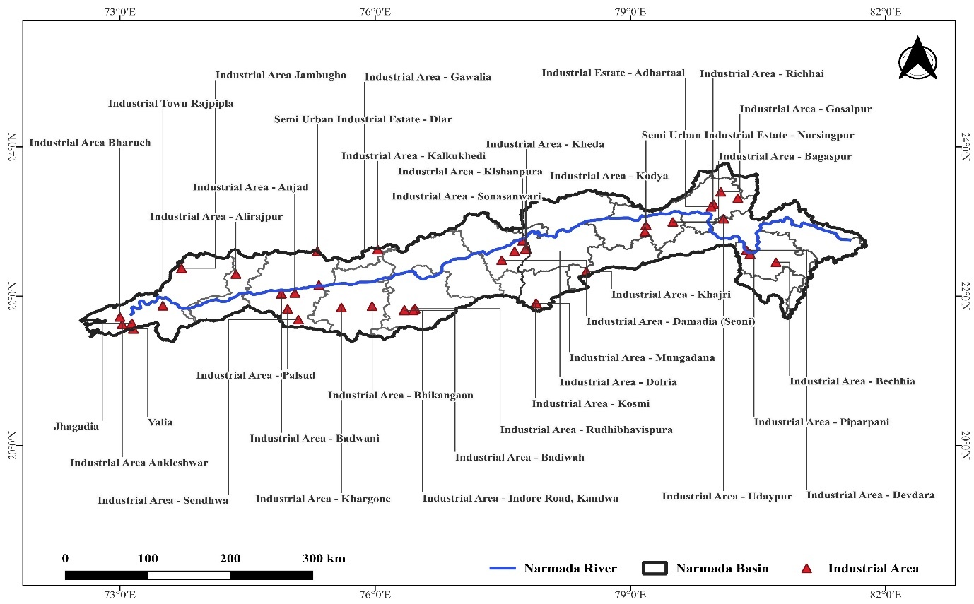
Figure 3: Spatial distribution of industrial areas across the Narmada River Basin (data extracted from Industrial Profiles of the districts)

Industrial Parks in the Basin
The Narmada Basin is home to a well-structured network of MSMEs and MPIDC Industrial Parks, which form the backbone of regional industrial development. This network strengthens local economies through resource-based manufacturing, employment generation, and improved market connectivity. Distributed across both the Upper and Middle Basin regions, these industrial parks serve as planned growth centers designed to support micro, small, and medium enterprises by providing essential infrastructure, land, utilities, and logistical support. Their strategic placement along key transport corridors and near major urban hubs such as Jabalpur, Indore, Katni, Dhar, and Narmadapuram enables efficient raw material movement and facilitates access to skilled labor. Collectively, the MSME and MPIDC Industrial Parks represent an integrated industrial ecosystem that promotes decentralized industrialization, enhances rural-urban linkages, and encourages balanced regional development. These parks not only stimulate value addition across agro-based, mineral-based, forest-based, and engineering sectors but also align with broader state and national priorities aimed at fostering self-reliant, sustainable, and inclusive industrial growth across the Narmada Basin.

MSME Industrial Park in Upper Narmada Basin
The Upper Narmada Basin hosts a network of Micro, Small, and Medium Enterprises (MSME) Industrial Parks, illustrated in Figure 4, strategically distributed across key districts to promote regional industrialization and balanced economic growth. These MSME parks are primarily located in districts such as Jabalpur, Katni, Damoh, Mandla, Chhindwara, Betul, Narmadapuram (Hoshangabad), Raisen, and Sehore, forming an interconnected industrial corridor that leverages the basin’s natural resources, transport infrastructure, and skilled workforce. Each of these parks has been established to support small and medium-scale industries by providing developed land, common facilities, power and water supply, and logistical connectivity. The concentration of MSME industrial parks in the western and central zones, particularly around Betul, Sehore, Narmadapuram, and Raisen, reflects the region’s industrial dynamism, driven by the agro-processing, engineering, and manufacturing sectors. The Jabalpur–Katni–Damoh belt, located in the northeastern part of the basin, constitutes another significant industrial cluster that benefits from mineral-based industries, fabrication units, and proximity to major transportation routes. Similarly, Chhindwara and Mandla have emerging MSME parks that cater to forest-based and agro-based enterprises, promoting sustainable utilization of local resources and providing employment opportunities to rural populations.
Overall, the spatial distribution of MSME Industrial Parks in the Upper Narmada Basin suggests a balanced approach to regional industrial planning, where each park serves as a localized growth center, fostering entrepreneurship, rural–urban linkages, and value addition to local raw materials. These parks not only strengthen the basin’s industrial ecosystem but also contribute to inclusive economic development, infrastructure expansion, and the long-term goal of self-reliant industrial growth under the framework of the Atmanirbhar Bharat initiative.

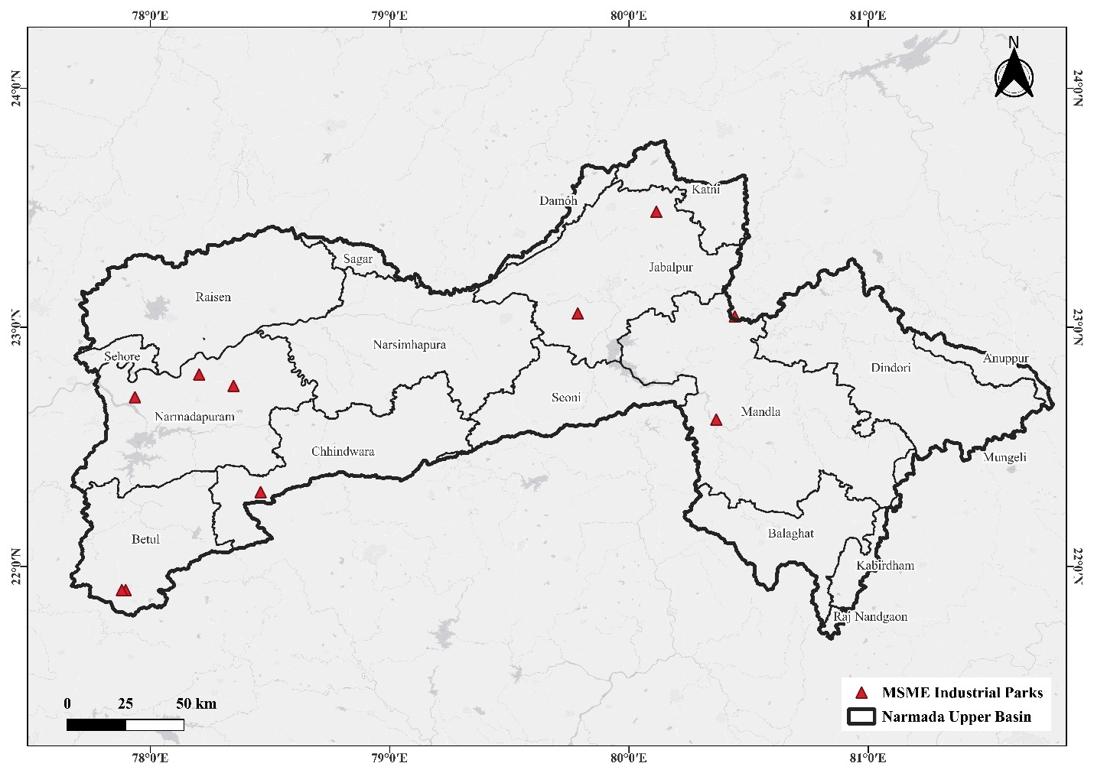
Figure 4: Geographical distribution of MSME Industrial Parks in the Upper Narmada River Basin
*Data retrieved from the website of Madhya Pradesh Industrial Development Corporation website.

MSME Industrial Park in the Middle Narmada Basin
The Middle Narmada Basin is home to several strategically located MSME Industrial Parks illustrated in Figure 5, reflecting the region’s growing role as a major industrial corridor in central India. These parks are distributed across key districts, including Indore, Dhar, Khargone (West Nimar), Barwani, Khandwa (East Nimar), Harda, and Dewas, forming a network of industrial hubs that collectively enhance regional productivity and connectivity. The concentration of these parks along the Indore, Dewas, Dhar, Khargone, and Burhanpur belt highlights the basin’s industrial strength, supported by well-developed transport infrastructure, availability of skilled manpower, and proximity to major highways and railway links.
Among these, Indore and Dhar serve as the industrial nucleus of the Middle Narmada Basin, with MSME parks facilitating manufacturing, engineering, agro-processing, textiles, and packaging industries. The Khargone and Khandwa industrial parks play a vital role in promoting agro-based and chemical industries, thanks to the region's high agricultural productivity and the presence of the Narmada River, which ensures a reliable water supply for industrial operations. The Barwani and Harda industrial parks are emerging as new centers for small-scale enterprises, fostering local entrepreneurship and generating employment opportunities in rural and semi-urban areas.
Overall, the distribution of MSME Industrial Parks in the Middle Narmada Basin represents a balanced regional industrial development strategy. These parks not only support the growth of micro, small, and medium enterprises (MSMEs) but also strengthen supply chains and resource-based industries within the basin. By promoting decentralized industrialization, these parks make significant contributions to economic diversification, inclusive employment generation, and rural–urban industrial integration. Their presence aligns with the broader objectives of the Atmanirbhar Bharat Abhiyan, focusing on sustainable and self-reliant industrial growth in the heart of Madhya Pradesh.
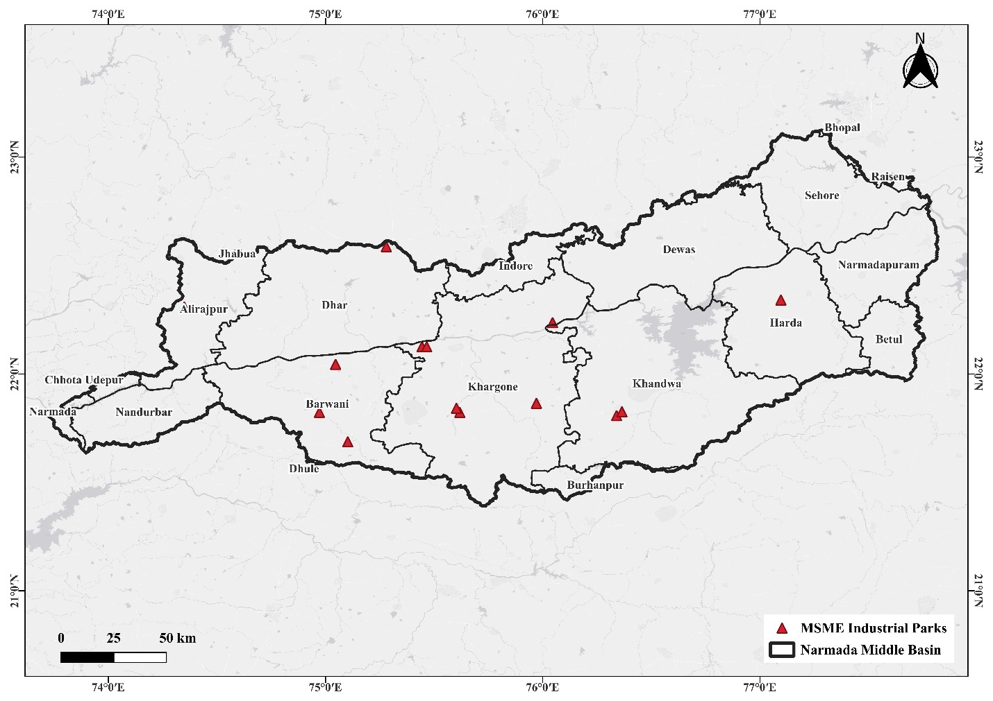
Figure 5: Geographical distribution of MSME Industrial Parks in the Middle Narmada River Basin
*Data retrieved from the website of Madhya Pradesh Industrial Development Corporation website.

MPIDC Industrial Park in Upper Narmada Basin
The map in Figure 6 shows the spatial distribution of industrial parks developed under the Madhya Pradesh Industrial Development Corporation (MPIDC) within the Upper Narmada Basin. The Upper Basin covers the eastern and central parts of Madhya Pradesh, encompassing districts such as Jabalpur, Narmadapuram, Katni, Sagar, Raisen, Seoni, Mandla, and Chhindwara, among others. This region forms the headwaters of the Narmada River and is characterized by moderately hilly terrain, rich forest cover, and emerging industrial development zones.
The industrial parks, represented by green triangular symbols, are strategically located near key urban centers, including Jabalpur, Katni, and Narmadapuram (Hoshangabad). These parks have been established to promote industrialization in non-metropolitan regions, leveraging the proximity to resource bases, transportation networks, and labor availability. The industrial sectors in these parks typically include food processing, agro-based industries, mineral processing, engineering goods, and small-scale manufacturing. The Narmada Upper Basin boundary, outlined in bold black, delineates the catchment area that contributes to the upstream flow of the river. Industrial growth within this region is being managed in accordance with sustainable development guidelines to prevent pollution of the Narmada River, which serves as a major water source for downstream cities and agricultural areas. The establishment of MPIDC Industrial Parks in this basin signifies the state government’s commitment to balanced regional industrial growth and employment generation, while integrating environmental safeguards. Proper wastewater treatment, effluent monitoring, and greenbelt development are essential components of these industrial zones to maintain ecological balance within the Narmada Basin.

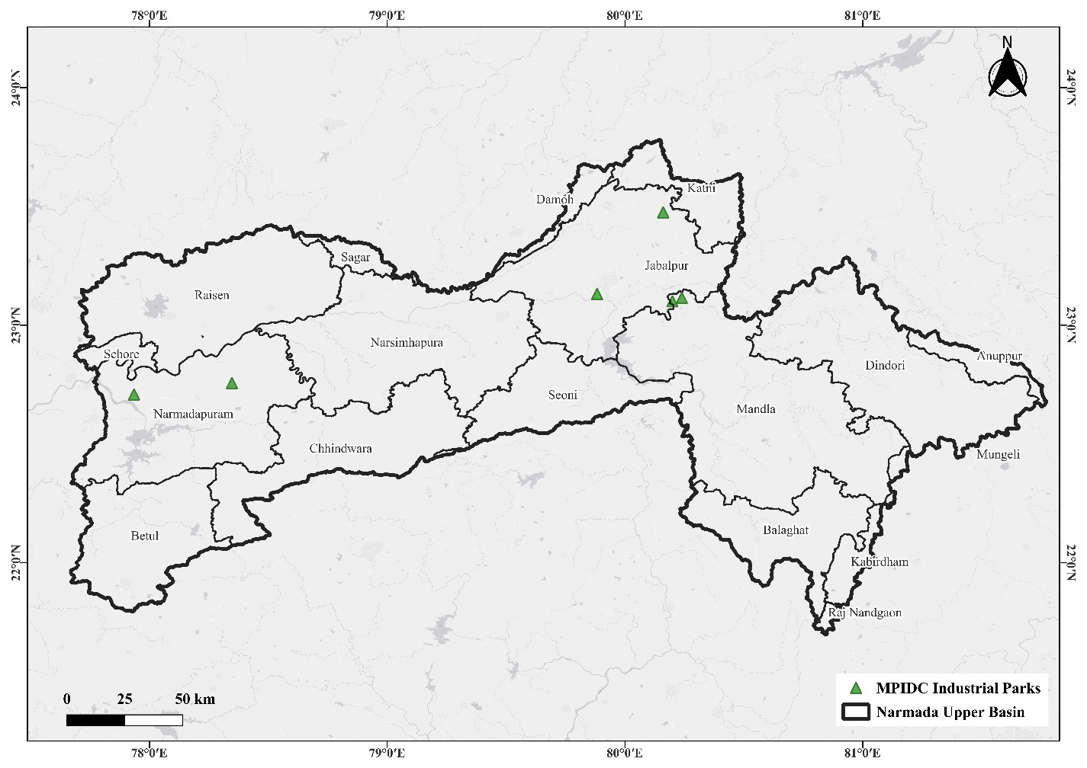
Figure 6: Location of MPIDC Industrial Parks within the Upper Basin of the Narmada
*Data retrieved from the website of Madhya Pradesh Industrial Development Corporation website.

MPIDC Industrial Park in the Middle Narmada Basin
The Middle Narmada Basin, spanning key districts such as Indore, Dhar, Dewas, Khargone, Barwani, Burhanpur, Khandwa, Harda, Bhopal, Sehore, Raisen, and Narmadapuram, features a strategic network of industrial infrastructure. The map illustrated in Figure 7 marks the locations of MPIDC Industrial Parks within this expansive area, emphasizing their role in driving regional industrialization and economic growth. The MPIDC Industrial Parks, marked by green triangles on the map, are strategically located near transport corridors, major urban centers, and resource zones, facilitating efficient logistics and access to resources. These parks help anchor industrial development in districts like Dhar, Barwani, and the surrounding region, leveraging local strengths such as agricultural output, mineral availability, and skilled labor. The clustering of parks within the middle basin boosts opportunities for manufacturing, agro-processing, mineral conversion, and allied industries. They serve as focal points for attracting investments, fostering entrepreneurship, and enabling collaborative industrial ecosystems. The parks are well integrated with the basin's road network and major cities (e.g., Indore, Bhopal), which enhances their connectivity and operational potential.

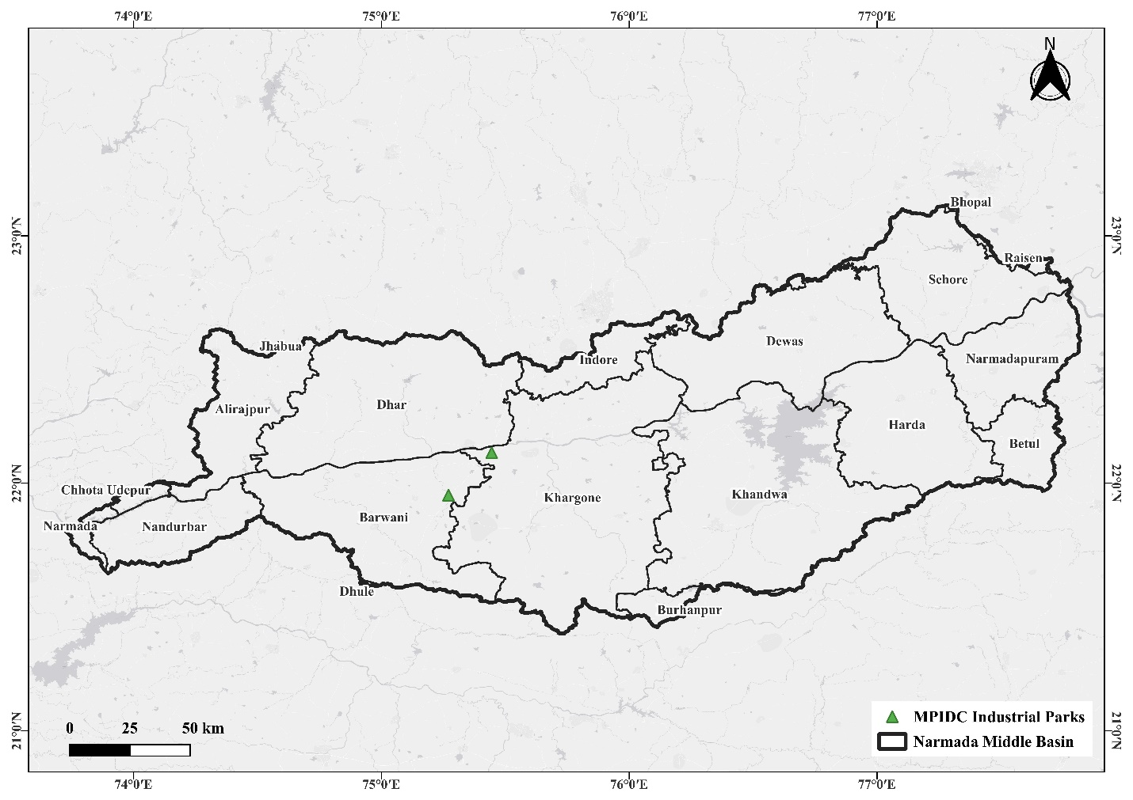
Figure 7: Location of MPIDC Industrial Parks within the Middle Basin of the Narmada
*Data retrieved from the website of Madhya Pradesh Industrial Development Corporation website.

Industries in the Basin
The industrial landscape of the Narmada Basin exhibits a diverse and regionally differentiated pattern of development, shaped by varying levels of resource availability, infrastructure, urbanization, and policy-driven industrial support. Both the Upper and Middle Narmada Basins exhibit a broad spectrum of industrial activity, ranging from micro- and household-scale enterprises to medium- and large-scale manufacturing units. While the Upper Basin is characterized by a mix of mineral-based, forest-based, and agro-linked small-scale industries with concentrated growth in districts such as Jabalpur, Balaghat, Sagar, Hoshangabad and Chhindwara, the Middle Basin demonstrates a stronger industrial presence supported by major urban centers like Indore, Bhopal, Dewas, and Dhar. The overall distribution of industries across the basins reveals significant spatial variations, ranging from emerging industrial nodes with limited development to highly industrialized districts with multiple industrial areas and numerous registered units. This industrial pattern highlights the need for targeted infrastructure development, investment promotion, and balanced regional planning to promote equitable industrial growth throughout the Narmada Basin.

Industries in the Upper Narmada Basin
The upper basin of the Narmada River covers several districts of Madhya Pradesh, including Anuppur, Balaghat, Betul, Chhindwara, Damoh, Dindori, Hoshangabad, Jabalpur, Katni, Mandla, Narasinghpur, Raisen, Sagar, Seoni, and Umaria. The industrial data from these districts reveals a varied pattern of industrial development, reflecting both concentrated and limited growth zones within the region.
In Anuppur, there are 863 registered industrial units, all of which are small-scale, with no designated industrial area and 3 registered medium and large units. Balaghat is a more industrially active district, hosting 10,223 registered and total industrial units across 4 industrial areas, including 2 medium and large units. Betul has 401 registered units out of a total of 166 reported active enterprises, encompassing 3 industrial areas and 1 medium- to large-sized unit. Chhindwara, with 6,209 registered units spread over 6 industrial areas, leads with 10 medium and large units, reflecting a strong industrial base.
Damoh shows 7,672 registered units, although records indicate only 41 operational units in total, suggesting data inconsistencies or inactive enterprises. It has 3 industrial areas and 2 large units. Dindori records 898 registered units but lacks information on industrial areas or large units, indicating minimal industrial activity. Hoshangabad is home to 9,739 registered units located across 7 industrial areas, with 2 large or medium industries supporting its economic profile.
Jabalpur stands out as the regional industrial hub, with 19,610 registered units and 17 medium and large enterprises, spread across 5 industrial areas. Similarly, Katni comprises 2,937 registered units and 9 large industries across 4 industrial areas, exhibiting a balanced industrial structure. Mandla has 2,794 registered units and 6 large units within a single industrial area, contributing moderately to regional output. Narasinghpur, however, has no registered industrial units, although an industrial area exists, possibly reserved for future development. Raisen displays steady growth, with 4,435 registered units distributed across 4 industrial areas, including 5 large and medium-sized industries.
Sagar holds 12,886 registered units and 6,304 total operational ones, with 7 industrial areas and 2 large industries, positioning it among the more industrialized districts. Seoni hosts 7,845 registered units across 3 industrial areas, though data on large units remains unavailable. Umaria has 2,109 registered units but lacks details on industrial areas or large-scale establishments.
Overall, industrial development within the upper Narmada basin, as shown in Table 7, is concentrated in districts such as Jabalpur, Balaghat, Sagar, Hoshangabad, and Chhindwara, supported by multiple industrial areas and a mix of medium and large units. In contrast, districts such as Narasinghpur, Dindori, Umaria, and Anuppur exhibit minimal industrial presence, indicating a developmental imbalance. Strengthening infrastructure, improving data management, and promoting investment in the underdeveloped districts can help achieve more uniform industrial growth across the Narmada’s upper basin.
Table 7: Industrial Profile of Upper Narmada Basin Districts
S. No | District | Registered Industrial Units | Total Industrial Units | Number of Industrial Area | Registered Medium and Large units
1 | ANUPPUR | 863 | 863 | nil | 3
2 | BALAGHAT | 10223 | 10223 | 4 | 2
3 | BETUL | 401 | 166 | 3 | 1
4 | CHHINDWARA | 6209 | 6209 | 6 | 10
5 | DAMOH | 7672 | 41 | 3 | 2
6 | DINDORI | 898 | 898 | - | -
7 | HOSHANGABAD | 9739 | 9739 | 7 | 2
8 | JABALPUR | 19610 | Not Known | 5 | 17
9 | KATNI | 2937 | 2937 | 4 | 9
10 | MANDLA | 2794 | - | 1 | 6
11 | NARASINGHPUR | nil | nil | 1 | 9
12 | RAISEN | 4435 | 4435 | 4 | 5
13 | SAGAR | 12886 | 6304 | 7 | 2
14 | SEONI | 7845 | 7845 | 3 | Data not available
15 | UMARIA | 2109 | - | - | -
*Data retrieved from the brief Industrial profile report of different districts
**Data is for the whole district

Industries in the Middle Narmada basin
The middle basin of the Narmada River covers districts such as Alirajpur, Barwani, Betul, Bhopal, Burhanpur, Dewas, Dhar, Harda, Hoshangabad, Indore, Jhabua, Khandwa (East Nimar), Khargone (West Nimar), Raisen, and Sehore. It reflects a strong and growing industrial network, with major concentrations in Indore, Dewas, Bhopal, and Dhar. The data presented in Table 8 reveal notable differences in industrial density and scale, indicating distinct levels of industrial development across the basin.
Alirajpur has 230 registered industrial units, all of which are small-scale, and there is no dedicated industrial area or large-scale unit, indicating limited industrialization. Barwani records 2,197 registered units spread across four industrial areas, including four medium and large units, indicating moderate economic activity. Betul, situated near the middle basin, has 401 registered units and 166 operational units across three industrial areas, including one large unit. Bhopal, the state capital, represents one of the most industrialized districts in the basin with 10,989 registered and 12,400 total industrial units. Spanning 4 major industrial areas and hosting 19 large or medium-sized enterprises, Bhopal serves as a significant industrial and administrative hub. Burhanpur follows with 600 registered units, one industrial area, and four large units, thereby sustaining a balanced local industrial base. Dewas demonstrates strong industrial development with 10,463 registered units and 10,643 total operational ones functioning in 4 industrial areas. The presence of 48 large and medium units underscores its role as one of the region’s industrial pillars. Dhar also exhibits exceptional industrial growth, with 7,292 registered units distributed across five industrial areas and a notable 116 medium- and large-scale industries, reflecting a vibrant manufacturing sector. Harda accounts for 2,355 registered and 2,359 total industrial units across one industrial area, with four large enterprises, implying stability in small and medium-sized sector operations. Hoshangabad, which shares characteristics with both the upper and middle Narmada basins, has 9,739 registered units across 7 industrial areas and houses 2 large units. Indore, the commercial capital of Madhya Pradesh, hosts 12,726 registered units within 7 industrial areas, along with 21 medium and large industries, making it the most industrially dynamic district in the basin. Jhabua shows 7,144 registered units, mainly small-scale, spread across a single industrial area, but an impressive 52 large industrial units indicate focused industrial investments. Khandwa (East Nimar) maintains 10,512 registered units over 3 industrial areas, with 1 large unit contributing to district-level industrial growth. Khargone (West Nimar) has 2,639 registered units operating through 3 industrial areas, supported by 9 large industries. Raisen continues to perform steadily with 4,435 registered units, 4 industrial areas, and 5 large industries. Sehore, with 91 registered and 94 total units across 6 industrial areas, is home to 4 medium and large industries, indicating gradual development. Across the middle Narmada basin, industrial growth is predominantly concentrated in Indore, Dewas, Dhar, and Bhopal, supported by significant infrastructure and large-scale industrial presence. Peripheral districts such as Alirajpur, Betul, and Sehore remain comparatively less industrialized. This variation highlights an uneven industrial distribution pattern influenced by factors such as connectivity, urbanization, availability of raw materials, and policy-driven investment areas. To promote balanced growth, industrial linkages and infrastructure expansion toward smaller districts could enhance overall economic sustainability within the Narmada basin.
Table 8: Industrial Profile of Middle Narmada Basin Districts
S. No | District | Registered Industrial Units | Total Industrial Units | Number of Industrial Area | Registered Medium and Large units
1 | ALIRAJPUR | 230 | 230 | 0 | 0
2 | BARWANI | 2197 | 2197 | 4 | 4
3 | BETUL | 401 | 166 | 3 | 1
4 | BHOPAL | 10989 | 12400 | 4 | 19
5 | BURHANPUR | 600 | 600 | 1 | 4
6 | DEWAS | 10463 | 10643 | 4 | 48
7 | DHAR | 7292 | 7292 | 5 | 116
8 | HARDA | 2355 | 2359 | 1 | 4
9 | HOSHANGABAD | 9739 | 9739 | 7 | 2
10 | INDORE | 12726 | 12726 | 7 | 21
11 | JHABUA | 7144 | - | 1 | 52
12 | KHANDWA (E.N.) | 10512 | 10512 | 3 | 1
13 | KHARGAONE (W.N..) | 2639 | 2639 | 3 | 9
14 | RAISEN | 4435 | 4435 | 4 | 5
15 | SEHORE | 91 | 94 | 6 | 4
*Data retrieved from the brief Industrial profile report of different districts
**Data is for the whole district

Agro-Based Industries
The agro-based industries form the foundational industrial segment within the Narmada Basin, closely aligned with the region’s extensive agricultural landscape and agrarian livelihoods. These industries, comprising general agro-processing units, cotton textiles, wool/silk/artificial thread-based products, jute and jute-derived units, and ready-made garments and embroidery, collectively contribute to value addition, rural employment, and local entrepreneurship. Their distribution reflects the agricultural diversity of the basin, where cotton-growing regions support textile units, and urban-agro linkages foster garment and embroidery clusters. As a result, the agro-based sector acts as a major driver of small-scale industrial development, socio-economic upliftment, and market integration across both rural and semi-urban districts of the Narmada Basin.

Agro-Based Industries in the Upper Narmada Basin
The upper basin of the Narmada River, encompassing districts such as Anuppur, Balaghat, Betul, Chhindwara, Damoh, Dindori, Hoshangabad, Jabalpur, Katni, Mandla, Narasinghpur, Raisen, Sagar, Seoni, and Umaria, displays a strong presence of agro-based industries shaped by local agricultural production, resource availability, and rural economic structures. The data indicate considerable variation in the scale and diversity of agro-based industrial activities across districts.
Anuppur hosts 79 agro-based industries, as well as 54 units engaged in ready-made garments and embroidery, indicating moderate involvement in agro-linked processing. Balaghat stands out as a major center, recording 2,869 agro-based units, 1 woolen and thread-based enterprise, 1 jute-based industry, and 1,719 garment and embroidery units. This composition highlights the district’s vibrant small-scale industrial sector driven by agro-production and cottage industries. Betul has limited agro-industrial development, with only 5 agro-based units and 193 garment and embroidery units, suggesting a growing yet underdeveloped industrial segment. Chhindwara operates 82 agro-based industries alongside 3 jute-based and 2 garment units, reflecting the influence of local agriculture and textile crafts. Damoh has 69 agro-based and 65 garment industries, indicating a modest presence in the processing and tailoring sectors. Dindori exhibits minimal industrial presence, with only one agro-based and two cotton textile units, complemented by ten garment establishments. Hoshangabad records no data, although the district is known agriculturally for soybean and wheat processing, suggesting that likely unreported or unregistered local units may exist. Jabalpur, a key industrial hub in the region, is home to 112 agro-based industries, 5 cotton textile units, and 257 garment and embroidery establishments, underscoring a substantial connection between agriculture and urban manufacturing. Katni houses 129 agro-based units, 12 jute-based units, and 50 garment industries, combining agricultural processing with small-scale, handicraft-oriented production. Mandla has 4 agro-based units, suggesting limited industrialization. Narasinghpur displays 126 agro-based industries, a single woolen and silk-based enterprise, and 89 garment units, indicating steady agro-linked economic activity. Raisen emerges as another key district, hosting 2,532 agro-based industries and 945 garment units, representing one of the largest agro-processing concentrations in the upper basin. Sagar also demonstrates strong agro-industrial development, with 1,303 agro-based units, 13 cotton textile units, 8 silk-based units, 1 jute industry, and 572 garment enterprises, reflecting a diverse range of production patterns. Seoni remains industrially inactive with no reported units, while Umaria possesses 119 agro-based industries and 1 garment unit, establishing a small but growing rural industry base.
Overall, agro-based industries in the upper Narmada basin, shown in Table 9, are concentrated primarily in Balaghat, Raisen, and Sagar, where favorable agricultural productivity and infrastructure support processing and manufacturing. In contrast, districts like Dindori, Mandla, and Seoni exhibit minimal industrial activity, emphasizing the need for supportive policies to develop agro-processing, textile, and rural industries. Expanding agricultural value chains, improving market access, and promoting skill development could foster inclusive industrial growth throughout the upper basin of the Narmada.
Table 9: Agro-Based Industries in the Upper Narmada Basin
 | District | Agro Based | Cotton Textile | Woolen, silk & artificial thread-based clothes. | Jute & jute based | Ready-made garments & embroidery
1 | ANUPPUR | 79 | nil | nil | nil | 54
2 | BALAGHAT | 2869 | nil | 1 | 1 | 1719
3 | BETUL | 5 | - | - | - | 193
4 | CHHINDWARA | 82 | - | - | 3 | 2
5 | DAMOH | 69 | - | - | - | 65
6 | DINDORI | 1 | 2 | - | - | 10
7 | HOSHANGABAD | - | - | - | - | -
8 | JABALPUR | 112 | 5 | 0 | 0 | 257
9 | KATNI | 129 | 0 | 0 | 12 | 50
10 | MANDLA | 4 | - | - | - | -
11 | NARASINGHPUR | 126 | - | 1 | - | 89
12 | RAISEN | 2532 | - | - | - | 945
13 | SAGAR | 1303 | 13 | 8 | 1 | 572
14 | SEONI | nil | nil | nil | nil | nil
15 | UMARIA | 119 | - | - | - | 1
*Data retrieved from the brief Industrial profile report of different districts
**Data is for the whole district

Agro-Based Industries in the Middle Narmada Basin
The Middle Narmada Basin, encompassing several districts in Madhya Pradesh, is home to a diverse range of agro-based industries that support the region’s agrarian economy and contribute significantly to rural development, employment generation, and the production of value-added agricultural products. These industries include basic agro-processing units, cotton textile units, woolen and silk-based industries, jute and jute-derived products, and a rapidly expanding sector of ready-made garments and embroidery units. The spatial distribution of these industries across the basin reveals clear variations in industrial concentration and specialization. Raisen District stands out as the dominant agro-industrial hub with 2,532 agro-based units, complemented by a large cluster of 945 ready-made garment and embroidery units, indicating both agricultural strength and rising industrial diversification. Khandwa (East Nimar) is home to 804 agro-based units, alongside 30 woolen/silk units and 661 garment units, reflecting its mixed agro-industrial character. Indore, a major urban-industrial center, hosts 370 agro-based industries and maintains a strong textile base comprising 44 cotton textile units, 79 woolen/silk units, 35 jute-based units, and 634 garment and embroidery units, illustrating its integrated agro-industrial ecosystem and superior supply chain logistics. Harda also shows a significant industrial presence with 230 agro-based units, though less dense compared to Raisen.
Cotton textile industries exhibit distinct geographical clustering, predominantly in districts such as Burhanpur (206 units), Barwani (95 units), and Khargone (92 units), which are historically known for their cotton cultivation in the Nimar region. The agro-climatic suitability for cotton, coupled with the availability of raw fiber, has supported the growth of ginning, spinning, and weaving units in these areas. Indore (44 units) and Dhar (20 units) contribute modestly to this sector. Woolen, silk, and artificial thread-based industries remain relatively limited in the Middle Narmada Basin, with Indore hosting the highest concentration (79 units) and Khandwa following with 30 units. Smaller clusters exist in Sehore (2 units) and Khargone (1 unit). These industries are largely urban-oriented and cater to localized textile and apparel markets.
Jute and jute-based industrial activity is minimal across the basin due to the absence of locally available raw jute and limited market connectivity. The few existing units, located in Bhopal, Indore, Sehore, and Khargone, primarily manufacture jute bags, ropes, and various handicraft items. In contrast, the ready-made garments and embroidery sector demonstrates broad spatial distribution and is one of the most dynamic agro-allied industries in the region. Bhopal leads with 2,000 units, supported by its robust urban infrastructure, skilled labor availability, and a growing garment market. Raisen (945 units) and Khandwa (661 units) also exhibit strong entrepreneurial activity in this sector, followed by Harda (788 units) and Indore (634 units), which highlights the expansion of apparel manufacturing in both semi-urban and industrial districts. This sector is a significant employment generator, particularly for women, and makes a substantial contribution to the socio-economic development of the Middle Narmada Basin.
Table 10: Agro-Based Industries in the middle Narmada basin
S. No | District | Agro Based | Cotton Textile | Woolen, silk & artificial thread-based clothes. | Jute & jute-based | Ready-made garments & embroidery
1 | ALIRAJPUR | 103 | - | - | - | 10
2 | BARWANI | 343 | 95 | - | - | 391
3 | BETUL | 5 | - | - | - | 193
4 | BHOPAL | 5 | 1 | - | 27 | 2000
5 | BURHANPUR | 48 | 206 | - | - | 78
6 | DEWAS | 22 | 6 | - | - | 1
7 | DHAR | 48 | 20 | nil | nil | 11
8 | HARDA | 230 | - | - | - | 788
9 | HOSHANGABAD | - | - | - | - | -
10 | INDORE | 370 | 44 | 79 | 35 | 634
11 | JHABUA | 12 | 15 | nil | nil | nil
12 | KHANDWA (E.N.) | 804 | - | 30 | - | 661
13 | KHARGAONE (W.N..) | 129 | 92 | 1 | nil | 5
14 | RAISEN | 2532 | - | - | - | 945
15 | SEHORE | 53 | - | 2 | 5 | 66
*Data retrieved from the brief Industrial profile report of different districts
**Data is for the whole district

Forest/Wood-Based Industries
The forest and wood-based industries represent a significant component of the Narmada Basin’s industrial profile, drawing strength from the basin’s rich forest cover and natural resource base. This sector encompasses wood furniture manufacturing and the paper and paper product industries, which are deeply connected to local forestry resources, artisanal skills, and small-scale entrepreneurial networks. These industries support livelihood creation, supply local construction and carpentry needs, and contribute to industrial diversification in both forest-dominated and urban-adjacent districts. Their distribution reflects variations in forest resource availability, transportation linkages, and local market dynamics, making them integral to sustainable resource utilization and forest-linked economic activities within the basin.

Forest/ Wood-based Industries in the Upper Narmada Basin
The Upper Narmada Basin, situated in the forest-rich districts of Madhya Pradesh, is characterized by abundant natural resources, including timber, bamboo, and minor forest products, which have significantly contributed to the development of forest and wood-based industries. These industries, including wood and wooden furniture manufacturing, as well as paper and paper product units, play a crucial role in regional livelihoods, small-scale industrial diversification, and local economic development, as highlighted in Table 11. The basin encompasses districts such as Balaghat, Mandla, Dindori, Seoni, and Anuppur, where dense forest cover supports both traditional woodworking practices and emerging industrial units. The spatial distribution of forest-based industries clearly reflects the dependence of local economies on forestry resources, while also revealing variations in industrialization patterns across districts. Among the two major categories, wood and wood-based furniture units represent the dominant industrial sector, forming the backbone of forest resource-driven economic activities.
Wood-based furniture manufacturing is highly concentrated in Balaghat, which emerges as the largest hub with 1,040 units. The district’s extensive forest resources, rich in teak, sal, and bamboo, support the production of furniture, building materials, wooden artifacts, and carpentry-based products. Sagar, with 639 units, and Raisen, with 315 units, follow as prominent centers, reflecting the growth of semi-urban woodworking industries and increased market demand in non-tribal regions. Anuppur (298 units) and Jabalpur (108 units) also demonstrate considerable industrial activity driven by both resource availability and urban consumer markets. Districts such as Damoh (74 units), Narsinghpur (36 units), Katni (32 units), and Chhindwara (51 units) exhibit moderate levels of woodworking industries, largely catering to local household requirements and small markets. Interestingly, despite having rich forest resources, Dindori (12 units) and Seoni (25 units) show low industrial utilization of forest materials, possibly due to limited infrastructure, regulatory restrictions, or conservation-focused governance. Mandla and Hoshangabad report negligible or no wood-based furniture units, further indicating constraints such as inadequate market access or strict forest regulations.
The paper and paper product industries, on the other hand, form a relatively smaller component of the industrial landscape in the Upper Narmada Basin. Their presence is restricted to districts with comparatively better industrial infrastructure and access to raw materials such as bamboo, wood pulp, or recycled paper. Jabalpur leads this segment with 56 units, supported by a well-established industrial base, transport connectivity, and demand for packaging and stationery products. Narsinghpur (25 units) and Sagar (11 units) follow, hosting small and medium enterprises involved in packaging materials, stationery products, and paper recycling. Smaller clusters exist in Chhindwara (9 units), Umaria (8 units), Anuppur (7 units), Katni (3 units), and Damoh (2 units), where units often rely on recycled materials or small-scale bamboo-based pulp production. In contrast, districts like Balaghat, Seoni, Raisen, Mandla, Dindori, Betul, and Hoshangabad either lack paper-related industries or exhibit minimal activity due to constraints such as inadequate technological investment, logistical challenges, and regulatory restrictions related to the use of forest resources for pulp-based manufacturing. Overall, the industrial profile of the Upper Narmada Basin reflects both the economic reliance on forest resources and the structural limitations inhibiting large-scale industrial expansion.
Table 11: Forest/Wood-based Industries in the Upper Narmada basin
S. No | District | Wood/wooden based furniture | Paper & Paper products
1 | ANUPPUR | 298 | 7
2 | BALAGHAT | 1040 | nil
3 | BETUL | 31 | -
4 | CHHINDWARA | 51 | 9
5 | DAMOH | 74 | 2
6 | DINDORI | 12 | -
7 | HOSHANGABAD | - | -
8 | JABALPUR | 108 | 56
9 | KATNI | 32 | 3
10 | MANDLA | - | -
11 | NARASINGHPUR | 36 | 25
12 | RAISEN | 315 | -
13 | SAGAR | 639 | 11
14 | SEONI | 25 | nil
15 | UMARIA | 138 | 8
*Data retrieved from the brief Industrial profile report of different districts
**Data is for the whole district

Forest/Wood-based Industries in the Middle Narmada basin
The Middle Narmada Basin, situated in the central region of Madhya Pradesh, functions as a transitional ecological and economic zone between the forest-dominated upper basin and the agriculturally intensive plains of the lower basin. While agriculture and agro-processing industries form the backbone of the regional economy, forest and wood-based industries also constitute an important segment of the small- and medium-scale industrial structure. As shown in Table 12, these industries primarily include wood and wooden furniture units, as well as paper and paper product manufacturing, both of which are influenced by the availability of forest resources and the presence of urban markets. The industrial composition of this sector is largely divided into two major categories: wood and wooden-based furniture units, representing traditional carpentry, household woodwork, and furniture production; and paper and paper product units, encompassing small-scale packaging, stationery, and recycled paper operations. Their distribution pattern indicates a strong correlation with urbanization levels, market access, and proximity to forested areas.
The wood and wooden-based furniture industries are widely distributed across the Middle Narmada Basin, ranging from small carpentry workshops to organized manufacturing units, with notable variations among districts. Bhopal District emerges as the leading center with 900 units, driven by urban demand, skilled labor, and well-developed infrastructure that supports a thriving carpentry and interior furnishing market. Raisen (315 units) and Khandwa (197 units) are the next major hubs, benefiting from proximity to forests, local timber availability, and the influence of neighboring urban markets. Sehore (156 units) and Barwani (152 units) also host substantial numbers of furniture units, mostly small-scale workshops serving rural and semi-urban customers. Moderate levels of activity are observed in Khargone (42 units) and Indore (30 units), where the latter focuses more on processed, value-added woodcraft rather than raw timber-based manufacturing. Districts such as Betul (31 units) and Burhanpur (25 units) exhibit limited industrial presence, primarily serving localized household demand. Very low activity is seen in Alirajpur (5 units), Jhabua (5 units), Dhar (8 units), and Dewas (7 units), indicating under-industrialized economies or shifts toward other dominant industrial sectors. Harda and Hoshangabad report negligible wood-based industries, likely due to the predominance of agricultural land, limited forest availability, and a focus on alternative industrial activities. Overall, the distribution of wood-based industries exhibits a dual pattern: high concentrations in urban-industrial centers, such as Bhopal, Indore, and Raisen, driven by rising market demand; and peripheral clusters in Barwani, Khandwa, and Sehore, supported by proximity to forests and traditional carpentry practices.
The paper and paper product industries, although fewer in number, are strategically located in districts with better industrial infrastructure, recycling capacity, and strong commercial demand. Indore District leads this sector with 177 units, underscoring its diversified industrial base and advanced processing facilities, which support the production of packaging materials, stationery, and recycled paper goods. Dhar (38 units) and Khandwa (24 units) exhibit emerging growth in paper manufacturing, likely driven by agro-industrial expansion and an increasing use of recycled materials. Smaller clusters exist in Bhopal (9 units) and Dewas (8 units), primarily serving local packaging and commercial needs. Minimal activity in districts such as Khargone (4 units) suggests that large-scale, pulp-based industries are not prevalent in this region due to resource limitations or environmental considerations. The overall concentration of paper-related industries in urban nodes such as Indore, Dhar, and Bhopal reflects a growing dependence on non-wood raw materials including recycled paper, agro-residues, and waste pulp indicating a shift toward environmentally sustainable and economically adaptive industrial practices in the Middle Narmada Basin.
Table 12: Forest/Wood-based Industries in the Middle Narmada basin
S. No | District | Wood/wooden based furniture | Paper & Paper products
1 | ALIRAJPUR | 5 | -
2 | BARWANI | 152 | -
3 | BETUL | 31 | -
4 | BHOPAL | 900 | 9
5 | BURHANPUR | 25 | -
6 | DEWAS | 7 | 8
7 | DHAR | 8 | 38
8 | HARDA | - | -
9 | HOSHANGABAD | - | -
10 | INDORE | 30 | 177
11 | JHABUA | 5 | nil
12 | KHANDWA (E.N.) | 197 | 24
13 | KHARGAONE (W.N..) | 42 | 4
14 | RAISEN | 315 | -
15 | SEHORE | 156 | -
*Data retrieved from the brief Industrial profile report of different districts
**Data is for the whole district

Chemical & Allied Industries
The chemical and allied industries constitute a diverse and evolving industrial segment in the Narmada Basin, encompassing chemical-based manufacturing, rubber/plastic/petro-derived units, as well as leather-based enterprises. These industries range from fertilizer, detergent, paint, and adhesive producers to plastic goods, rubber items, and leather processing units, reflecting the basin’s gradual transition toward modern manufacturing sectors. Their growth is influenced by urban demand, availability of raw materials, increasing industrial infrastructure, and employment-generating capacities. The sector forms an essential link between agriculture, urban markets, and industrial supply chains, contributing to both economic diversification and regional industrial modernization.

Chemical & Allied Industries in the Upper Narmada basin
The Upper Narmada Basin, located in the forested and mineral-rich regions of Madhya Pradesh, is home to a modest yet diverse range of chemical and allied industries that contribute to the region’s evolving industrial landscape. Although not as dominant as agro-based or forest-based sectors, these industries, including soda water production, leather-based enterprises, chemical and chemical-based units, and rubber, plastic, and petrochemical industries, provide essential linkages to urban centers, agriculture, and local resources. The industrial structure across the basin exhibits spatial patterns strongly tied to levels of urbanization, resource availability, and infrastructure development. Soda water manufacturing represents a small-scale industry catering primarily to local urban markets, with Sagar (4 units) and Jabalpur (3 units) being the only significant districts showing activity. Other districts, such as Katni, report no operational units. This limited distribution underscores the localized and demand-driven nature of this segment.
Leather-based industries form a more prominent component of the chemical and allied industrial group in the Upper Narmada Basin, driven by traditional craftsmanship and the availability of raw materials. Balaghat, with 340 leather-based units, stands out as the primary center, followed by Seoni (150 units) and Narsinghpur (59 units), demonstrating strong artisanal capabilities and local market support. Jabalpur (26 units) and Dindori (17 units) also maintain moderate levels of leather-based industrial activity, driven by urban consumption patterns and trade networks. Smaller clusters are observed in Damoh (7 units), Katni (5 units), Raisen (12 units), and Umaria (6 units), reflecting localized manufacturing, whereas Mandla and Hoshangabad exhibit minimal activity. The leather sector’s dominance in select districts highlights its labor-intensive nature and importance in generating rural employment and supporting small-scale industrialization.
Chemical and chemical-based industries represent a diverse sector that produces fertilizers, paints, detergents, soaps, adhesives, acids, and other chemical intermediates. These industries are generally concentrated in urban-industrial centers with advanced infrastructure and logistics support. Jabalpur leads the region with 81 chemical-based units, followed by Sagar (63 units) and Katni (55 units), all of which are emerging as key manufacturing hubs within the Upper Narmada Basin. Moderate industrial activity is observed in Narsinghpur (21 units) and Chhindwara (8 units), where the demand for agricultural and domestic chemicals fuels localized growth. Smaller concentrations in Balaghat (12 units) and Betul (4 units) primarily cater to local consumers, while districts like Anuppur (2 units) and Raisen (1 unit) exhibit minimal industrial presence. Hoshangabad and Dindori report no chemical-based industries, indicating uneven regional industrialization and infrastructure disparities.
The rubber, plastic, and petro-based industries represent emerging modern industrial activities driven by growing demand for packaging materials, plastic pipes, rubber goods, and agro-based applications. Sagar dominates this sector with 68 units, reflecting a strong manufacturing base geared toward construction, agriculture, and packaging. Jabalpur follows with 43 units, showcasing its diversified industrial landscape. Chhindwara (9 units) and Seoni (5 units) demonstrate moderate industrial growth, while Katni, Narsinghpur, and Balaghat (each with 2 units) and Mandla (1 unit) have only small-scale units serving local needs. Overall, the limited spread of this sector suggests that petrochemical and polymer-based industries are still at an early stage of development within the basin, primarily concentrated in urban centers and industrial corridors. District-wise industrial highlights for this sector are presented in Table 13, illustrating the region’s gradual shift toward modern industrialization while retaining traditional manufacturing strengths.
Table 13: Chemical & Allied Industries in the Upper Narmada basin
S. No | District | Soda Water | Leather based | Chemical/Chemical based | Rubber, Plastic & petro based
1 | ANUPPUR | nil | 15 | 2 | nil
2 | BALAGHAT | nil | 340 | 12 | 2
3 | BETUL | - | 2 | 4 | -
4 | CHHINDWARA | - | 2 | 8 | 9
5 | DAMOH | - | 7 | - | -
6 | DINDORI | - | 17 | - | -
7 | HOSHANGABAD | - | - | - | -
8 | JABALPUR | 3 | 26 | 81 | 43
9 | KATNI | 0 | 5 | 55 | 2
10 | MANDLA | - | - | 1 | 1
11 | NARASINGHPUR | - | 59 | 21 | 2
12 | RAISEN | - | 12 | 1 | -
13 | SAGAR | 4 | 12 | 63 | 68
14 | SEONI | nil | 150 | nil | 5
15 | UMARIA | - | 6 | - | 1
*Data retrieved from the brief Industrial profile report of different districts
**Data is for the whole district

Chemical & Allied Industries in the Middle Narmada basin
The Chemical and Allied Industries in the Middle Narmada Basin, as shown in Table 14, form a significant segment of the region’s industrial landscape, featuring a combination of traditional, small-scale, and modern chemical-based manufacturing activities. This sector plays a vital role in supporting both agricultural and urban economies by producing essential goods, including fertilizers, paints, detergents, plastics, footwear, and packaging materials. The industrial pattern across the basin reveals significant spatial variation, with certain districts, such as Indore, Dhar, Dewas, Barwani, and Khandwa, emerging as prominent industrial centers, while others, including Harda, Hoshangabad, and Alirajpur, exhibit limited industrial activity.
The soda water manufacturing units, although limited in number, represent small-scale beverage and carbonated water producers, primarily concentrated in the Bhopal and Khandwa (East Nimar) districts. These units primarily cater to local consumption and the hospitality sector. The leather-based industries, on the other hand, display substantial regional prominence, particularly in Indore (431 units), Khandwa (258 units), Barwani (217 units), Sehore (97 units), and Burhanpur (85 units). These industries are engaged in tanning, footwear production, and leather goods manufacturing, often operating at the small and medium enterprise (SME) level. Their concentration in these districts indicates the availability of raw materials, traditional skills, and market connectivity, which together sustain the sector.
The chemical and chemical-based industries represent one of the most technologically diverse categories, including the manufacture of fertilizers, paints, soaps, detergents, and industrial chemicals used in both domestic and industrial applications. The highest concentrations are observed in Indore (179 units), followed by Dhar (96 units), Khandwa (38 units), Barwani (32 units), and Harda (10 units). The presence of these industries underscores Indore’s role as a regional industrial hub, supported by robust infrastructure, transport connectivity, and proximity to urban markets. These industries contribute to agricultural productivity and industrial diversification, aligning with the basin’s evolving economic framework.
The rubber, plastic, and petrochemical-based industries add another dimension to the industrial ecosystem, producing a variety of products, including plastic goods, rubber components, pipes, hoses, and packaging materials. The largest clusters are found in Indore (265 units), Dhar (88 units), and Dewas (18 units), reflecting the growing importance of polymer and petrochemical-based manufacturing in the region. These industries are often closely linked to urban construction, irrigation infrastructure, and the production of consumer goods. Their expansion also demonstrates an industrial shift toward materials-based manufacturing sectors with high value-added and employment potential.
In contrast, districts like Hoshangabad, Harda, and Alirajpur exhibit negligible industrial activity in these sectors, indicating regional disparities that may be due to lower industrial infrastructure, limited urbanization, or the predominance of agriculture-based livelihoods.
In summary, the Middle Narmada Basin’s chemical and allied industries exhibit a dynamic industrial framework. While Indore stands out as the principal industrial hub with extensive diversification across leather, chemical, and plastic-based industries, other districts, such as Dhar, Dewas, and Khandwa, also play vital roles in supporting regional manufacturing. The sector not only contributes to employment and economic growth but also reflects the gradual industrial transition of the basin from a resource-based economy to one characterized by integrated manufacturing and processing activities.
Table 14: Chemical & Allied Industries in the Middle Narmada basin
S. No | District | Soda Water | Leather based | Chemical/Chemical based | Rubber, Plastic & petro based
1 | ALIRAJPUR | - | - | - | -
2 | BARWANI | - | 217 | 32 | -
3 | BETUL | - | 2 | 4 | -
4 | BHOPAL | 5 | 16 | 20 | 6
5 | BURHANPUR | - | 85 | - | -
6 | DEWAS | - | 21 | 6 | 18
7 | DHAR | nil | nil | 96 | 88
8 | HARDA | - | - | 10 | -
9 | HOSHANGABAD | - | - | - | -
10 | INDORE | - | 431 | 179 | 265
11 | JHABUA | nil | nil | 7 | nil
12 | KHANDWA (E.N.) | 2 | 258 | 38 | 37
13 | KHARGAONE (W.N..) | nil | nil | 3 | nil
14 | RAISEN | - | 12 | 1 | -
15 | SEHORE | - | 97 | 1 | -
*Data retrieved from the brief Industrial profile report of different districts
**Data is for the whole district

Mineral & Metal-Based Industries
Mineral and metal-based industries form the backbone of the basin’s resource-driven industrial economy, leveraging abundant deposits of limestone, dolomite, marble, clay, and other minerals. These industries, comprising mineral processing units and metal-based enterprises (such as steel fabrication), play a pivotal role in supplying critical materials for construction, infrastructure, and engineering. Mineral-based units support operations involving the production of cement, lime, and stone, while metal fabrication units manufacture structural steel, machinery components, tools, and engineering goods essential for industrial and agricultural activities. The spatial distribution of this sector highlights strong resource industry linkages, particularly in districts where geological advantages and industrial corridors converge, supporting rapid manufacturing growth.

Mineral & metal-based Industries in the Upper Narmada basin
The Upper Narmada Basin possesses a diverse and evolving industrial profile, with mineral-based and metal-based (steel fabrication) industries forming a significant part of the region’s economic structure, as shown in Table 15. These sectors have developed in response to favorable geological conditions, abundant mineral resources, and evolving industrial infrastructure. Key industrial districts such as Jabalpur, Katni, Sagar, Balaghat, and Narsinghpur have emerged as major hubs due to their resource availability, connectivity, and established processing networks. Mineral-based industries in the Upper Narmada Basin primarily utilize locally available minerals, including limestone, dolomite, marble, and laterite, which support the cement, lime, and stone-crushing industries that supply essential raw materials to the construction and manufacturing sectors. Jabalpur leads the mineral-based industry with 187 units, thanks to its rich deposits of limestone and dolomite, as well as its well-developed transportation facilities, making it a major supplier of processed minerals. Katni follows with 114 units, supported by extensive limestone reserves and the presence of cement plants and associated quarrying activities. Sagar (111 units) and Narsinghpur (94 units) also demonstrate strong mineral-based industrial development, driven by increasing demand for construction materials. Seoni (64 units), Umaria (62 units), and Anuppur (58 units) contribute moderately through small-scale stone-crushing units and lime production. Balaghat (23 units), Chhindwara (22 units), Damoh (13 units), and Raisen (11 units) show smaller clusters, reflecting localized resource utilization. Overall, mineral-based industries are widely distributed, with a greater concentration in central and eastern districts, where mineral deposits are abundant, contributing significantly to employment generation and regional economic growth.
Metal-based industries, particularly steel fabrication units, play a crucial role in the basin’s industrial ecosystem by supporting construction, engineering, and machinery manufacturing activities. Balaghat emerges as the leading district in metal-based industries with 683 units, driven by availability of skilled labor, established small-scale enterprises, and access to raw materials. Jabalpur, with 212 units, also serves as a major center with a strong engineering and fabrication base supported by superior infrastructure and urban market access. Districts such as Katni (99 units), Raisen (98 units), Sagar (118 units), and Narsinghpur (90 units) constitute secondary industrial belts where fabrication, casting, and machinery workshops are integrated with regional markets. Chhindwara (62 units), Umaria (40 units), and Seoni (35 units) maintain smaller but notable clusters, primarily engaged in the fabrication of agricultural tools and localized engineering works. In contrast, Betul (8 units), Damoh (4 units), and Dindori (5 units) have limited activity due to weaker industrial infrastructure and reduced market access, while Anuppur and Mandla show negligible metal-based industrial presence. The distribution of these industries highlights that Jabalpur and Balaghat serve as the most industrially advanced districts, functioning as key suppliers of structural steel, machinery components, and fabricated goods within and beyond the basin.
The combined presence of mineral-based and metal-based industries underscores the Upper Narmada Basin’s rich resource endowment and its substantial industrial potential. Districts such as Jabalpur, Katni, Sagar, Balaghat, and Narsinghpur function as core industrial zones where mineral extraction and metal fabrication activities are closely linked to urban growth, infrastructure development, and market demand. These industries make significant contributions to employment generation, promote small and medium-sized enterprises, and support regional construction and engineering activities. However, disparities persist across the basin, with districts such as Hoshangabad, Mandla, and Dindori exhibiting minimal industrial presence due to inadequate connectivity, limited resource exploitation, or environmental constraints. Overall, the Upper Narmada Basin exhibits a regionally differentiated yet balanced industrial structure, where mineral-based industries provide the necessary raw materials and metal-based industries drive manufacturing and construction-oriented development. This synergy between resource utilization and industrial production solidifies the basin’s role as an important economic corridor in central India, with Jabalpur and Balaghat serving as pivotal industrial hubs.
Table 15: Mineral & metal-based Industries in the Upper Narmada basin
S. No | District | Mineral based | Metal based (Steel Fab.)
1 | ANUPPUR | 58 | nil
2 | BALAGHAT | 23 | 683
3 | BETUL | - | 8
4 | CHHINDWARA | 22 | 62
5 | DAMOH | 13 | 4
6 | DINDORI | - | 5
7 | HOSHANGABAD | - | -
8 | JABALPUR | 187 | 212
9 | KATNI | 114 | 99
10 | MANDLA | - | -
11 | NARASINGHPUR | 94 | 90
12 | RAISEN | 11 | 98
13 | SAGAR | 111 | 118
14 | SEONI | 64 | 35
15 | UMARIA | 62 | 40
*Data retrieved from the brief Industrial profile report of different districts
**Data is for the whole district

Mineral & metal-based Industries in the Middle Narmada basin
The Middle Narmada Basin serves as an important industrial corridor in Madhya Pradesh, characterized by substantial activity in mineral-based and metal-based (steel fabrication) industries, as shown in Table 16. These sectors significantly shape the basin’s industrial landscape by supplying essential raw materials, structural components, and machinery required for construction, manufacturing, and agricultural operations. The region benefits from a combination of mineral resources, strong urban centers such as Indore and Bhopal, and emerging industrial nodes in Dhar and Khandwa, which together form a connected and increasingly integrated manufacturing ecosystem. The presence of mineral-based industries is closely linked to the availability of local minerals, such as limestone, dolomite, clay, and building stones, which support operations for cement, lime, stone crushing, and tile-making.
Khargone (West Nimar) dominates the mineral-based industrial sector with 332 units, benefiting from abundant mineral deposits and active quarrying operations that support the region’s construction sector. Khandwa (38 units) also shows notable mineral-based industrial development, with limestone and dolomite resources serving as key inputs for local processing units. Indore (27 units) and Barwani (28 units) maintain a steady presence of mineral-based industries, supplying materials to rapidly growing urban real estate and infrastructure projects. Smaller clusters in Dhar (22 units), Jhabua (22 units), and Alirajpur (20 units) cater primarily to local markets through stone processing and lime manufacturing activities. By contrast, districts such as Bhopal (5 units), Dewas (3 units), and Raisen (11 units) exhibit limited mineral-based industry presence, due to a more diversified industrial composition and reduced dependency on mineral extraction. Harda, Hoshangabad, Betul, and Sehore exhibit negligible mineral-based industrial activity, likely due to limited mineral availability, competing land use patterns, or regulatory restrictions. Overall, the distribution of mineral-based industries suggests strong resource industry linkages, with Khargone and Khandwa emerging as key resource-driven industrial hubs supporting construction and infrastructure development across the basin.
Metal-based (steel fabrication) industries form one of the fastest-growing sectors in the Middle Narmada Basin, driven by the increasing demand for steel structures, agricultural tools, machinery components, and fabrication services. Indore stands out as the dominant center with 430 units, reflecting its role as the industrial capital of Madhya Pradesh, supported by modern infrastructure, diverse engineering facilities, and a skilled workforce. Dhar (141 units) and Khandwa (130 units) are also major hubs, benefitting from proximity to Indore and the presence of industrial estates that stimulate small and medium-scale fabrication enterprises. Barwani (105 units) and Raisen (98 units) further contribute to the region’s steel fabrication sector, extending industrial activity beyond major cities. Bhopal (90 units) hosts a strong engineering base producing industrial machinery, steel furniture, and fabricated equipment, leveraging its status as the state capital. Districts such as Burhanpur (47 units), Dewas (34 units), Jhabua (25 units), and Sehore (21 units) maintain smaller clusters that primarily serve agricultural and construction needs. Meanwhile, Alirajpur (10 units) and Betul (8 units) show emerging industrial potential, though on a limited scale. Harda, Hoshangabad, and Khargone (West Nimar) show negligible metal-based activities, indicating that their economies are more resource-dependent rather than manufacturing-oriented. The overall distribution demonstrates clear concentration along the industrial corridor connecting Indore, Dhar, Khandwa, and Barwani, where infrastructure, market access, and skilled labor availability support sustained industrial growth.
The industrial structure of the Middle Narmada Basin reflects a balanced interplay between mineral-based industries, which provide essential raw materials, and metal-based industries, which contribute to the manufacturing and engineering sectors. Indore emerges as the industrial nucleus due to its extensive metal fabrication capacity, while Khargone dominates the mineral-based sector owing to abundant mineral deposits. Districts such as Dhar, Khandwa, Barwani, and Raisen function as intermediate industrial zones, accommodating both mineral processing and fabrication units. In contrast, districts such as Harda, Hoshangabad, and Sehore exhibit limited industrial growth in these sectors due to resource constraints, infrastructure limitations, or shifting policy priorities. Collectively, this reveals an uneven but functionally complementary spatial distribution of industries across the basin.
The coexistence of mineral extraction units and metal fabrication industries underscores the strategic industrial significance of the Middle Narmada Basin. The Khargone–Khandwa–Indore–Dhar belt has emerged as a dynamic industrial corridor, integrating resource availability, manufacturing capacity, and market distribution. This synergy creates a resilient industrial environment that supports regional employment, drives infrastructure development, and fosters downstream industrial linkages essential for sustained economic growth. The Middle Narmada Basin thus acts as a transitional industrial zone, effectively bridging resource-driven sectors and advanced manufacturing, enhancing its role in strengthening Madhya Pradesh’s overall industrial landscape.
Table 16: Mineral & metal-based Industries in the Middle Narmada basin
S. No | District | Mineral based | Metal-based (Steel Fab.)
1 | ALIRAJPUR | 20 | 10
2 | BARWANI | 28 | 105
3 | BETUL | - | 8
4 | BHOPAL | 5 | 90
5 | BURHANPUR | - | 47
6 | DEWAS | 3 | 34
7 | DHAR | 22 | 141
8 | HARDA | - | -
9 | HOSHANGABAD | - | -
10 | INDORE | 27 | 430
11 | JHABUA | 22 | 25
12 | KHANDWA (E.N.) | 38 | 130
13 | KHARGAONE (W.N..) | 332 | nil
14 | RAISEN | 11 | 98
15 | SEHORE | - | 21
*Data retrieved from the brief Industrial profile report of different districts
**Data is for the whole district

Engineering & Services
The engineering and services sector represents the technologically oriented and service-driven component of the Narmada Basin’s industrial ecosystem. This category includes engineering units, electrical machinery and transport equipment units, repair and servicing industries, and soda water manufacturing. These industries provide essential technical support to manufacturing sectors, agricultural operations, transportation systems, and consumer markets. Concentrated primarily in urban and semi-urban nodes, the engineering and services sector enhances industrial productivity, supports maintenance and equipment supply chains, and contributes to skill-based employment generation. Its growth reflects increasing urbanization, expansion of industrial infrastructure, and rising demand for technical, mechanical, and service-based industrial solutions across the basin.

Engineering & Service-based Industries in the Upper Narmada Basin
The Upper Narmada Basin exhibits a diversified industrial profile, characterized by a notable presence of engineering, electrical machinery, transport equipment, and service-oriented repair and maintenance units shown in Table 17. These industries make significant contributions to local employment, infrastructure development, and small-scale industrialization across the basin’s districts. The following section provides a district-wise overview of the engineering and service-based industrial scenario in the Upper Narmada Basin.
Anuppur district hosts 72 engineering units, indicating a modest level of industrial engagement primarily focused on small-scale mechanical fabrication, equipment assembly, and general engineering works. The district also has 22 units producing electrical machinery and transport equipment, which include small workshops for motor rewinding, transformer servicing, and vehicle maintenance. Additionally, 68 repair and servicing units operate within the district, catering to agricultural machinery, vehicles, and domestic appliances, reflecting a growing demand for service-based enterprises. Balaghat exhibits a moderate concentration of engineering activities with 64 engineering units engaged in machinery fabrication, spare part production, and tool manufacturing. Notably, no units of electrical machinery and transport equipment are reported. However, the district boasts a strong repair and servicing sector, with 97 units, primarily focused on vehicle repair, electrical maintenance, and servicing agricultural equipment, supporting both rural and mining-based economies. Betul district features 6 engineering units, highlighting a limited engineering base, but a relatively better presence in the electrical machinery and transport equipment sector, with 19 units. The repairing and servicing sector is significant, with 133 units, providing maintenance support to local transport fleets, agricultural equipment, and household machinery. This indicates a service-driven industrial pattern, characterized by the emergence of technical skills in employment. Chhindwara has five engineering units, indicating minimal industrialization in the engineering sector. The district lacks data for electrical machinery and transport equipment, suggesting limited industrial diversification in this category. Nevertheless, 23 repair and servicing units are operational, primarily focusing on automotive repairs and small-scale machine servicing, which reflects a local service-based industrial ecosystem. In Damoh, 13 engineering units are operational, focusing on small-scale fabrication, welding work, and the manufacture of construction machinery parts. The 8 units under electrical machinery and transport equipment cater to the repair and assembly of electric motors, transformers, and light transport equipment. Moreover, the 62 repair and servicing units strengthen the district’s small-scale service economy by offering a wide range of maintenance services to both industrial and domestic sectors. Dindori’s industrial scenario comprises 18 engineering units, which are generally involved in small-scale mechanical and fabrication work. There are no registered units of electrical machinery or transport equipment, indicating limited mechanization. The 25 repair and servicing units primarily address rural repair needs, including maintenance of tractors, pumps, and electrical appliances. No engineering, electrical, or service-based units are reported in the Hoshangabad district.
The absence of these sectors suggests either a lack of industrial infrastructure or a predominant focus on agriculture and allied sectors. Jabalpur stands out as a significant industrial hub within the Upper Narmada Basin. It has 37 engineering units, focusing on machinery fabrication, foundry works, and industrial equipment manufacturing. The 23 electrical machinery and transport equipment units serve local demands for electrical systems, transformers, and automotive components. Additionally, the 227 district’s repairing and servicing units highlight Jabalpur’s strong service sector, supporting urban and industrial activities. Katni is another key industrial center with 5 engineering units but an impressive 63 electrical machinery and transport equipment units, indicating a high level of mechanized industry presence. The district also has an extensive repair and service sector, comprising 732 units, which reflects its role as a regional service hub for machinery maintenance, vehicle servicing, and equipment repair. Mandla exhibits minimal industrial activity, with only 4 engineering units and no electrical or transportation equipment units. The absence of a significant service sector further indicates the district’s predominantly rural and agricultural economic structure. Narsinghpur presents 10 engineering units, mostly engaged in fabrication and small-scale mechanical works. While there are no registered electrical or transport equipment units, the district has a remarkably high number of 534 repair and servicing units, demonstrating strong service-based industrial growth centered around machinery maintenance and agricultural support systems. Raisen district maintains a balanced industrial structure, comprising 20 engineering units, 50 electrical machinery and transport equipment units, and 101 repair and servicing units.
The presence of these industries suggests a diversified industrial ecosystem, providing both manufacturing and post-production maintenance services to the regional economy. Sagar is one of the most industrially active districts in the Upper Narmada Basin, housing 107 engineering units, which contribute significantly to local fabrication and equipment production. The 3 electrical machinery and transport equipment units serve a limited but specialized market, while the 509 repairing and servicing units indicate a robust service industry catering to both urban and rural sectors. Seoni district shows an exceptional dominance of repairing and servicing units (4375), indicating a highly service-oriented industrial economy. However, no engineering or electrical machinery units are reported. The enormous number of service units reflects extensive engagement in vehicle repair, electrical maintenance, and mechanical servicing, possibly driven by the widespread presence of small workshops and informal enterprises. Umaria has no recorded engineering or electrical machinery and transport equipment units, but a minimal presence of 3 repair and servicing units. This limited industrial base reflects a predominantly resource-based local economy with minimal mechanization.
The Upper Narmada Basin exhibits diverse industrial characteristics, with engineering and service-based sectors playing vital roles in regional development. Districts such as Seoni, Katni, Sagar, and Jabalpur exhibit notable industrial activity, particularly in the repair and servicing sector, which dominates the industrial landscape of the basin. These industries collectively contribute to employment generation, technical skill development, and local economic resilience, despite varying levels of mechanization and infrastructural support across the districts.
Table 17: Engineering & Service-based Industries in the Upper Narmada Basin
S. No | District | Engineering units | Electrical machinery and transport equipment | Repairing & servicing
1 | ANUPPUR | 72 | 22 | 68
2 | BALAGHAT | 64 | nil | 97
3 | BETUL | 6 | 19 | 133
4 | CHHINDWARA | 5 | - | 23
5 | DAMOH | 13 | 8 | 62
6 | DINDORI | 18 | - | 25
7 | HOSHANGABAD | - | - | -
8 | JABALPUR | 37 | 23 | 227
9 | KATNI | 5 | 63 | 732
10 | MANDLA | 4 | - | -
11 | NARASINGHPUR | 10 | - | 534
12 | RAISEN | 20 | 50 | 101
13 | SAGAR | 107 | 3 | 509
14 | SEONI | nil | nil | 4375
15 | UMARIA | - | - | 3
*Data retrieved from the brief Industrial profile report of different districts
**Data is for the whole district

Engineering & Service-based Industries in the Middle Narmada basin
The Middle Narmada Basin exhibits a highly diversified industrial profile, characterized by a growing base of engineering units, electrical machinery and transport equipment industries, and an extensive network of repair and servicing enterprises, as shown in Table 18. The industrial activities in this region are closely linked to urbanization, agricultural mechanization, and infrastructural development. The basin’s key industrial centers, including Bhopal, Indore, Khandwa, and Khargone, serve as vital nodes that support regional economic growth.
The following section provides a detailed district-wise analysis of engineering and service-based industries within the Middle Narmada Basin.
Alirajpur has a modest industrial base, comprising 5 engineering units, primarily engaged in light fabrication, metalworking, and small-scale mechanical manufacturing. The district does not have any reported units for electrical machinery and transport equipment, reflecting a limited mechanized industry. However, the 20 repairing and servicing units play an important role in maintaining agricultural tools, vehicles, and electrical appliances, indicating a growing demand for local service facilities in rural areas. Barwani exhibits a strong service-based industrial pattern, housing 21 engineering units and an impressive 475 units for repairing and servicing. Although there are no electrical machinery and transport equipment industries, the district’s large number of servicing units highlights its role as a maintenance and repair hub for agricultural machinery, irrigation equipment, and transport vehicles. The engineering units primarily focus on small-scale fabrication and hardware production, supporting the rural and semi-urban economies. Betul maintains a balanced industrial structure, comprising 6 engineering units, 19 electrical machinery and transport equipment units, and 133 repair and service units. The engineering sector primarily focuses on machinery fabrication, agricultural tools, and small mechanical works. The presence of electrical and transport equipment units reflects emerging mechanization, while the strong servicing sector caters to vehicle repairs, pump maintenance, and electrical installations across the district. Bhopal, the capital city of Madhya Pradesh, serves as a major industrial and service hub in the Middle Narmada Basin. It has a substantial number of 626 engineering units, engaged in precision machining, fabrication, manufacturing of industrial components, and equipment design. The 22 electrical machinery and transport equipment units produce and service transformers, switchgear, and vehicle components. Moreover, the district’s 1472 repairing and servicing units reflect the dominance of the tertiary sector, providing maintenance support for automobiles, industrial machines, and domestic appliances. Bhopal’s industrial base benefits from strong infrastructure, skilled labor, and urban market connectivity.
Burhanpur has 12 engineering units specializing in small-scale fabrication, construction materials, and the manufacture of mechanical components. The district has no electrical machinery or transport equipment units, indicating limited industrial diversification. Nevertheless, its 65 repair and servicing units fulfill local maintenance requirements, especially in the textile, agricultural, and transport sectors. Dewas district maintains 30 engineering units that are involved in the production, fabrication, and manufacturing of light machinery, as well as industrial components. The district also has 1 unit related to electrical machinery and transport equipment, likely focused on assembly or repair services. Its 124 repair and servicing units provide mechanical and electrical repair support for agricultural and industrial operations, indicating a stable service-based industrial structure. Dhar boasts a growing industrial base, comprising 94 engineering units, which reflects significant industrialization in metal works, machinery manufacturing, and construction-related fabrication. The 21 electrical machinery and transport equipment units enhance the district’s capability in mechanical and electrical maintenance. The 155 repairing and servicing units cater to a wide range of industrial and domestic needs, supporting both urban and peri-urban economies.
Harda district, though lacking formal engineering or electrical machinery units, has a remarkably large repairing and servicing sector comprising 571 units. These units mainly provide maintenance for tractors, pumps, transport vehicles, and household electrical appliances. This dominance of service-based enterprises highlights the district’s reliance on small-scale mechanical workshops and informal industrial support systems, which are crucial for the agricultural and local economies. No engineering, electrical, or servicing units are reported for the Hoshangabad district. This suggests either a data gap or a regional industrial orientation that is more focused on agriculture and forestry rather than manufacturing or service industries.
Indore is one of the most industrially advanced districts in the Middle Narmada Basin. It has 101 engineering units, contributing to machinery production, metal fabrication, and industrial design. The 106 electrical machinery and transport equipment units reflect a strong base in electrical engineering, automotive servicing, and machine assembly. Additionally, 920 repairing and servicing units support the city’s vast industrial and transportation network, underscoring Indore’s status as a central manufacturing and service hub for the region. Jhabua has a limited industrial profile, with only 5 engineering units and no electrical or transportation equipment units. However, it sustains 25 repairing and servicing units, primarily supporting local vehicle maintenance, irrigation equipment repairs, and mechanical workshops, indicating early-stage service sector development in this tribal-dominated district. Khandwa stands out as one of the most industrially diversified districts in the basin, with 171 engineering units engaged in mechanical fabrication, tools manufacturing, and infrastructure components. The 236 electrical machinery and transport equipment units form a strong industrial base catering to machinery production, vehicle assembly, and electrical component servicing. Additionally, the 1087 repairing and servicing units highlight Khandwa’s dynamic service economy that supports both rural and urban sectors with widespread technical maintenance facilities. Khargone district is characterized by 87 engineering units, primarily engaged in small-scale mechanical work, the fabrication of agricultural tools, and the manufacture of construction equipment. Although there are no electrical machinery and transport equipment units, the 759 repairing and servicing units demonstrate a robust local service economy catering to agricultural machinery, vehicle maintenance, and domestic repairs, making Khargone a regional center for service-based enterprises. Raisen has a moderate industrial profile, comprising 20 engineering units, 50 electrical machinery and transport equipment units, and 101 repair and servicing units. The district’s engineering industries are primarily involved in fabrication, while the electrical units contribute to small-scale transformer repair and motor winding services. The strong presence of repair units enhances local employment and technical skill development, reflecting balanced industrial growth. Sehore’s industrial activity remains limited, with no engineering units, but a small presence of one electrical machinery and transport equipment unit and two repair and servicing units. This minimal industrial presence suggests a dependence on nearby industrial hubs, such as Bhopal, for mechanical and electrical services, with only local-level repair workshops operating within the district.
The Middle Narmada Basin boasts a diverse industrial landscape, with districts such as Bhopal, Indore, Khandwa, and Khargone leading the way in both engineering and service-based sectors. These regions have established themselves as industrial and economic centers driven by manufacturing, electrical machinery production, and extensive service industries. Conversely, districts such as Alirajpur, Jhabua, and Sehore exhibit limited industrialization but are experiencing emerging service activities. The overall industrial pattern of the Middle Narmada Basin highlights the transition from traditional fabrication industries to a service-dominated economy, which supports the basin’s growing urbanization and infrastructural expansion.
Table 18: Engineering & Service-based Industries in the Middle Narmada basin
S. No | District | Engineering units | Electrical machinery and transport equipment | Repairing & servicing
1 | ALIRAJPUR | 5 | - | 20
2 | BARWANI | 21 | - | 475
3 | BETUL | 6 | 19 | 133
4 | BHOPAL | 626 | 22 | 1472
5 | BURHANPUR | 12 | - | 65
6 | DEWAS | 30 | 1 | 124
7 | DHAR | 94 | 21 | 155
8 | HARDA | - | - | 571
9 | HOSHANGABAD | - | - | -
10 | INDORE | 101 | 106 | 920
11 | JHABUA | 5 | nil | 25
12 | KHANDWA (E.N.) | 171 | 236 | 1087
13 | KHARGAONE (W.N..) | 87 | nil | 759
14 | RAISEN | 20 | 50 | 101
15 | SEHORE | - | 1 | 2
*Data retrieved from the brief Industrial profile report of different districts
**Data is for the whole district

Other Industries in the Upper Narmada Basin
The Upper Narmada Basin exhibits a heterogeneous distribution of miscellaneous industries, grouped under the category “Other Industries, “shown in Table 19. These industries are not confined to specific sectors, such as engineering, chemicals, or agro-based activities, but encompass a wide range of enterprises, including handicrafts, food processing, packaging, stone carving, household goods, repair units, small manufacturing setups, and service-oriented trades. The overall pattern shows a mixed industrial ecosystem influenced by resource availability, demographic characteristics, and local entrepreneurship.
Anuppur records 188 other industries, primarily small-scale units involved in forest product processing, handicrafts, carpentry, and local food production. The industrial presence reflects community-based economic activities supported by forest and agricultural resources. Balaghat demonstrates the highest concentration of other industries (3372 units) in the Upper Narmada Basin. This is attributed to its rich forest base and mining operations, which promote auxiliary industries like packaging, bamboo craft, wooden products, and secondary service enterprises. The strong presence of micro, small, and medium enterprises (MSMEs) indicates a diversified and vibrant local economy. No significant data is recorded for Betul under this category, possibly due to overlapping classification with agro- and engineering-based industries. Chhindwara has 325 other industries, primarily engaged in agro-processing, furniture manufacturing, and small-scale repair workshops. The district’s strategic connectivity and growing industrial base support the establishment of non-specific small enterprises. Damoh’s 84 miscellaneous industries include stone carving, brick kilns, and local manufacturing units. The limited number reflects a moderate level of industrial diversification. Dindori records 50 other industries, mainly community-driven enterprises that utilize minor forest products, traditional crafts, and local markets. The economy remains primarily agrarian with small-scale industrial support. No data is reported, possibly indicating that most industries are categorized under agro- or forest-based sectors. Jabalpur, a major urban-industrial center, reports 810 other industries, representing a diversified service economy including food processing, handicrafts, plastic manufacturing, packaging, and repair units. This complements its strong engineering and metal-based industrial foundation. Katni exhibits a substantial 1,536 other industries, benefiting from its proximity to mining and cement activities. These include stone processing, marble finishing, packaging, and auxiliary manufacturing units, which support large industries by processing raw materials and maintaining their supply chains. No data were recorded, suggesting limited, non-specific industrial activities, possibly overshadowed by the forestry and agro-based sectors. Narsinghpur hosts 471 other industries, primarily food packaging, small-scale machinery workshops, and retail-linked processing units. The local economy benefits from agricultural surpluses and the emergence of rural industries.
Raisen accounts for 350 other industries, engaged in construction materials, food-related production, and local fabrication works. The district’s proximity to Bhopal influences its industrial development. Sagar records 27 miscellaneous industries, indicating limited diversification. The economy is largely dominated by traditional sectors, including cement and metal-based industries. Seoni shows a significant number of 2,479 other industries, indicating a rapidly growing micro-industrial sector. These enterprises include agro-service centers, repair workshops, and local manufacturing of consumer goods, reflecting strong entrepreneurial activity. Umaria exhibits 1,727 other industries, largely driven by small manufacturing, forest product processing, and trade-oriented enterprises. The industrial structure highlights the district’s dependence on both natural and human resource potential.
Table 19: Other Industries in the Upper Narmada Basin
S. No | District | Others
1 | ANUPPUR | 188
2 | BALAGHAT | 3372
3 | BETUL | -
4 | CHHINDWARA | 325
5 | DAMOH | 84
6 | DINDORI | 50
7 | HOSHANGABAD | -
8 | JABALPUR | 810
9 | KATNI | 1536
10 | MANDLA | -
11 | NARASINGHPUR | 471
12 | RAISEN | 350
13 | SAGAR | 27
14 | SEONI | 2479
15 | UMARIA | 1727
*Data retrieved from the brief Industrial profile report of different districts
**Data is for the whole district

Other Industries in the Middle Narmada Basin
In the Middle Narmada Basin, the “Other Industries” shown in Table 20 category encompasses a diverse range of small- and medium-scale enterprises that fall beyond conventional industrial classifications. These include handicrafts, construction materials, packaging, local manufacturing, trade-based services, repair workshops, and agro-support units. The industrial structure of this basin reflects rapid urbanization, proximity to major cities like Bhopal and Indore, and enhanced connectivity, which promote non-traditional industrial growth.
Alirajpur records 57 other industries, primarily small units specializing in handicrafts, agricultural tools, and rural processing activities. The limited industrial base reflects the predominantly agrarian and tribal nature of its economy. Barwani has 212 other industries, including agro-service centers, handicrafts, and local packaging units. The growth of these small enterprises highlights increasing rural entrepreneurship and linkage with local agricultural production. No data is available, indicating minimal representation of industries beyond the classified sectors. Bhopal stands out with 5,778 other industries, representing the highest concentration in the Middle Narmada Basin. This dominance stems from its diversified urban industrial environment, which encompasses a range of consumer goods, service enterprises, packaging, furniture, electronics, and the production of construction materials. The strong presence of MSMEs supports the city’s role as a commercial and administrative center for central India. Burhanpur records 216 other industries, including textile-supporting units, repair workshops, and small-scale packaging industries. These enterprises complement the district’s major textile-based economy.
No data is reported, although the district is known for its large-scale industries, implying that smaller units may be categorized elsewhere. Dhar has 312 other industries, primarily small-scale enterprises producing building materials, local crafts, and machinery parts. These units form a vital support network for larger industries in nearby areas. Harda exhibits 531 other industries, focusing on agricultural equipment repair, food processing, and consumer product manufacturing. The district’s industrial profile reflects balanced growth between agrarian and service-based sectors. No data available for this district, possibly due to classification under agro-industrial or forest-based categories. Indore surprisingly shows only 67 other industries, though this is likely due to the reclassification of many small enterprises under engineering, service, or chemical categories. The district remains the largest industrial hub overall, with a strong organized sector dominating over unclassified small industries. No “other industries” reported, reflecting low industrialization and dependence on primary sectors. Khandwa features a substantial number of 4,550 other industries, marking it as one of the key industrially vibrant regions. These units include local manufacturing, repair, agro-support, packaging, and trade-oriented enterprises, collectively enhancing the district’s economic diversity. Khargone records 1,285 other industries, mainly involved in agro-processing, construction materials, and rural workshops. The industrial spread reflects strong linkages between the agricultural and secondary sectors.
Raisen has 350 other industries, engaged in general manufacturing, service enterprises, and construction-related activities. The district benefits from its proximity to Bhopal, attracting small industries that serve both rural and urban markets. No data available, likely due to overlap with engineering and service-based categories.
Table 20: Other Industries in the Middle Narmada basin
S. No | District | Others
1 | ALIRAJPUR | 57
2 | BARWANI | 212
3 | BETUL | -
4 | BHOPAL | 5778
5 | BURHANPUR | 216
6 | DEWAS | -
7 | DHAR | 312
8 | HARDA | 531
9 | HOSHANGABAD | -
10 | INDORE | 67
11 | JHABUA | nil
12 | KHANDWA (E.N.) | 4550
13 | KHARGAONE (W.N..) | 1285
14 | RAISEN | 350
15 | SEHORE | -
*Data retrieved from the brief Industrial profile report of different districts
**Data is for the whole district

Real-Time Monitoring Systems Installed by Industries in the Basin
The deployment of real-time environmental monitoring systems across industries in the Narmada Basin, as reflected in the district-wise dataset, highlights the increasing emphasis on compliance, transparency, and responsible industrial operations. The monitoring infrastructure includes multiple advanced systems such as Reverse Osmosis (R.O) units for effluent treatment, Continuous Ambient Air Quality Monitoring Stations (CAAQMS) for tracking air pollutants, Continuous Emission Monitoring Systems (CEMS) for stack emission measurement, and Continuous Effluent Quality Monitoring Systems (CEQMS) for online effluent monitoring. Additionally, the integration of flow meters and Industrial Pollution Control (IPC) devices enables precise measurement of water usage, wastewater discharge, and process emissions. The structured reporting of these monitoring systems by district, sector, and industry provides a comprehensive overview of the level of technological readiness and regulatory compliance within industrial clusters of the Narmada Basin. This dataset not only facilitates performance comparison among industries but also supports evidence-based decision-making for pollution control, risk assessment, and environmental management across the basin.

Real-time monitoring of Agro & Food Industries in Upper Basin
Real-time monitoring systems installed in agro and food industries in the Upper Narmada Basin reveal a structured deployment of environmental compliance mechanisms, as shown in Table 21. Industries such as Hanumant Sugars Pvt. Ltd., Shrijee Sugar and Power Pvt. Ltd., and Ramdev Sugar Pvt. Ltd. consistently feature CEMS and CEQMS installations, indicating compliance with emission and effluent norms. Distillery units, such as Shri Balaji BioSolutions Fuels LLP and Orient Ethanol Industries Pvt. Ltd., exhibit more advanced monitoring configurations, including CAAQMS systems and multiple sensors. Sugar industries in Narsinghpur, such as Narmada Sugar Mills and Kareli Sugar Mills, show the highest monitoring coverage with multiple CEQMS and flow meters. This pattern illustrates the increasing adoption of real-time monitoring technologies in larger agro-industrial districts, primarily centered around Jabalpur and Narsinghpur.
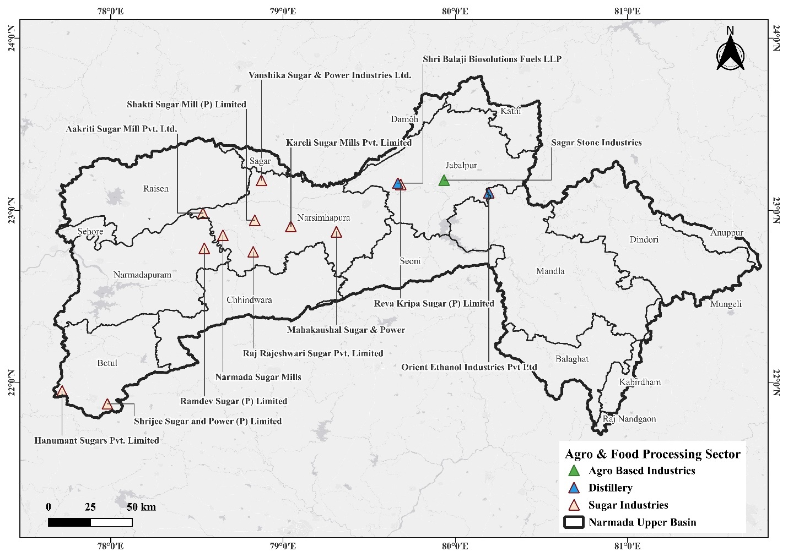
Figure 8: Spatial Distribution of Real-Time Monitoring Stations in Agro & Food Processing Industries of the Upper Narmada Basin
Table 21: Real-time Monitoring of Agro & Food Industries in the Upper Narmada Basin
Industry Name | District | Sector | R.O | CAAQMS | CEMS | CEQMS | Flow Meter | IPC | Total
Hanumant Sugars Pvt. Limited | Betul | Sugar | Chhindwara | 0 | 0 | 1 | 1 | 1 | 3
Shrijee Sugar and Power (P) Limited | Betul | Sugar | Chhindwara | 0 | 0 | 1 | 1 | 1 | 3
Ramdev Sugar (P) Limited | Hoshangabad | Sugar | Mandideep | 0 | 0 | 1 | 1 | 1 | 3
Sagar Stone Industries | Jabalpur | Agro Based | Jabalpur | 0 | 0 | 0 | 0 | 4 | 4
Shri Balaji Biosolutions Fuels LLP | Jabalpur | Distillery | Jabalpur | 0 | 1 | 1 | 1 | 2 | 5
Reva Kripa Sugar (P) Limited | Jabalpur | Sugar | Jabalpur | 0 | 0 | 1 | 1 | 0 | 2
Orient Ethanol Industries Pvt Ltd | Mandla | Distillery | Jabalpur | 0 | 1 | 1 | 1 | 0 | 3
Aakriti Sugar Mill Pvt. Ltd. | Narsinghpur | Sugar | Jabalpur | 0 | 0 | 1 | 1 | 1 | 3
Kareli Sugar Mills Pvt. Limited | Narsinghpur | Sugar | Jabalpur | 0 | 0 | 1 | 2 | 1 | 4
Mahakaushal Sugar & Power | Narsinghpur | Sugar | Jabalpur | 0 | 0 | 1 | 1 | 0 | 2
Narmada Sugar Mills | Narsinghpur | Sugar | Jabalpur | 0 | 2 | 1 | 1 | 1 | 5
Raj Rajeshwari Sugar Pvt. Limited | Narsinghpur | Sugar | Jabalpur | 0 | 1 | 1 | 1 | 0 | 3
Shakti Sugar Mill (P) Limited | Narsinghpur | Sugar | Jabalpur | 0 | 0 | 1 | 1 | 1 | 3
Vanshika Sugar & Power Industries Ltd. | Narsinghpur | Sugar | Jabalpur | 0 | 0 | 1 | 1 | 1 | 3
*Data retrieved from the MPPCB website (https://erc.mp.gov.in/IMS/CRUD/R_RTM)

Real-time monitoring of Agro & Food Industries in Middle Basin
The Middle Narmada Basin demonstrates strong compliance across agro and distillery units, as presented in Table 22. Maa Rewa Sugar Pvt. Ltd. in Dhar utilizes comprehensive monitoring systems, including CAAQMS, CEMS, CEQMS, and flow meters. The Security Paper Mill in Hoshangabad records the highest monitoring intensity among agro-based industries, with five CAAQMS installations and multiple CEQMS units. Distillery units in Khargone, including Agrawal Distilleries and Associated Alcohols & Breweries, show robust effluent monitoring with multiple CEQMS units. This distribution reflects the Middle Basin’s advanced compliance culture, reinforced by industrial clusters around Dhar, Indore, and Khargone. Monitoring Stations are mentioned in figure 9.
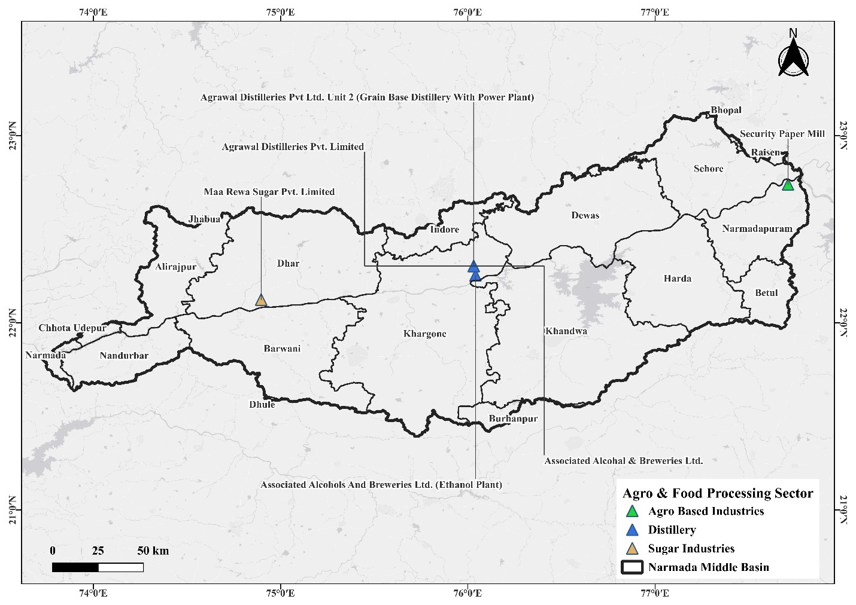
Figure 9: Spatial Distribution of Real-Time Monitoring Stations in Agro & Food Processing Industries of the Middle Narmada Basin
Table 22: Real-time Monitoring of Agro & Food Industries in the Middle Narmada Basin
Industry Name | District | Sector | R.O | CAAQMS | CEMS | CEQMS | Flow Meter | IPC | Total
Maa Rewa Sugar Pvt. Limited | Dhar | Sugar | Dhar | 0 | 1 | 1 | 1 | 1 | 4
Security Paper Mill | Hoshangabad | Agro Based | Mandideep | 0 | 5 | 1 | 1 | 1 | 8
Agrawal Distilleries Pvt. Limited | Khargone | Distillery | Indore | 0 | 1 | 0 | 3 | 1 | 5
Associated Alcohal & Breweries Ltd. | Khargone | Distillery | Indore | 0 | 2 | 0 | 1 | 2 | 5
Associated Alcohols And Breweries Ltd. (Ethanol Plant) | Khargone | Distillery | Indore | 0 | 1 | 0 | 1 | 1 | 3
Agrawal Distilleries Pvt Ltd. Unit 2 (Grain Base Distillery with Power Plant) | Khargone | Distillery | Indore | 0 | 1 | 0 | 1 | 0 | 2
*Data retrieved from the MPPCB website (https://erc.mp.gov.in/IMS/CRUD/R_RTM)

Real-time monitoring of the Manufacturing sector in Upper Basin
Manufacturing industries in the Upper Basin show limited yet essential real-time monitoring coverage, as captured in Table 23. Narmada Gelatines Limited in Jabalpur utilizes flow meters and IPC monitoring, while Perfect Soneware Pipes Ltd. in Mandla reports a CAAQMS setup. Although installations remain minimal, the presence of core monitoring systems demonstrates basic compliance with environmental guidelines in manufacturing operations within the region. Monitoring Stations are mentioned in Figure 10.
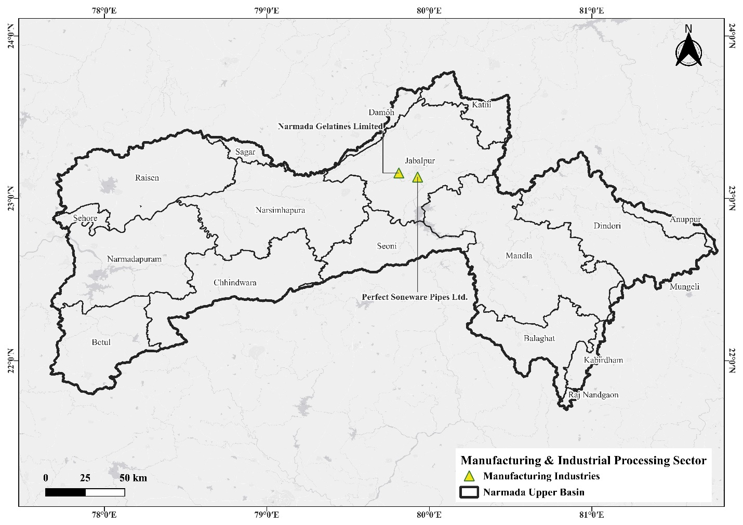
Figure 10: Spatial Distribution of Real-Time Monitoring Installations in Manufacturing & Industrial Processing Sector of the Upper Narmada Basin This also
Table 23: Real-time Monitoring of the Manufacturing Sector in the Upper Narmada Basin
Industry Name | District | Sector | R.O | CAAQMS | CEMS | CEQMS | Flow Meter | IPC | Total
Narmada Gelatines Limited | Jabalpur | Manufacturing | Jabalpur | 0 | 0 | 0 | 0 | 2 | 2
Perfect Soneware Pipes Ltd. | Mandla | Manufacturing | Jabalpur | 0 | 1 | 0 | 0 | 0 | 1
*Data retrieved from the MPPCB website (https://erc.mp.gov.in/IMS/CRUD/R_RTM)

Real-time monitoring of the Manufacturing sector in the Middle Basin
Manufacturing units in the Middle Basin exhibit significantly advanced monitoring systems, as detailed in Table 24. Textile units under Trident Corporation and Trident Limited display CEQMS, flow meters, and CAAQMS installations, reflecting intensive environmental governance. Cement units such as Sagar Cements and Ultratech Cement in Dhar show the highest device count, with up to 14 monitoring instruments installed. The extent of monitoring underscores the regulatory importance of controlling emissions and effluent from the cement and textile industries.
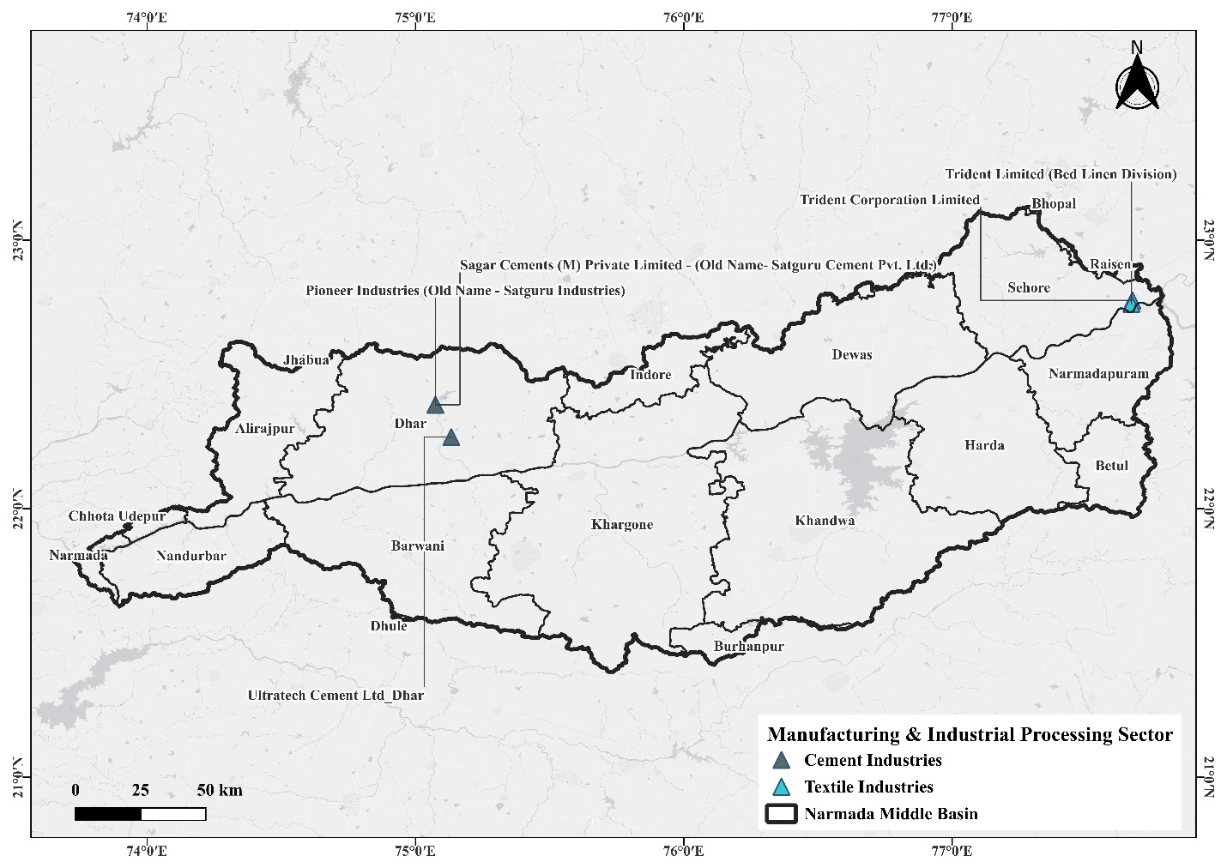
Figure 11: Spatial Distribution of Real-Time Monitoring Installations in Manufacturing & Industrial Processing Sector of the Middle Narmada Basin
Table 24: Real-time Monitoring of the Manufacturing Sector in the Middle Narmada Basin
Industry Name | District | Sector | R.O | CAAQMS | CEMS | CEQMS | Flow Meter | IPC | Total
Trident Corporation Limited | Sehore | Textile | Bhopal | 0 | 0 | 0 | 2 | 4 | 6
Trident Limited (Bed Linen Division) | Sehore | Textile | Bhopal | 1 | 1 | 0 | 0 | 0 | 2
Sagar Cements (M) Private Limited - (Old Name- Satguru Cement Pvt. Ltd.) | Dhar | Cement | Dhar | 2 | 5 | 0 | 0 | 0 | 7
Ultratech Cement Ltd_Dhar | Dhar | Cement | Dhar | 4 | 9 | 0 | 0 | 1 | 14
Pioneer Industries (Old Name - Satguru Industries) | Dhar | Cement | Bhopal | 0 | 1 | 0 | 0 | 0 | 1
*Data retrieved from the MPPCB website (https://erc.mp.gov.in/IMS/CRUD/R_RTM)

Real-time monitoring of chemical-based Industries in the Middle Basin
Chemical-based industries exhibit comprehensive real-time monitoring in the Middle Basin, as illustrated in Table 25. Coromandel International Limited and Khaitan Chemical & Fertilizers in Khargone have multiple CAAQMS and CEQMS units, reflecting stringent regulation in the fertilizer sector. Khaitan Chemical displays the highest number of monitored devices (13), demonstrating a robust compliance framework for emission and effluent handling.

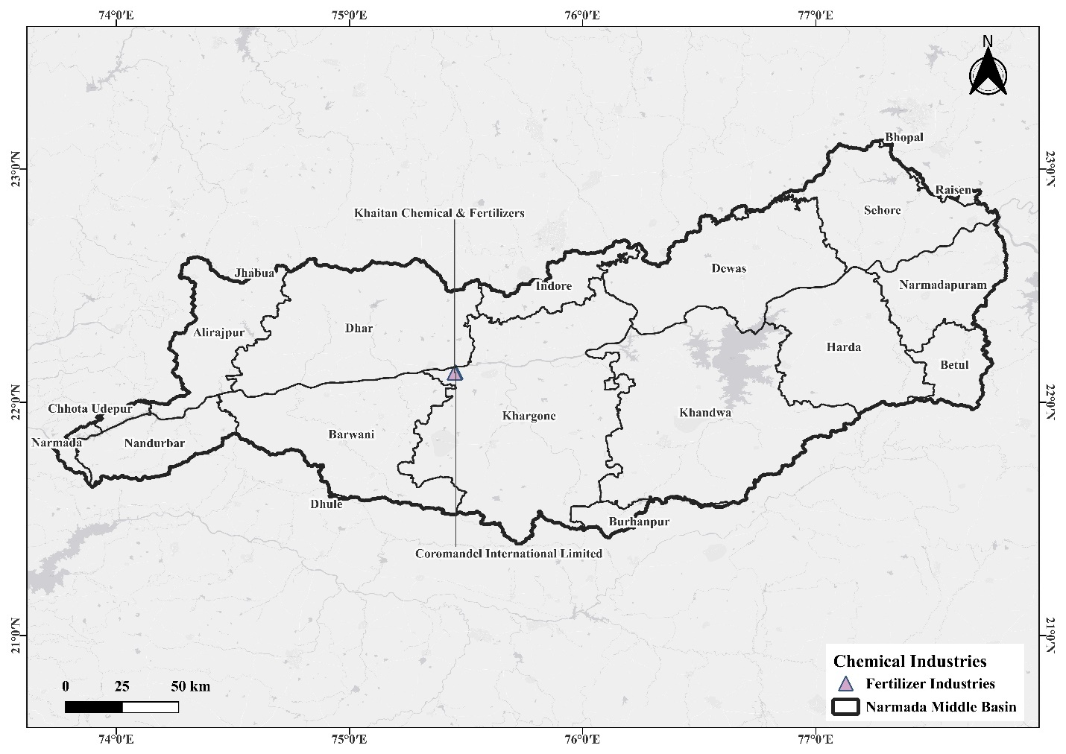
Figure 12: Geographical Mapping of Real-Time Monitoring Stations in Chemical & Fertilizer Industries of the Middle Narmada Basin
Table 25: Real-time Monitoring of Chemical-Based Industries in the Middle Narmada Basin
Industry Name | District | Sector | R.O | CAAQMS | CEMS | CEQMS | Flow Meter | IPC | Total
Coromandel International Limited | Khargone | Fertilizer | Indore | 0 | 4 | 0 | 1 | 2 | 7
Khaitan Chemical & Fertilizers | Khargone | Fertilizer | Indore | 0 | 8 | 0 | 2 | 3 | 13
*Data retrieved from the MPPCB website (https://erc.mp.gov.in/IMS/CRUD/R_RTM)

Real-time monitoring of Thermal Power Plants in Upper Basin
Thermal power plants in the Upper Basin present substantial monitoring system deployments, as shown in Table 26. The Super Thermal Power Station in Narsinghpur leads with 10 devices, including CEQMS, CAAQMS, and CEMS installations. Satpura Thermal Power Station (Betul) exhibits extensive monitoring for ash pond and stack emissions. Jhabua Power Limited and BLA Power Pvt. Ltd. similarly demonstrate multi-system configurations. These installations support continuous regulatory monitoring of pollution from power generation.
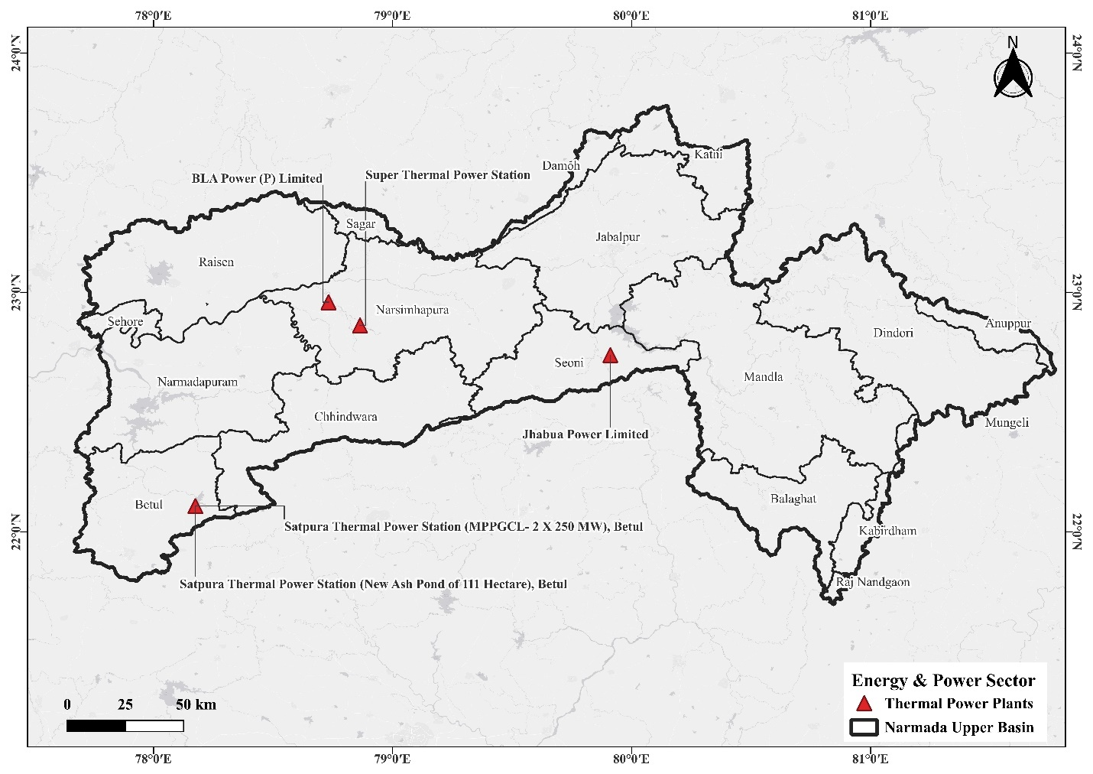
Figure 13: Distribution of Real-Time Monitoring Systems across Thermal Power Plants in the Upper Narmada Basin
Table 26: Real-time Monitoring of Thermal Power Plants in the Upper Narmada Basin
Industry Name | District | Sector | R.O | CAAQMS | CEMS | CEQMS | Flow Meter | IPC | Total
Satpura Thermal Power Station (MPPGCL- 2 X 250 MW), Betul | Betul | Thermal Power | Chhindwara | 0 | 2 | 0 | 0 | 0 | 2
Satpura Thermal Power Station (New Ash Pond of 111 Hectare), Betul | Betul | Thermal Power | Chhindwara | 2 | 0 | 1 | 1 | 3 | 7
BLA Power (P) Limited | Narsinghpur | Thermal Power | Jabalpur | 1 | 1 | 0 | 0 | 1 | 3
Super Thermal Power Station | Narsinghpur | Thermal Power | Jabalpur | 4 | 2 | 1 | 0 | 3 | 10
Jhabua Power Limited | Seoni | Thermal Power | Jabalpur | 1 | 1 | 1 | 0 | 1 | 4
*Data retrieved from the MPPCB website (https://erc.mp.gov.in/IMS/CRUD/R_RTM)

Real-time monitoring of Thermal Power Plants in Middle Basin
Thermal power units in the Middle Basin maintain strong real-time monitoring coverage, as summarized in Table 27. NTPC Khargone registers the highest monitoring level with 13 sensors across CAAQMS, CEMS, and flow meters. The Singaji Thermal Power Project in Khandwa exemplifies a structured approach to effluent and emissions monitoring. Vardhman Fabrics (CPP) reflects compliance typically for captive power units. These systems ensure continuous real-time data reporting to regulatory authorities.
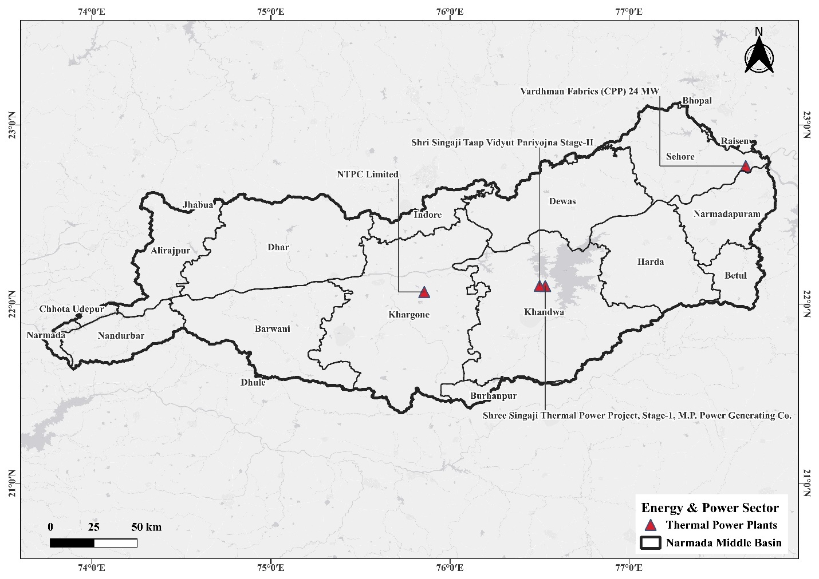
Figure 14: Distribution of Real-Time Monitoring Systems across Thermal Power Plants in the Middle Narmada Basin

Table 27: Real-time Monitoring of Thermal Power Plants in the Middle Narmada Basin
Industry Name | District | Sector | R.O | CAAQMS | CEMS | CEQMS | Flow Meter | IPC | Total
NTPC Limited | Khargone | Thermal Power | Indore | 4 | 4 | 1 | 0 | 4 | 13
Shree Singaji Thermal Power Project, Stage-1, M.P. Power Generating Co. | Khandwa | Thermal Power | Indore | 2 | 2 | 0 | 1 | 1 | 6
Shri Singaji Taap Vidyut Pariyojna Stage-II | Khandwa | Thermal Power | Indore | 1 | 2 | 0 | 0 | 1 | 4
Vardhman Fabrics (CPP) 24 MW | Sehore | Thermal Power | Bhopal | 1 | 1 | 1 | 1 | 2 | 6
*Data retrieved from the MPPCB website (https://erc.mp.gov.in/IMS/CRUD/R_RTM)

Real-time monitoring of Mines in Upper Basin
Mining operations in the Upper Basin have limited but necessary monitoring installations, as reflected in Table 28. Hindustan Copper Ltd., Western Coalfields (Pench Area), and Western Coalfields (Pathakhera) each have R.O. monitoring systems, ensuring compliance with water quality requirements. Jakhodia Minerals installs IPC monitoring relevant to extraction operations. Although sparse, these installations indicate basic adherence to mining-sector environmental regulations.
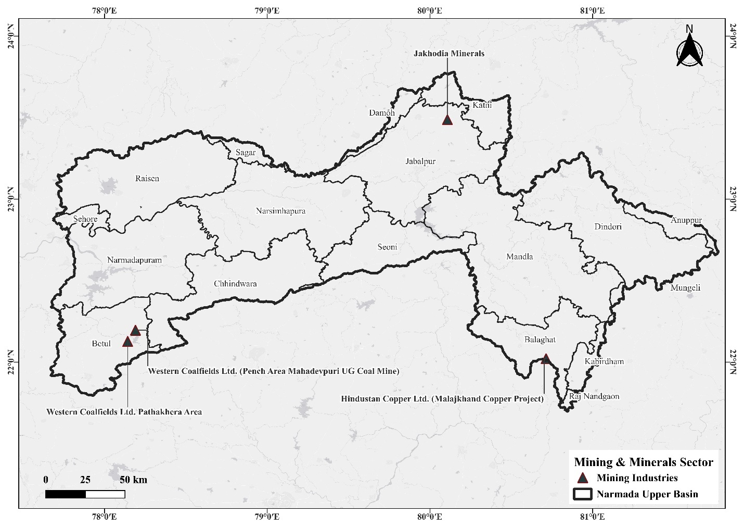
Figure 15: Location of Real-Time Monitoring Systems in Mining Industries of the Upper Narmada Basin
Table 28: Real-time Monitoring of Mining Industries in the Upper Narmada Basin
Industry Name | District | Sector | R.O | CAAQMS | CEMS | CEQMS | Flow Meter | IPC | Total
Hindustan Copper Ltd. (Malajkhand Copper Project) | Balaghat | Mining | Bhopal | 1 | 0 | 0 | 0 | 0 | 1
Western Coalfields Ltd. (Pench Area Mahadevpuri UG Coal Mine) | Chhindwara | Mining | Chhindwara | 1 | 0 | 0 | 0 | 0 | 1
Western Coalfields Ltd. Pathakhera Area | Betul | Mining | Chhindwara | 1 | 0 | 0 | 0 | 0 | 1
Jakhodia Minerals | Jabalpur | Mining | Jabalpur | 0 | 0 | 0 | 0 | 1 | 1
*Data retrieved from the MPPCB website (https://erc.mp.gov.in/IMS/CRUD/R_RTM)

Real-time monitoring of Mines in Middle Basin
Mining in the Middle Basin is represented by a single monitored unit Ultratech Cement Limestone Mine in Dhar as shown in Table 29. The unit includes R.O. and flow meter installations, reflecting water management and discharge compliance standards associated with mining operations.
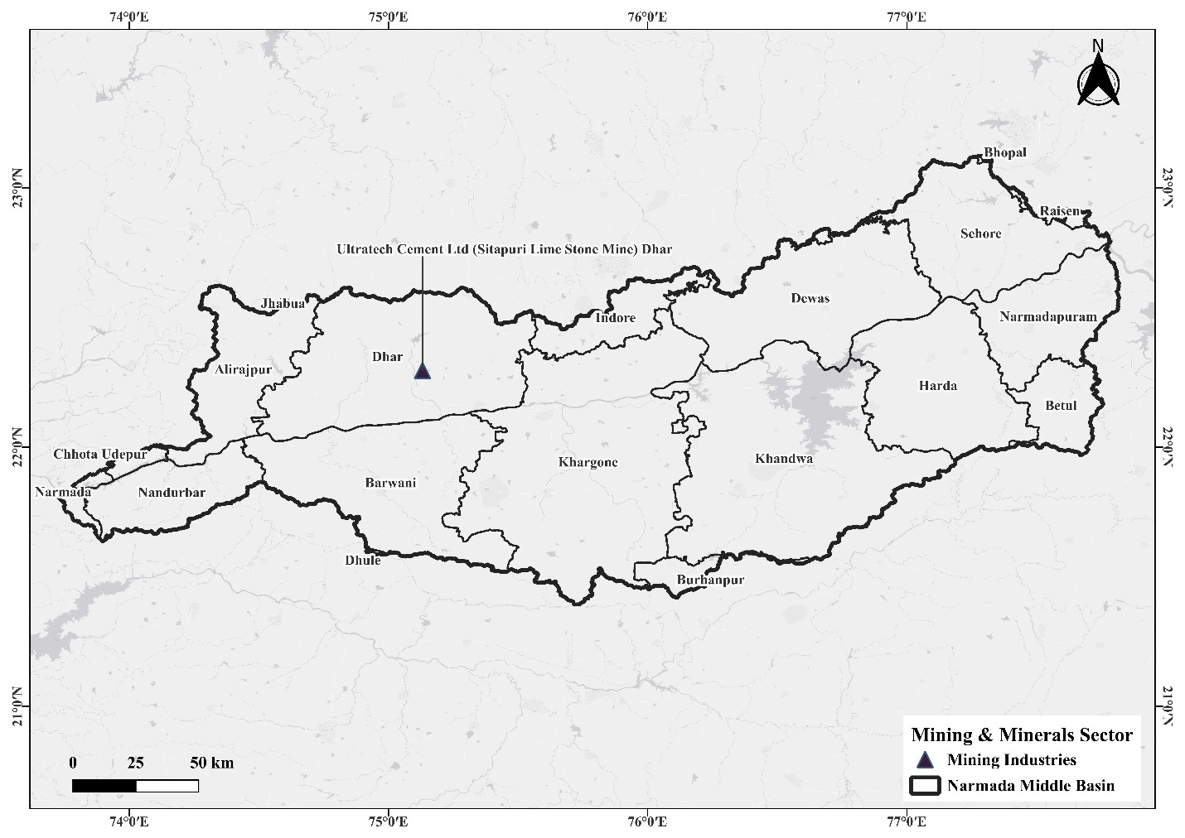
Figure 16: Location of Real-Time Monitoring Systems in Mining Industries of the Middle Narmada Basin
Table 29: Real-time Monitoring of Mining Industries in the Middle Narmada Basin
Industry Name | District | Sector | R.O | CAAQMS | CEMS | CEQMS | Flow Meter | IPC | Total
Ultratech Cement Ltd (Sitapuri Lime Stone Mine) Dhar | Dhar | Mining | Dhar | 2 | 0 | 0 | 0 | 1 | 3
*Data retrieved from the MPPCB website (https://erc.mp.gov.in/IMS/CRUD/R_RTM)

Real-time monitoring of water & waste management in Upper Basin
Waste and water management facilities in the Upper Basin display selective real-time monitoring infrastructure, as documented in Table 30. Jabalpur’s 32 MLD STP shows multiple CEQMS and CEMS devices, ensuring continuous surveillance of effluent discharge quality. Biomedical waste and municipal waste facilities, including Elite Engineers and Jabalpur MSW Pvt. Ltd., incorporate CAAQMS units to monitor air quality at incineration sites. These monitoring systems help safeguard downstream water quality in the Narmada Basin.
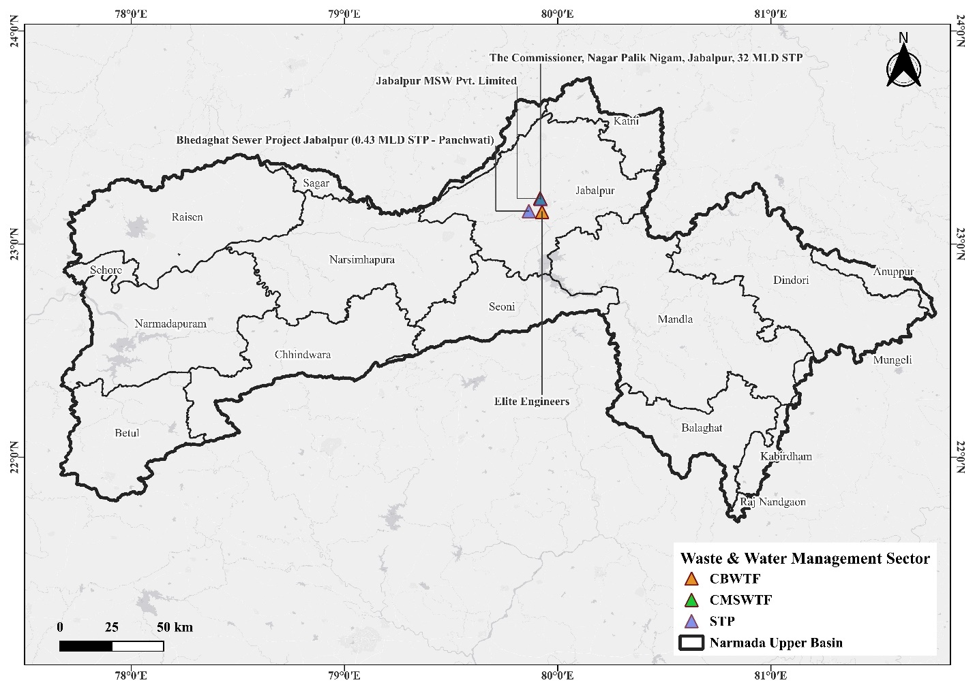
Figure 17: Spatial Distribution of Real-Time Monitoring Stations in Waste & Water Management Sector within the Narmada Upper Basin.
Table 30: Real-time Monitoring of Water and Waste Management Facilities in the Upper Narmada Basin
Industry Name | District | Sector | R.O | CAAQMS | CEMS | CEQMS | Flow Meter | IPC | Total
Elite Engineers | Jabalpur | CBWTF | Jabalpur | 0 | 1 | 0 | 0 | 0 | 1
Jabalpur MSW Pvt. Limited | Jabalpur | CMSWTF | Jabalpur | 0 | 1 | 0 | 0 | 0 | 1
Bhedaghat Sewer Project Jabalpur (0.43 MLD STP - Panchwati) | Jabalpur | STP | Jabalpur | 0 | 0 | 1 | 0 | 0 | 1
The Commissioner, Nagar Palik Nigam, Jabalpur, 32 MLD STP | Jabalpur | STP | Jabalpur | 0 | 0 | 2 | 2 | 0 | 4
*Data retrieved from the MPPCB website (https://erc.mp.gov.in/IMS/CRUD/R_RTM)

Real-time monitoring of water & waste management in Middle Basin
The Middle Basin’s water and waste management units feature structured monitoring systems, as depicted in Table 31. The Khargone STP (17.60 MLD) uses multiple CEQMS and CEMS installations to ensure compliance with effluent standards. Medisure Incinerators in Khandwa utilizes CAAQMS for continuous air quality assessment around biomedical waste operations. These systems reinforce environmental compliance and support basin-wide pollution prevention strategies.
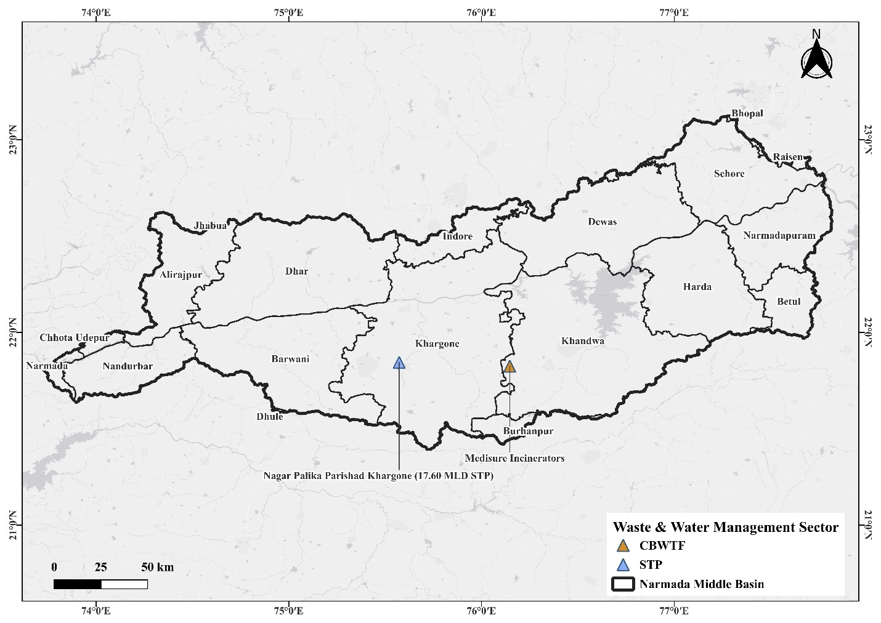
Figure 18: Spatial Distribution of Real-Time Monitoring Stations in Waste & Water Management Sector within the Narmada Middle Basin.
Table 31: Real-time Monitoring of Water and Waste Management Facilities in the Middle Narmada Basin
Industry Name | District | Sector | R.O | CAAQMS | CEMS | CEQMS | Flow Meter | IPC | Total
Nagar Palika Parishad Khargone (17.60 MLD STP) | Khargone | STP | Indore | 0 | 0 | 2 | 2 | 0 | 4
Medisure Incinerators | Khandwa | CBWTF | Indore | 0 | 1 | 0 | 0 | 0 | 1
*Data retrieved from the MPPCB website (https://erc.mp.gov.in/IMS/CRUD/R_RTM)

Raw Materials for Different Industries
This review synthesizes scholarly research on the raw materials utilized by key manufacturing sectors in India. The industries under examination range from traditional agro-based sectors, such as cotton textiles and jute, to modern industries like engineering, plastics, and electronics. A critical understanding of the raw material base is essential for assessing the sustainability, supply chain resilience, and economic viability of these industries. The following table compiles findings from peer-reviewed articles, highlighting the specific raw materials used and their context within the Indian industrial landscape, as documented in publications from the specified major publishing houses. Table 32 shows a brief literature review of raw material usage in various industries.
Table 32: Literature Review of Raw Materials in Indian Industries
Type of Industry | Raw Materials Used (Indian Context) | Citation
Agro-Based | Sugarcane (for sugar, ethanol), Wheat, Rice, Pulses, Oilseeds (Mustard, Groundnut). Focus on agricultural residue as secondary raw material. | Singh, R., et al. (2021).
Soda Water | Carbon Dioxide (CO₂), Water (highly purified), Sodium Benzoate, Citric Acid, Flavouring Essences, Sugar/Artificial Sweeteners. | Krishnan, R., et al. (2019).
Cotton Textile | Raw Cotton (Gossypium spp.), Water (for processing), Sizing Agents (Starch, PVA), Dyestuffs, Chemical Auxiliaries (enzymes, surfactants). | Chetty, A. S., & Reddy, M. M. (2020).
Artificial Thread-based Clothes | Wood Pulp (for Viscose/Rayon), Petroleum-based chemicals (for Polyester, Nylon, Acrylic), Acetic Anhydride & Cellulose (for Acetate). | Maity, S., et al. (2022).
Jute & Jute-based | Jute Fiber (Corchorus capsularis & olitorius), Water, Bitumen (for jute geotextiles), Starch, Mineral Fillers. | Das, S., et al. (2018).
Ready-made Garments & Embroidery | Fabrics (Cotton, Silk, Polyester, Blends), Threads (Cotton, Rayon, Metallic), Zippers, Buttons, Interlining Fabrics, Adornments (Sequins, beads). | Gopalakrishnan, L., & Sreenivasan, J. (2021).
Wood/Wooden-based Furniture | Timber (Teak, Sal, Sheesham, Mango, Rubberwood), Plywood, Particle Board, MDF, Adhesives (Urea-Formaldehyde), Varnishes, Stains. | Dev, I., et al. (2019).
Paper & Paper Products | Wood Pulp (from Eucalyptus, Subabul), Agro-residues (Wheat Straw, Bagasse), Recycled Paper (Wastepaper), Chemicals (Caustic Soda, Sodium Sulphate). | Majumdar, S., et al. (2020).
Leather-based | Animal Hides & Skins (Cow, Buffalo, Goat, Sheep), Chemicals for Tanning (Chromium Salts, Vegetable Tannins), Fatliquoring Agents, Dyes. | Sivakumar, V., et al. (2021). 283, 124636. (Elsevier)
Chemical/Chemical-based | Basic Feedstocks (Naphtha, Natural Gas, Benzene), Inorganic Chemicals (Salt, Sulphur, Phosphates), Aromatics. | Malhotra, A., & Joshi, R. M. (2019).
Rubber, Plastic & Petro-based | Crude Oil & Natural Gas (for monomers like Ethylene, Propylene), Naphtha, Additives (Plasticizers, Stabilizers, Fillers like Calcium Carbonate). | Patel, M. K., & Kumar, J. (2022).
Mineral-based | Limestone (for Cement), Gypsum, Iron Ore, Bauxite, Silica Sand, Feldspar. | Mishra, A., & Pradhan, B. (2020).)
Metal-based (Steel Fab.) | Iron Ore, Coking Coal, Fluxes (Limestone, Dolomite), Ferro-alloys (Ferro-manganese, Ferro-silicon), Scrap Steel. | Singh, R., & Chandel, M. K. (2021).
Engineering Units | Castings & Forgings (Iron, Steel, Aluminum), Steel Sheets, Bars, and Rods, Bearings, Seals, Standard Components (Bolts, Nuts). | Kumar, S., & Barai, S. V. (2019).
Electrical Machinery | Copper (for windings), Electrical Steel (Silicon Steel for cores), Plastics (for insulation and housing), Semiconductors (Silicon), Ceramics (for insulators). | Shrivastava, A., et al. (2020)
Transport Equipment | Steel & Aluminum (for chassis and body), Plastics & Composites (for interior panels), Glass, Rubber (for tires and seals), Electronics (for control units). | Gandhi, A., & Suresh, P. (2022).
Repairing & Servicing | (Focus on Reverse Logistics/Remanufacturing) Used/End-of-Life Products and Components as raw materials for refurbishment. | Jayant, A., et al. (2019).
Chemical/Chemical-based | (Focus on Agrochemicals) Basic Feedstocks (Benzene, Sulphur, Phosphoric Acid), Inert Carriers (Clay, Diatomaceous Earth). | Kumar, S., & Dhal, P. K. (2020).
Mineral-based | (Focus on Cement) Limestone (primary), Clay/Shale, Sand, Iron Ore, Gypsum, Fly Ash (as additive). | Madhavi, T. C., et al. (2018).
Agro-Based (Specialty Products) | Makhana (Fox Nut), Honey, Pulses, Spices, Herbs. Focus on value addition and supply chain. | Kumar, M., et al. (2022).
Soda Water / Beverages | High Fructose Corn Syrup (HFCS) as an alternative sweetener, Natural Colorants (e.g., anthocyanins), Stabilizers (Gum Acacia). | Singh, P. P., & Kaur, S. (2020).
Cotton Textile (Sustainable Raw Materials) | Organic Cotton, Recycled Cotton Fibers, Natural Dyes (from plants like Indigo, Turmeric), Bio-based Sizing Agents. | Chakraborty, S., & Majumdar, G. (2021).
Artificial Thread-based (Non-Wood Pulp) | Bamboo Pulp, Banana Pseudostem Fibers, Soybean Proteins, Corn Zein as sustainable alternatives for cellulosic and protein fibers. | Joshi, M., et al. (2020).
Jute & Jute-based (Composites) | Jute Fiber as reinforcement, Polyester/Epoxy Resins (as matrix), Jute Nanocellulose for advanced applications. | Sinha, A. K., et al. (2019).
Ready-made Garments (Sustainable Inputs) | GOTS Certified Organic Fabrics, Recycled Polyester, Biodegradable Sequins, Water-based Inks for printing. | Karthik, T., & Gnanapprabha, M. (2021)
Wood/Wooden based (Alternatives) | Laminated Bamboo Lumber (LBL), Rice Husk Panels, Coir-based Composites, Waste Wood Plastic Composites (WPC). | Sharma, B., et al. (2020).
Paper & Paper Products (Non-wood Pulp) | Rice Straw, Wheat Straw, Bagasse, and Sarkanda Grass as primary pulping raw materials, addressing silica-related challenges. | Yadav, S., & Gupta, D. (2019).
Leather-based (Green Chemistry) | Pre-tanning agents (enzymes), Vegetable Tannins (Acacia, Myrobalan), Oxazolidine-based tanning agents, Bio-based Fatliquors. | Kanagaraj, J., et al. (2020).
Chemical/Chemical-based (Green Chemicals) | Bio-based Ethanol (for derivatives), Glycerol (from biodiesel production), Castor Oil (for specialty polymers), Lignin. | Patel, A. D., & Serrano-Ruiz, J. C. (2021).
Rubber, Plastic & Petro-based (Biodegradables) | Poly Lactic Acid (PLA from corn starch), Polyhydroxyalkanoates (PHA from microbes), Starch Blends, Jute-reinforced Biocomposites. | Ranganathan, S., et al. (2022).
Mineral-based (Waste Utilization) | Fly Ash (from coal plants), Blast Furnace Slag, Red Mud (from alumina production), Marble Slurry as secondary raw materials. | Bheel, N., et al. (2021)
Metal-based (Ferroalloys) | Manganese Ore, Chromite Ore, Silica, Coke for the production of Ferro-manganese and Ferro-chrome, critical for steel making. | Swamy, Y. V., et al. (2019)
Engineering Units (Casting) | Pig Iron, Spheroidal Graphite (SG) Iron, Foundry Sand (Silica, Chromite), Binders (Phenolic Resins). | Kumar, S., & Satsangi, P. S. (2020)
Electrical Machinery (E-Waste Recycling) | Recycled Copper from e-waste, Rare Earth Elements (Neodymium, Dysprosium) from recycled magnets, Recovered Plastics. | Awasthi, A. K., et al. (2019)
Transport Equipment (Auto Components) | Aluminum Alloys (for engine blocks, wheels), Carbon Fiber Composites (high-end), Specialty Plastics (Polycarbonate for lights), Ceramics (for sensors). | Ramesh, B., et al. (2021)
Repairing & Servicing (Automotive) | Re-refined Lubricating Oils, Remanufactured Components (turbochargers, starters), Recycled Refrigerants. | Mangla, S. K., et al. (2019)
Chemical/Chemical-based (Pharmaceuticals) | Active Pharmaceutical Ingredients (APIs), Excipients (Lactose, Starch), Solvents (Methanol, Isopropyl Alcohol). | Ramakrishnan, A., & Singh, S. K. (2022).
Mineral-based (Refractories) | Bauxite, Magnesite, Graphite, Zirconia for manufacturing refractory bricks used in high-temperature furnaces (steel, glass). | Sarkar, R. (2020)
Artificial Thread-based (Technical Textiles) | High-tenacity Polyester, Nylon, Aramid, Glass Filaments, Carbon Fibers for industrial, geotechnical, and medical applications. | Gupta, S., & Maity, S. (2021)

Waste Generation from Different Industries
Understanding the waste streams generated by industrial sectors is crucial for developing effective waste management, recycling, and circular economy strategies. In India, with its rapid industrialization and stringent environmental regulations, the characterization and sustainable handling of industrial waste have become a key research area. This review compiles findings from high-quality research articles that document the nature, composition, and environmental impact of wastes from the specified industries, providing a foundation for further research and policy intervention.
Table 33: Literature Review of Waste Generated from Industries
Type of Industry | Waste Generated | Citation
Agro-Based | Press Mud (from sugar mills), Rice Husk, Bagasse Pith, Fruit & Vegetable Peels, Effluents high in organic load (BOD/COD). | Yadav, R. L., & Solomon, S. (2020).
Soda Water / Beverages | Wastewater with high sugar content, rejected PET bottles & glass, Sludge from water treatment, and Outdated syrup concentrates. | Murugan, K., & Joseph, A. (2019)
Cotton Textile | High Alkali Desizing Wastewater, Synthetic Dyes & Chemicals, Fiber Fly & Short Fibers, Chemical Sludge from Effluent Treatment Plants (ETP). | Kant, R. (2021).
Artificial Thread-based | Acidic Wastewater (from viscose process), Carbon Disulphide (CS₂) emissions, Spent Solvents, Cellulose Sludge, Rejected Yarns. | Maity, S., et al. (2022).
Jute & Jute-based | Jute Cuttings & Dust (Batching Oil contaminated), Hard Twigs (Jute Stick), Wastewater from Retting and Softening. | Basu, G., et al. (2019)
Ready-made Garments | Fabric Scraps & Cuttings, Off-spec garments, Plastic Packaging Waste, Thread Bits, Used Needles. | Gopalakrishnan, L., & Sreenivasan, J. (2021)
Wood/Wooden-based Furniture | Sawdust, Wood Off cuts & Shavings, Sanding Dust, Waste Varnish & Solvents, Adhesive Containers. | Dev, I., et al. (2019).
Paper & Paper Products | Black Liquor (from pulping), De-inking Sludge, Rejected Paper, Lime Mud, Wastewater with high suspended solids. | Majumdar, S., et al. (2020)
Leather-based | Chrome-tanned Shavings & Trimmings, Fleshing Wastes, Sulfide-rich Liquors, Solid Sludge from ETP, Dyestuffs. | Sivakumar, V., et al. (2021).
Chemical/Chemical-based | Spent Acids & Catalysts, Distillation Residues, Off-spec Products, Reactive Chemical Sludges, Solvent Contaminated Water. | Malhotra, A., & Joshi, R. M. (2019)
Rubber, Plastic & Petro-based | Plastic Scrap & Fluff, Off-spec Polymer Pellets, Catalyst Fines, Waste Oils & Emulsions, VOCs. | Patel, M. K., & Kumar, J. (2022)
Mineral-based (Cement) | Cement Kiln Dust, Quarry Overburden, Particulate Matter (PM) emissions, Waste Gypsum. | Madhavi, T. C., et al. (2018)
Metal-based (Steel Fab.) | Blast Furnace Slag, Steel Slag, Mill Scale, Pickling Sludge (acidic, heavy metals), Refractory Waste. | Singh, R., & Chandel, M. K. (2021).
Engineering Units | Metal Scrap (Turnings, Swarf), Used Cutting Oils & Emulsions, Spent Acid for Pickling, Waste Abrasives. | Kumar, S., & Barai, S. V. (2019)
Electrical Machinery | E-waste (PCBs, wires), Insulation Scrap, Contaminated Plastics, Waste Oils from transformers, Acid from batteries. | Awasthi, A. K., et al. (2019)
Transport Equipment | End-of-Life Vehicles (ELVs), Metal-Plastic Composite Waste, Waste Tires, Spent Batteries, Used Lubricants. | Gandhi, A., & Suresh, P. (2022).
Repairing & Servicing | Used/Spent Parts (filters, brakes), Waste Oils & Coolants, Contaminated Rags, Empty Packaging, E-waste from diagnostics. | Jayant, A., et al. (2019).
Chemical/Chemical-based (Agrochemicals) | Obsolete Pesticides, Contaminated Packaging, Wastewater with pesticide residues, Off-spec formulations. | Kumar, S., & Dhal, P. K. (2020)
Mineral-based (Ceramics & Refractories) | Broken/Rejected Fired Products, Green (unfired) Scrap, Used Refractory Bricks, Abrasive Sludge from polishing. | Sarkar, R. (2020)
Rubber, Plastic (End-of-Life) | Post-consumer Plastic Packaging, Used Tires, Multilayer Laminates, Plastic Films from agriculture. | Ranganathan, S., et al. (2022)

Summary and Conclusion

References
- Awasthi, A. K., Cheela, V. S., D’adamo, I., Iacovidou, E., & Islam, M. R. (2019). Estimating the generation of end-of-life electrical and electronic equipment in India. Waste Management & Research, 37(9), 924–930. https://doi.org/10.1177/0734242X19855466
- Basu, G., Mishra, L., & Jose, S. (2019). Utilization of jute industrial waste for development of sustainable composites. Waste and Biomass Valorization, 10(5), 1247–1257. https://doi.org/10.1007/s12649-017-0143-3
- Bheel, N., Memon, S. A., Khaskheli, I. A., & Mehmod, Q. (2021). Use of fly ash and marble powder as a partial replacement of cement in concrete: A review. International Journal of Engineering, Transactions B: Applications, 34(2), 378–387. https://doi.org/10.5829/ije.2021.34.02b.14
- Chakraborty, S., & Majumdar, G. (2021). Natural dyeing of cotton with marigold flower: Optimization and color fastness properties. The Journal of The Textile Institute, 112(4), 644–652. https://doi.org/10.1080/00405000.2020.1777340
- Chetty, A. S., & Reddy, M. M. (2020). Sustainable raw material selection in Indian textile industry: A fuzzy AHP approach. The Journal of The Textile Institute, 111(5), 660–670. https://doi.org/10.1080/00405000.2019.1663617
- Das, S., Saha, A., & Majumdar, G. (2018). A comprehensive review on the potential of jute-based biocomposites. Journal of Natural Fibers, 15(5), 659–674. https://doi.org/10.1080/15440478.2017.1349017
- Dev, I., Poonia, S., & Jha, S. K. (2019). Assessment of wood waste from furniture manufacturing units in Uttar Pradesh and its potential for particleboard. Journal of the Indian Academy of Wood Science, 16(2), 108–115. https://doi.org/10.1007/s13196-019-00244-x
- Gandhi, A., & Suresh, P. (2022). A system dynamics analysis of end-of-life vehicle management in India. Proceedings of the Institution of Mechanical Engineers, Part D: Journal of Automobile Engineering, 236(6), 1189–1202. https://doi.org/10.1177/09544070211034716
- Gopalakrishnan, L., & Sreenivasan, J. (2021). Material flow analysis and waste characterization in a ready-made garment cluster of South India. Fashion and Textiles, 8(1), 1–19. https://doi.org/10.1186/s40691-020-00232-7
- Gupta, S., & Maity, S. (2021). Technical textiles in India: A review of the raw material landscape and future opportunities. Journal of Industrial Textiles, 50(5), 735–760. https://doi.org/10.1177/1528083719842795
- Jayant, A., Azhar, M., & Singh, P. (2019). Analysis of the barriers of reverse logistics in the Indian automobile service sector. International Journal of Logistics Systems and Management, 32(1), 62–84. https://doi.org/10.1504/IJLSM.2019.100187
- Joshi, M., Ali, W., & Rajendran, S. (2020). Extraction and characterization of novel cellulosic fibers from Borassus flabellifer (Asian Palmyra) fruit for textile applications. Journal of Natural Fibers, 17(12), 1797–1807. https://doi.org/10.1080/15440478.2019.1599314
- Kanagaraj, J., Velappan, K. C., Babu, N. K., & Sadulla, S. (2020). A review on source reduction and cleaner tanning possibilities in leather processing. Journal of the American Leather Chemists Association, 115(2), 49–60. https://doi.org/10.34314/jalca.v115i2.2890
- Kant, R. (2021). Textile dyeing industry: An environmental hazard and approaches to mitigate its impact. Natural Hazards, 106(1), 887–915. https://doi.org/10.1007/s11069-020-04487-7
- Karthik, T., & Gnanapprabha, M. (2021). A roadmap for sustainable raw material selection in the Indian apparel industry. Research Journal of Textile and Apparel, 25(2), 176–195. https://doi.org/10.1108/RJTA-05-2020-0048
- Krishnan, R., Agarwal, A., & Dutta, S. (2019). Process optimization for the production of carbonated beverages using membrane technology. Journal of Food Engineering, 245, 1–8. https://doi.org/10.1016/j.jfoodeng.2018.10.002
- Kumar, M., Choudhary, D., & Kumar, R. (2022). Value chain analysis of Makhana (Euryale ferox Salisb.) in India: A review. Journal of Ethnic Foods, 9(1), 1–12. https://doi.org/10.1186/s42779-022-00125-8
- Kumar, S., & Barai, S. V. (2019). Waste minimization and resource recovery in Indian engineering industries: A case study. Journal of Cleaner Production, 231, 1175–1187. https://doi.org/10.1016/j.jclepro.2019.05.238
- Kumar, S., & Dhal, P. K. (2020). Remediation of pesticide contaminated sites in India: A review. Journal of Hazardous Materials, 389, 121–132. https://doi.org/10.1016/j.jhazmat.2019.121132
- Madhavi, T. C., Rajasekhar, K., & Reddy, L. S. (2018). Sustainable use of fly ash as a raw material for the production of Portland cement in India. Journal of Materials in Civil Engineering, 30(10), 04018245. https://doi.org/10.1061/(ASCE)MT.1943-5533.0002450
- Madhya Pradesh Pollution Control Board. (2025). Environmental Surveillance Centre: Real Time Monitoring Database. Government of Madhya Pradesh. https://erc.mp.gov.in/IMS/CRUD/R_RTM
- Madhya Pradesh Industrial Development Corporation. (2025). MPIDC GeoPortal. Government of Madhya Pradesh. https://geoportal.mp.gov.in/mpidc/home.aspx#
- Maity, S., Singha, K., & Pandit, P. (2022). Environmental impacts of viscose rayon manufacturing in India and strategies for waste minimization. Journal of Cleaner Production, 368, 133–145. https://doi.org/10.1016/j.jclepro.2022.133145
- Majumdar, S., Kumar, A., & Arora, A. (2020). Characterization and valorization of paper mill sludge for sustainable development. Journal of Material Cycles and Waste Management, 22(5), 1380–1393. https://doi.org/10.1007/s10163-020-01032-3
- Malhotra, A., & Joshi, R. M. (2019). Hazardous waste management in Indian chemical industries: A review. Resources, Conservation and Recycling, 145, 937–947. https://doi.org/10.1016/j.resconrec.2019.02.008
- Mangla, S. K., Luthra, S., Mishra, N., Singh, A., Rana, N. P., Dora, M., & Dwivedi, Y. (2019). Barriers to Effective Circular Supply Chain Management in a Developing Country Context Production Planning & Control, 30(16), 1378–1395. https://doi.org/10.1080/09537287.2019.1639462
- Ministry of Micro, Small & Medium Enterprises. (2025). District Wise Udyog Aadhaar Registration Details: Madhya Pradesh. Government of India. https://dashboard.msme.gov.in/uam_dist_wise.aspx?stid=23
- Ministry of MSME. (2016-17) Brief Industrial Profile of Anuppur District Madhya Pradesh. Government of India. https://dcmsme.gov.in/dips/Anuppur%20distt.pdf
- Ministry of MSME. (2016-17) District Profile of Balaghat. Government of India. https://dcmsme.gov.in/dips/District%20profile%20of%20Balaghat%20(1).pdf
- Ministry of MSME. (2016-17) Brief Industrial Profile of Betul District. Government of India. https://dcmsme.gov.in/dips/betul.pdf
- Ministry of MSME. (2016-17) District Profile of Chhindwara. Government of India. https://dcmsme.gov.in/dips/District%20profile%20of%20Chindwara.pdf
- Ministry of MSME. (2016-17) Industrial Profile: Damoh District (Survey). Government of India. https://dcmsme.gov.in/dips/SURVEY%20DAMOH-OK.pdf
- Ministry of MSME. (2016-17). Brief Industrial Profile of Dindori District. Government of India. https://dcmsme.gov.in/dips/2016-17/Dindori.pdf
- Ministry of MSME. (2016-17) Brief Industrial Profile of Hoshangabad District. Government of India. https://dcmsme.gov.in/dips/HOSHANGABAD.pdf
- Ministry of MSME. (2016-17) District Industrial Profile: Jabalpur District. Government of India. https://dcmsme.gov.in/dips/Distt%20Industrial%20Profile%20Jabalpur.pdf
- Ministry of MSME. (2016-17) District Industrial Profile: Katni District. Government of India. https://dcmsme.gov.in/dips/survey_katni.pdf
- Ministry of MSME. (2016-17) District Industrial Profile: Mandla District. Government of India. https://dcmsme.gov.in/dips/Distt%20Industrial%20Profile%20mandla.pdf
- Ministry of MSME. (2016-17) District Industrial Profile: Narsinghpur District. Government of India. https://dcmsme.gov.in/dips/NARSINGHPUR.pdf
- Ministry of MSME. (2016-17). District Industrial Profile: Raisen District. Government of India. https://dcmsme.gov.in/dips/2016-17/RAISEN.pdf
- Ministry of MSME. (2016-17) Industrial Survey of Sagar District. Government of India. https://dcmsme.gov.in/dips/SURVEY%20SAGAR.pdf
- Ministry of MSME. (2016-17) District Industrial Profile: Seoni District. Government of India. https://dcmsme.gov.in/dips/Seoni%20dips.pdf
- Ministry of MSME. (2016-17) District Industrial Profile: Umariya District. Government of India. https://dcmsme.gov.in/dips/Umariya%20IPS.pdf
- Ministry of MSME. (2016-17) District Industrial Profile: Alirajpur District. Government of India. https://dcmsme.gov.in/dips/DIP_Alirajpur.pdf
- Ministry of MSME. (2016-17) District Industrial Profile: Barwani District. Government of India. https://dcmsme.gov.in/dips/D_I_PBarwani.pdf
- Ministry of MSME. (2016-17) Brief Industrial Profile of Betul District. Government of India. https://dcmsme.gov.in/dips/betul.pdf
- Ministry of MSME. (2016-17) District Industrial Profile: Bhopal District. Government of India. https://dcmsme.gov.in/dips/Bhopal.pdf
- Ministry of MSME. (2016-17) District Industrial Profile: Burhanpur District. Government of India. https://dcmsme.gov.in/dips/Burhanpur%20IPS.pdf
- Ministry of MSME. (2016-17). District Industrial Profile: Dewas District. Government of India. https://dcmsme.gov.in/dips/2016-17/Dewas.pdf
- Ministry of MSME. (2016-17) District Industrial Profile: Dhar District. Government of India. https://dcmsme.gov.in/dips/DIP%20Dhar.pdf
- Ministry of MSME. (2016-17) District Industrial Profile: Harda District. Government of India. https://dcmsme.gov.in/dips/HARDA.pdf
- Ministry of MSME. (2016-17) District Industrial Profile: Indore District. Government of India. https://dcmsme.gov.in/dips/frorma%20-%20dips%20-%20Indore.pdf
- Ministry of MSME. (2016-17) District Industrial Profile: Jhabua District. Government of India. https://dcmsme.gov.in/dips/DIP_Jhabua.pdf
- Ministry of MSME. (2016-17) District Industrial Profile: Khandwa District. Government of India. https://dcmsme.gov.in/dips/Khandwa%20IPS.pdf
- Ministry of MSME. (2016-17) District Industrial Profile: Khargone District. Government of India. https://dcmsme.gov.in/dips/DIPSR_Khargone_MP.pdf
- Ministry of MSME. (2016-17) District Industrial Profile: Sehore District. Government of India. https://dcmsme.gov.in/dips/Distt%20Industrial%20Profile%20Sehore.pdf
- Mishra, A., & Pradhan, B. (2020). A geospatial analysis of limestone resources for the cement industry in Rajasthan, India. Natural Resources Research, 29(5), 3147–3165. https://doi.org/10.1007/s11053-020-09647-x
- Murugan, K., & Joseph, A. (2019). Management of wastewater from soft drink industry: A review with emphasis on Indian scenario. Journal of Environmental Management, 244, 355–362. https://doi.org/10.1016/j.jenvman.2019.05.056
- Patel, A. D., & Serrano-Ruiz, J. C. (2021). Catalytic transformation of biomass-derived carbohydrates into fuels and chemicals in India: Current status and prospects. Catalysis Today, 372, 136–149. https://doi.org/10.1016/j.cattod.2020.07.073
- Patel, M. K., & Kumar, J. (2022). Characterization and quantification of plastic waste from manufacturing units in Gujarat, India. Waste Management & Research, 40(5), 532–544. https://doi.org/10.1177/0734242X211033716
- Ramesh, B., Sathishkumar, S., & Manikandan, N. (2021). Material selection for automotive brake caliper: A hybrid MCDM approach. Materials Today: Proceedings, 46, 7797–7803. https://doi.org/10.1016/j.matpr.2021.02.955
- Ranganathan, S., Kumar, S., & Dutta, V. (2022). Challenges and opportunities in recycling of multilayer plastic packaging in India. Waste Management, 150, 107–116. https://doi.org/10.1016/j.wasman.2022.06.035
- Sarkar, R. (2020). Sustainable management of refractory waste in Indian steel plants. Transactions of the Indian Ceramic Society, 79(3), 115–121. https://doi.org/10.1080/0371750X.2020.1793001
- Sharma, B., Gatoo, A., & Ramage, M. H. (2020). Engineered bamboo for structural applications: A review of processing, performance, and commercialization. Construction and Building Materials, 261, 120011. https://doi.org/10.1016/j.conbuildmat.2020.120011
- Shrivastava, A., Sharma, R., & Kumar, A. (2020). Critical raw materials for India's energy transition: A case of solar PV and wind energy. Sustainable Materials and Technologies, 25, e00177. https://doi.org/10.1016/j.susmat.2020.e00177
- Singh, P. P., & Kaur, S. (2020). Adoption of alternative sweeteners in the Indian beverage industry: Challenges and opportunities. Journal of Food Science and Technology, 57(8), 2821–2831. https://doi.org/10.1007/s13197-020-04283-8
- Singh, R., & Chandel, M. K. (2021). A review on utilization of steel slag in road construction in India. Mineral Processing and Extractive Metallurgy Review, 42(6), 391–405. https://doi.org/10.1080/08827508.2020.1781109
- Singh, R., Tiwari, S., & Garg, S. K. (2021). Agro-industrial sustainability: A review of sugar mills in India. Journal of Cleaner Production, 279, 123713. https://doi.org/10.1016/j.jclepro.2020.123713
- Sinha, A. K., Bhattacharya, S., & Narang, H. (2019). Development and characterization of jute-polyester composites for automotive interior applications. Journal of Industrial Textiles, 48(8), 1337–1356. https://doi.org/10.1177/1528083718760801
- Sivakumar, V., Sundar, S., & Muralidharan, C. (2021). Management of solid wastes from tanneries: A review of enzymatic and thermal hydrolysis for collagen recovery. Journal of Cleaner Production, 283, 124636. https://doi.org/10.1016/j.jclepro.2020.124636
- Swamy, Y. V., Kar, B. B., & Mohanty, J. K. (2019). Resource efficiency and lean manufacturing in Indian ferroalloy industries: A case study. Mineral Processing and Extractive Metallurgy Review, 40(4), 281–291. https://doi.org/10.1080/08827508.2019.1604522
- Yadav, R. L., & Solomon, S. (2020). Potential of developing sugarcane-based industry in India: A review of press mud and its valorization. Sugar Tech, 22(2), 183–197. https://doi.org/10.1007/s12355-019-00775-0

